**SEMI-ANNUAL PERFORMANCE REPORT**

Period: October 1, 2014 – March 31, 2015

(Annex: Period: April – June, 2015)

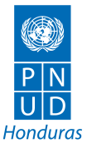Project: “Strengthening Democratic Governance in Honduras

Through Technical Electoral Assistance and the Promotion of Citizen Security

and a Culture of Peace”

Grant: AID-522-IO-11-00001

UNDP Elections and Citizen Security

Duration: October 1, 2014 – June 30, 2017

Total Budget: USD 12,226,552.28 (Federal)

USD 1,374,654.00 (Non-Federal)

Geographic Coverage: Nationwide

July 2015

**Content**

[Acronyms and Abbreviations 8](#_Toc426973020)

[1. Executive Summary 10](#_Toc426973021)

[1.1 Component 1: Electoral Technical Assistance 10](#_Toc426973022)

[1.2 Component 2: Technical Assistance in Citizen Identification 10](#_Toc426973023)

[1.3 Component 3: Development of Public Policies for Citizen Security and Coexistence 12](#_Toc426973024)

[2. Implementation of activities 15](#_Toc426973025)

[2.1 Component 1: Electoral Technical Assistance 15](#_Toc426973026)

[2.1.1 Indicator performance tracking table 15](#_Toc426973027)

[2.1.2 Progress Narrative 18](#_Toc426973028)

[2.1.3 Status of Activity level logic models 20](#_Toc426973029)

[2.1.4 Implementation Challenges and Opportunities 20](#_Toc426973030)

[2.2 Component 2: Technical Assistance in Citizen Identification 20](#_Toc426973031)

[2.2.1 Indicator Performance Tracking Table 20](#_Toc426973032)

[2.2.2 Progress Narrative 21](#_Toc426973033)

[2.2.3 Status of activity level logic models 22](#_Toc426973034)

[2.2.4 Implementation Challenges and Opportunities 22](#_Toc426973035)

[2.3 Component 3: Development of Public Policies for Citizen Security and Coexistence 23](#_Toc426973036)

[2.3.1 Indicator Performance Tracking Table 23](#_Toc426973037)

[2.3.2 Progress Narrative 25](#_Toc426973038)

[2.3.3 Status of activity level logic models 34](#_Toc426973039)

[2.3.4 Implementation Challenges and Opportunities 40](#_Toc426973040)

[3. Collaboration and/or knowledge sharing with other USAID activities 41](#_Toc426973041)

[3.1 Component 1: Electoral Technical Assistance 41](#_Toc426973042)

[3.1.1 Relationship with other USAID activities 41](#_Toc426973043)

[3.1.2 Key highlights of collaboration 41](#_Toc426973044)

[3.1.3 Challenges of collaboration 41](#_Toc426973045)

[3.2 Component 2: Technical Assistance in Citizen Identification 42](#_Toc426973046)

[3.2.1 Relationship with other USAID activities 42](#_Toc426973047)

[3.2.2 Key highlights of collaboration 42](#_Toc426973048)

[3.2.3 Challenges of collaboration 42](#_Toc426973049)

[3.3 Component 3: Development of Public Policies for Citizen Security and Coexistence 42](#_Toc426973050)

[3.3.1 Relationship with other USAID activities 42](#_Toc426973051)

[3.3.2 Key highlights of collaboration 43](#_Toc426973052)

[3.3.3 Challenges of collaboration 43](#_Toc426973053)

[4. Collaboration and/or knowledge sharing with government partners or other donors 43](#_Toc426973054)

[4.1 Component 1: Electoral Technical Assistance 43](#_Toc426973055)

[Links with relevant ministries and donor agencies 43](#_Toc426973056)

[4.2 Component 2: Technical Assistance in Citizen Identification 44](#_Toc426973057)

[Links with relevant ministries and donor agencies 44](#_Toc426973058)

[4.3 Component 3: Development of Public Policies for Citizen Security and Coexistence 44](#_Toc426973059)

[Links with relevant ministries and donor agencies 44](#_Toc426973060)

[5. Special reporting requirements (USAID forward, presidential initiative) 45](#_Toc426973061)

[6. Integration of cross-cutting variables 45](#_Toc426973062)

[6.1 Component 1: Electoral Technical Assistance 45](#_Toc426973063)

[6.1.1 Gender 45](#_Toc426973064)

[6.2 Component 2: Technical Assistance in Citizen Identification 45](#_Toc426973065)

[6.3 Component 3: Development of Public Policies for Citizen Security and Coexistence 45](#_Toc426973066)

[6.3.1 Gender 45](#_Toc426973067)

[7. Administrative and management issues 47](#_Toc426973068)

[7.1 Component 1: Electoral Technical Assistance 47](#_Toc426973069)

[7.1.1 Constraints and critical issues 47](#_Toc426973070)

[7.1.2 Personnel 47](#_Toc426973071)

[7.1.3 Changes to activities 48](#_Toc426973072)

[7.1.4 Modifications and amendments 48](#_Toc426973073)

[7.2 Component 2: Technical Assistance in Citizen Identification 49](#_Toc426973074)

[7.2.1 Constraints and critical issues 49](#_Toc426973075)

[7.2.2 Personnel 49](#_Toc426973076)

[7.2.3 Adaptation of the activity 49](#_Toc426973077)

[7.2.4 Modifications and Amendments 49](#_Toc426973078)

[7.3 Component 3: Development of Public Policies for Citizen Security and Coexistence 50](#_Toc426973079)

[7.3.1 Constraints and critical issues 50](#_Toc426973080)

[7.3.2 Personnel 51](#_Toc426973081)

[7.3.3 Changes to activities: Adaptation of the activity 51](#_Toc426973082)

[7.3.4 Modifications and Amendments 51](#_Toc426973083)

[8. Evaluations and lessons learned 51](#_Toc426973084)

[8.1 Component 1: Electoral Technical Assistance 51](#_Toc426973085)

[8.1.1 Lessons learned and best practices 51](#_Toc426973086)

[8.1.2 Actions and way forward 51](#_Toc426973087)

[8.2 Component 2: Technical Assistance in Citizen Identification 52](#_Toc426973088)

[8.2.1 Lessons learned and best practices 52](#_Toc426973089)

[8.2.2 Actions and way forward 52](#_Toc426973090)

[8.3 Component 3: Development of Public Policies for Citizen Security and Coexistence 52](#_Toc426973091)

[8.3.1 Lessons learned and best practices 52](#_Toc426973092)

[8.3.2 Actions and way forward 53](#_Toc426973093)

[9. Activities planned for the next semester 54](#_Toc426973094)

[9.1 Component 1: Electoral Technical Assistance 54](#_Toc426973095)

[9.2 Component 2: Technical Assistance in Citizen Identification 58](#_Toc426973096)

[9.3 Component 3: Development of Public Policies for Citizen Security and Coexistence 60](#_Toc426973097)

[10. Financial information 65](#_Toc426973098)

[10.1 Component 1: Electoral Technical Assistance 65](#_Toc426973099)

[10.1.1 Financial status as of March 31, 2015 65](#_Toc426973100)

[10.1.2 Budget Details and Notes 65](#_Toc426973101)

[10.1.3 Sub-Award Details 65](#_Toc426973102)

[10.2 Component 2: Technical Assistance in Citizen Identification 66](#_Toc426973103)

[10.2.1 Financial status as of March 31, 2015 66](#_Toc426973104)

[10.2.2 Budget Details and Notes 66](#_Toc426973105)

[10.2.3 Sub-Award Details 66](#_Toc426973106)

[10.3 Component 3: Development of Public Policies for Citizen Security and Coexistence 67](#_Toc426973107)

[10.3.1 Financial status as of March 31, 2015 67](#_Toc426973108)

[10.3.2 Budget Details and Notes 67](#_Toc426973109)

[10.3.3 Sub-Award Details 67](#_Toc426973110)

[11. Branding, communication and dissemination 68](#_Toc426973111)

[11.1 Component 2: Technical Assistance in Citizen Identification 68](#_Toc426973112)

[11.1.1 Key communication activities 68](#_Toc426973113)

[11.1.2 Branding 68](#_Toc426973114)

[11.2 Component 3: Development of Public Policies for Citizen Security and Coexistence 68](#_Toc426973115)

[11.2.1 Key communication activities 68](#_Toc426973116)

[11.2.2 Branding 71](#_Toc426973117)

[12. Sustainability and exit strategy 73](#_Toc426973118)

[12.1 Component 1: Electoral Technical Assistance 73](#_Toc426973119)

[12.2 Component 2: Technical Assistance in Citizen Identification 73](#_Toc426973120)

[12.3 Component 3: Development of Public Policies for Citizen Security and Coexistence 73](#_Toc426973121)

[13. Annexes 75](#_Toc426973122)

[13.1 Annex 1: Component 2: Technical Assistance in Citizen Identification 75](#_Toc426973123)

[13.1.1 Success Stories 75](#_Toc426973124)

[13.1.2 Training report 75](#_Toc426973125)

[13.1.3 Pictures (events, trainings, etc) 76](#_Toc426973126)

[13.2 Annex 1: Component 3: Development of Public Policies for Citizen Security and Coexistence 80](#_Toc426973127)

[13.2.1 Success Stories 80](#_Toc426973128)

[13.2.2 Training report 80](#_Toc426973129)

[13.3 Annex 3: Quarterly Performance Report (April 1 – June 30, 2015) 95](#_Toc426973130)

[13.3.1 Executive Summary 95](#_Toc426973131)

[13.3.1.1 Component 1: Electoral Technical Assistance 95](#_Toc426973132)

[13.3.1.2 Component 2: Technical Assistance in Citizen Identification 96](#_Toc426973133)

[13.3.1.3 Component 3: Development of Public Policies for Citizen Security and Coexistence 96](#_Toc426973134)

[13.3.2 Activity implementation 102](#_Toc426973135)

[13.3.2.1 Component 1: Electoral Technical Assistance 102](#_Toc426973136)

[13.3.2.2 Component 2: Technical Assistance in Citizen Identification 107](#_Toc426973137)

[13.3.2.3 Component 3: Development of Public Policies for Citizen Security and Coexistence 112](#_Toc426973138)

[13.3.3 Modifications and amendments 127](#_Toc426973139)

[13.3.4 Financial Information 128](#_Toc426973140)

[13.3.4.1 Financial status as of June 30, 2015 - Component 1: Electoral Technical Assistance 128](#_Toc426973141)

[13.3.4.2 Financial status as of June 30, 2015 - Component 2: Technical Assistance in Citizen Identification 129](#_Toc426973142)

[13.3.4.3 Financial status as of June 30, 2015 - Component 3: Development of Public Policies for Citizen Security and Coexistence 130](#_Toc426973143)

[13.3.5 Further information on Component 1: Electoral Technical Assistance 130](#_Toc426973144)

# Acronyms and Abbreviations

|  |
| --- |
| AMDC: Alcaldía Municipal del Distrito Central (Central District Municipality) |
| AOP or AWP: Annual Operating Plan or Annual Work Plan |
| ATE Project: Proyecto de Asistencia Técnica Electoral (Electoral Technical Assistance Project) |
| AVCC: Actores Voluntarios de Convivencia Comunitaria (Voluntary Stakeholders for Community Coexistence) |
| CARSI: Central America Regional Security Initiative |
| CABEI: Central American Bank for Economic Integration |
| CCIA: Cámara de Comercio e Industrias de Atlántida |
| CDE : Business Development Centers |
| COMVIDA: Comité para la Niñez, Adolescencia y Juventud (Committee for Children, Adolescents and Youth) |
| CONADEH.- Comisión Nacional de Derechos Humanos (National Human Rights Commission) |
| CPTED: Crime Prevention Through Environmental Design |
| CRIC.- Centro de Registro Civil e Identificación Ciudadana (Center for Civil and Registry and Citizen Identification ) |
| CSO: Civil Society Organization |
| DIM: Dirección de Infraestructura Mayor (Major Infrastructure Division) |
| DNIC: Dirección Nacional de Investigación Criminal (National Directorate of Criminal Investigation) |
| EAD/DPA: Electoral Affairs Division of the Department of Political Affairs |
| FAC: Community Artistic Trainers (Formadores Artísticos Comunitarios) |
| FHIS: Fondo Hondureño de Inversión Social (Honduran Fund for Social Investment) |
| G-FORT.- Grupo de Fortalecimiento Institucional (Institutional Strengthening Group) |
| GSE: Grupo de Seguimiento Electoral (Electoral Monitoring Group) |
| G-16 Grupo de los 16 donantes en Honduras (Group of 16 donors in Honduras) |
| IDEA: Institute for Democracy and Electoral Assistance |
| IDECOAS: Instituto de Desarrollo Comunitario, Agua y Saneamiento (Institute of Community Development, Water and Sanitation) |
| INE: Instituto Nacional de Estadísticas (National Institute of Statistics) |
| IPECC: Instituto de Participación y Educación Cívica y Ciudadana (Institute for Civic and Citizen Participation and Education) |
| INAM : National Women's Institute |
| IUDPAS: Instituto Universitario para la Democracia, Paz y Seguridad (University Institute for Democracy, Peace and Security) |
| KAS : Konrad Adenauer Stiftung |
| LEOP: Ley Electoral y de Organizaciones Políticas (Law for Elections and Political Organizations) |
| MANUD: Marco de Apoyo del Sistema de Naciones Unidas al Desarrollo (United Nations Support Framework System for Development) |
| MER: Mesa Electoral Receptora (Polling Station) |
| MOE-OEA: Misión de Observación Electoral de la OEA (Electoral Observation Mission of the OAS) |
| MOE-UE: Misión de Observación Electoral de la Unión Europea ((Electoral Observation Mission of the European Union) |
| MOU: Letter of understanding |
| NDI: National Democratic Institute |
| NEC: National Electoral Census |
| NIMD: Netherlands Institute for Multi-party Democracy |
| OAS: Organization of American States |
| OMM: Oficinas Municipales de la Mujer (Women Municipal Office) |
| NGO: Organizaciones no gubernamentales (Non-governmental organizations) |
| OSC: Organizaciones de sociedad civil (Civil Society Organizations) |
| PCC: Puntos de Convivencia Comunitaria (Community Coexistence Groups/Points) |
| PEC: Proyectos de Ejecución Comunitaria (Community Implemented Projects) |
| GDP: Producto Interno Bruto (Gross Internal Product) |
| PLCySC: Plan Local de Convivencia y Seguridad Ciudadana (Local Plan of Citizen Coexistence and Security) |
| PMIAJ / COMVIDA: Programa Municipal de Infancia, Adolescencia y Juventud |
| PNUD/UNDP: Programa de las Naciones Unidas para el Desarrollo (United Nations Development Programme) |
| POA: Plan Operativo Anual (Anual Work Plan) |
| RIO: Red de Inscripción Oportuna |
| RCM.- Registro Civil Municipal (Municipal Civil Registry) |
| RNP: Registro Nacional de las Personas (National Civil Registry) |
| SEPLAN: Secretaría de Planificación (Planning Ministry) |
| TDRs: Términos de Referencia (Terms of Reference) |
| TSE: Tribunal Supremo Electoral (Supreme Electoral Court) |
| UMC: Unidades de Mediación y Conciliación (Mediation and Conciliation Units) |
| UNAH: Universidad Nacional Autónoma de Honduras (National Autonomous University of Honduras) |
| UNDP: United Nations Development Programme |
| USAID: United States Agency for International Development |

# Executive Summary

The Project: “Strengthening Democratic Governance in Honduras through Technical Electoral Assistance and the Promotion of Citizen Security and a Culture of Peace” is structured along three components:

1. Electoral Technical Assistance (ATE)

2. Technical Assistance in Citizen Identification

3. Development of Public Policies for Citizen Security and Coexistence

## 1.1 Component 1: Electoral Technical Assistance

During the period covered by this report, an important event occurred affecting the implementation of UNDP’s Asistencia Técnica Electoral (Electoral Technical Assistance or ATE) Project: the continuation of the Project and the setting up of the new Base Team of the Project.

The TSE has been following in the distance during the last months the two main issues in the political-electoral arena: 1) presidential re-election and 2) an electoral runoff. Nonetheless, due to the changes in the political arena (mainly the “indignados” protests and pressure from different CSO), the two main issues that are currently being discussed are the need to depoliticize the polling stations and the need to control political financing. The TSE is inclined to study both issues from a technical point of view in order to be able to participate in the electoral reform process.

On the other hand, due to the complexity of the issue of the reform of the electoral law, the TSE is working on several proposals of regulations in order to make the electoral process more efficient.

The 2014-2015 Project AWP followed the same action lines discussed in previous meetings with USAID and is based on the recommendations of the needs assessment mission. Overall, the AWP responds to the TSE’s requests for assistance regarding (1) support for electoral reform, (2) training for the TSE’s Board of Magistrates and department heads, and (3) strengthening of the operating units, especially the Department for Training and Civic Education.

## 1.2 Component 2: Technical Assistance in Citizen Identification

Citizen identification and civil registration are key to the realization of human rights, the strengthening of democracy, and the development and security of a country. Identification expressed as the right to a name and a nationality is the basis for citizenship, which in turn is the essence of democracy. Similarly, a timely, reliable, secure, and transparent civil registry is a fundamental input not only for the development and maintenance of a reliable electoral census, but also for the design of inclusive public policies aimed at strengthening democratic governance by reducing poverty, promoting development, and improving security. These are public goods that a democratic State should not, under any circumstances, postpone. For this reason, UNDP, with the support of USAID, has agreed to support the RNP through a project to strengthen its capacities. The work of government institutions, civil society, and donors, united by a commitment to advance the process of democratization in this country, has made possible the encouraging results described in this report and serves as an example of the optimization of resources, in the context of efficient and transparent public administration.

**Results**

The “Support for Strengthening Management Capacity of the National Civil Registry” Project set as a result at this stage, that the RNP develops appropriate capacities to provide better service to citizens through the following products:

1) **"Increased Security and Transparency in Honduran Identification"**, Activities have focused on current reduction of the registration of civil acts of citizens, from a perspective that transcends electoral processes and tries to rather generate conditions for access for citizens to register all acts of civil life: birth certificates, death certificates, divorces and marriages. To fulfill this purpose, cooperation agreements have been subscribed, and coordination ties with other state institutions have become closer; institutions as the Public Ministry, the Ministry of Health and the UNAH; the last one being the ground where the Centers for Civil Registry and Citizen Identification were built. Furthermore, strengthening of the RNP information databases security has been supported through staff training on info-technological security policies.

2) **" Strengthened Management of primary inputs of the National Electoral Census "**, a process in which 180 cities have been visited to produce a Diagnosis of under registration of deaths, interviewing Municipal Civil Registry officers, Local Government Authorities, Hospitals and Health Centers staff and Heads of Cemeteries. These are the instances through which the information of deceased persons in each municipality flows, which were approached with the purpose of knowing what type of controls are used to register deaths, and to be able to compare this information with the information that the RNP administrates. Also, this visiting tour aims to determine the death sub registration index in the country.

3) **" Strengthened Capacities of the National Civil Registry**". Support was provided for the production of the terms of reference to acquire safety equipment in order to increase RNP data safety. Additionally, the terms of reference for the consultancy ‘Amendments to the Law’ and RNP regulation were produced, to decrease the death under registration index.

**Project Problems**

**Project Problem1:**

The change of government at the RNP, has led to delays in the implementation of some planned project activities as workshops with the RNP Strengthening and Transparency Group (G - FORT ), which have not been able to take place, as well as planned acquisitions, as the new RNP purchasing committee has not been formally appointed yet.

Implemented Actions:

Approaching new authorities to socialize the project and obtain their support for timely implementation.

Interagency coordination imposes particular working rhythms beyond control of the project, as it depends on contractual aspects of partner institutions.

**Project Problem 2:**

Untimely approval of the Annual 2014 Operating Plan has generated a lag on the implementation process of the project and achievement of expected results.

Implemented Actions:

Activities as the implementation of diverse communication mechanisms and monitoring of agreements subscription at various levels are being carried out according to planned as far as possible

**Learned Lessons**

1. When producing operational plans in periods of government change, a time of transition must be taken into account, which can cause lags on plans implementation. Therefore, it is important to socialize the project to be implemented immediately with the new authorities.

In the case of new authorities, there is always resistance within the institutions. Permanent participation and ownership of this new practice by the RNP has been instrumental in advancing the objectives of the project.

1. Successes or Best Practices: Considering the importance of identification processes, especially in the current context of political and social polarization, a Best Practice is the opening of institutions and processes to citizen control and supervision. This practice ensures transparency and therefore legitimacy. At the same time, it constitutes a significant support in achieving better institutional performance through ongoing assistance for new procedures.

Services concentration has always been one of the most disputed issues in public administration. Current decentralization of Register services provides an interesting experience for the rest of government.

1. Speeding up of the paper work related to funds approval is important, in order to implement activities as planned.

**Recommendations:** Greater community involvement through organized and existing grassroots structures and state institutions with a local presence could encourage ownership of the processes by the citizenry and ensure sustainability beyond specific time periods. Regarding ongoing challenges, it is important to continue working to install non-partisanship (or de-partisanship) of the processes and the institution itself. This is critical to advance the legitimacy that institutions as the RNP require in order to fulfill their mandates in an efficient, effective, and transparent manner.

To monitor and evaluate in a timely and systematic way not only for the purpose of continuous improvement of the project, but for partner organizations and Honduran society at large to become aware and embrace the impact of the project.

## 1.3 Component 3: Development of Public Policies for Citizen Security and Coexistence

Throughout the period and under the cooperation agreement established among the National Autonomous University of Honduras (UNAH) and the United Nations Development Programme (UNDP),and through the project " Strengthening Democratic Governance in Honduras: Promotion of Coexistence and Citizen Security in municipalities with high incidence of violence", the National Observatory of Violence under this Project has established actions that have allowed development and strengthening of Local Observatories of Violence, and analysis of the reality of violence and crime, for development of strategies and local policies on citizen security and coexistence in the municipalities; and identifying effective prevention work lines.

A Cooperation Agreement with the Ministry of Security has been subscribed, which has allowed access to information and the development of a process of validation, cleansing, geo referencing, and generation of reliable statistical information, for the development of Bulletins containing geo-referenced information in time, person and place.

Municipal Management developed throughout this period has led to significant progress in project implementation, achieving completion of the 2014 Annual Work Plans in four of the five Project target municipalities: Choloma, La Ceiba, San Pedro Sula and Tela. The Local Plan of Citizen Security and Coexistence was delivered for certification in the Central District Municipality to the Ministry of Security, in order to forward technical assistance in the establishment of the Technical Unit as the main mechanism to consolidate city management spaces ​​that lead to the implementation of the actions identified in the Plan and its subsequent monitoring.

It is noteworthy to mention that since the AOPs could allow progress on quantification of the investment in public safety in the municipalities by different funding sources, development of workshops with officials from the municipalities of San Pedro Sula, Choloma, Tela and La Ceiba was considered necessary to build monitoring and evaluation capacity , in order to direct the work towards measuring the actions defined in the Annual Work Plans, in order to accurately guide management and municipal administration. Therefore, the activity allowed progress in obtaining inputs for the definition of indicators that facilitate subsequent measurement, and therefore, periodic documentation of progress and of Program results, as well as municipal investment.

Concerning management of the Security Tax funds, the Central District, Choloma and Tela are still awaiting national level response about proposed projects for funding. However, Municipalities continue to implement actions in social prevention using municipal funds, and are committed to implement coexistence and citizen security actions defined in the AOP, including social infrastructure actions.

Significant progress has been registered in the Mediation and Conciliation component, achieving compliance with the objectives that have helped advance the strategy at community and institutional levels. A larger level of community empowerment by the AVCC was observed, through coordination for activities development and actions in promoting coexistence. Regarding the institutional aspect, Diploma Certificate participants gained knowledge that was implemented in different units, faced also with the challenge of joint actions along the UMC. The opening of the UMC was achieved in the Central District, and simultaneously, the creation of the network of AVCC began, in order to level the municipality with the other units of mediation and conciliation. Most significant advances in this semester include:

- Completion of the Diploma Certificate in Community Conflict Settlement and Mediation, attended by 27 professionals from different target municipalities and Peace Magistrate Court staff.

- Re-opening of the Mediation and Monciliation unit of the Central District.

- Expanding the AVCC in San Pedro Sula, Choloma, Tela and La Ceiba; certifying 67 leaders in Community Coexistence .

- Accreditation of the AVCC network for their work during 2014.

- Beginning of the motivation and awareness events of the AVCC in the Central District (Villa Nueva, Estados Unidos and Kennedy neighborhoods and the Jesus Milla Selva High school).

- Meetings with the Judiciary, aimed at the creation of a proposal for the creation of alternative dispute resolution methods at country level.

The Youth and Civic Culture Component had significant advances in this period, particularly in the areas of strengthening artistic and civic youth abilities for youth from five municipalities, and in the area of promoting youth entrepreneurship skills.

Three artistic training workshops were conducted with youth in five target municipalities, organizing and putting together the same number of community artist groups that are coordinated and subscribed to COMVIDA. These groups received human training: peace culture, civic culture, human rights, values ​​etc., as well as artistic education in 7 disciplines: stilts, mural, living statues, mime, break dance, samba and percussion.

Once the groups were formed, 10 leaders, one in each Municipality, were selected along with COMVIDA, based on their artistic and human leadership, to train them as Artistic Community Trainers. To achieve this, two workshops of three days each were implemented, using the training methodology ‘from youth to youth’, supported by the facilitators group of Comayagua.

Once trained, a neighborhood in conditions of vulnerability and violence was selected with approval of the municipal mayors, for the new facilitators in each municipality to replicate their experience. From February until March 2015 young leaders replicated the experience in the following neighborhoods: Colonia 15 de Septiembre (Tela); Barrio el Centro (La Ceiba); Barrio Concepción (Choloma); Barrio San Miguel (Tegucigalpa) and Colonia Rivera Hernández (SPS). COMVIDA and Community Boards of each neighborhood supported the organization, physical space, logistics and catering for the workshops. A group of young artists for peace in every neighborhood was the main result.

Regarding youth entrepreneurship, three financing funds were launched for young entrepreneurs in La Ceiba, Tela and Choloma, reaching greater achievements in La Ceiba. Institutional alliances with UNAH, municipalities and Chambers of Commerce were established in each municipality. In Tela, the Tourism Chamber and the CEPUDO Foundation also joined the activities.

The first step was the identification of partner institutions to participatory develop a Handbook for Operation of the Financing Fund for each municipality. Also the Microcapital Agreements among UNDP and each of the parts were subscribed, the parts being: In La Ceiba, the Chamber of Commerce and Industry of Atlantis, in Tela, the Municipality, and in Choloma, the Chamber of Commerce. In all cases, an assessment of the administrative capacities was carried out by UNDP. Contributions were made available by the project, the municipality and the chambers of commerce. Also UNAH contributed with technical assistance for the training of entrepreneurs, except in Choloma where a there is no University. The agreement of La Ceiba and the transfer of resources from UNDP had been subscribed and implemented in February. Also, the identification and training of entrepreneurs was implemented. In May, targeting and delivery of seed capital in kind was implemented in La Ceiba. In Tela and Choloma, Agreements were signed with UNDP, and the remaining process is about to be implemented.

The campaign “I am young, Making a Difference” was developed and validated, also producing shirts, caps and bags for young people. Also, a collective creation workshop for a rap version musical theme that will be recorded for a video clip took place, with the participation of a youth representative from the five target Municipalities. Two workshops on mime and statues were also developed, building 15living statues and15 mimes that will serve to disseminate messages of violence prevention as part of the communication campaign.

Regarding the support to the Municipal Offices for Women, as well as the other components of the project, during this semester a gender focus was promoted in the 2015 AOPs of 4 municipalities (La Ceiba, Tela, San Pedro Sula and Choloma, where work by consensus took place among the OMM, organized women and cooperative institutions working on gender issues in Municipalities. Also, 3 workshops on sex-gender theory were implemented in the Central District, Tela and San Pedro Sula, as part of the training process carried out by the component of Local Plans aimed at Prevention Committees. The OMM / INAM Management and Information System was installed, which arises from the need to strengthen three fundamental aspects:

* Monitoring of the National Women's Institute ( INAM ) and the municipal offices of Women ( OMM ) in relation to progress of the Second Equality and Gender Equality Policy in Honduras ( II PIEGH ) .
* Documenting cases of violence against women in an orderly manner and with an adequate systematization by the OMM. This issue is very important, because prior to the system installation, the information was manually registered, using forms and notebooks. Although the OMMs made ​​a major effort to keep records in order, there was an ongoing risk of damage or loss.
* Encourage the establishment of an accountability mechanism from the OMMs to the Municipalities, civil society organizations and institutions in the Municipality.

Seven modules of the "University Certificate Diploma in Gender, Citizen Security and Coexistence" have been completed, and presentation of research results, as well as the graduation ceremony has taken place on March 23.

The Diploma led an academic and awareness space for understanding and facilitation of tools to address problems related to coexistence and citizen security considering the specific needs of women. Human and institutional capacities of civil servants and officials of the Municipalities were strengthened, mainly from the Municipal Women Offices, the Prosecution Offices, police, courts, as well as civil society organizations and women networks in Choloma, Tela, San Pedro Sula, La Ceiba and the Central District.

A communication campaign for the prevention of gender violence called "Here and now, my right to live" was developed, which included the promotion of care services to women, as well as design, production and communication products dissemination through various means in the target municipalities. This awareness campaign "Here and Now, my Right to Live", was participatory built with the OMMs and Women Networks in the municipalities, promoting violence prevention through messages that emphasize the value of the role of women in society, also promoting related care services.

# Implementation of activities

## 2.1 Component 1: Electoral Technical Assistance

### 2.1.1 Indicator performance tracking table

**Output 1: Technical Assistance for the Legal and Regulatory Framework and Restructuring of the TSE’s Operating Units**

**Description**: Development of a proposal for comprehensive legal reform of the electoral system. A comprehensive assessment of the 2012 and 2013 electoral processes. Creation of the TSE’s institutional report for 2009-2014. Deepening and consolidating the TSE’s organizational reform process which began in 2009, through its operating units, such as Mapping and Census, Information Technology, and Public Relations.

|  |  |
| --- | --- |
| **Indicators** | **Indicator performance** |
| Matrix with comments on the various electoral reform proposals (July 2014) | The initiative to create the matrix is currently being implemented by NIMD and NDI. |
| Proposal with articles and input from relevant stakeholders (December 2014) | Fluid communication with UN headquarters in New York in order to obtain CVs of candidates in the database of EAD/DPA to contract a legal consultant with experience in electoral reform. Various candidates have been identified and will be contacted to find out their interest and availability.  Additionally, processes were begun for contracting the ATE Project team and they are expected to start in November 2014. Once formed, this team together with the legal and electoral reform expert will work closely with the TSE and the Congressional Committee for Electoral Affairs to draft a proposal with articles and with input from all relevant stakeholders. |
| Congressional debates (2015) | No progress on this indicator because the Project does not yet have a team to conduct the relevant activities.  After the notification of the continuation of the Project by the EAD/DPA at the end of August and the approval of the 2014-15 AOP by the Project Board at the beginning of September, the process of contracting staff began. The team members should begin work in November 2014. Once the team is in place, the Project will have the necessary support to begin interacting with the National Congress. |
| Magistrates and department directors have participated in 2 regional trainings (December 2014) | No progress on this indicator |
| Assistance plan agreed on by the Directors of the Unit for Electoral Training and Civic Education and the Gender Unit (June 2014) | In close collaboration with the staff and coordinators of the Unit for Electoral Training and Civic Education and of the Gender Unit, the ATE Project drafted a plan for activities for 2014-2015 in order to improve the coordination and implementation of activities in various areas such as research methods, organization and planning, mainstreaming democratic/civic education, training and implementation of educational campaigns, and creation and dissemination of printed and digital materials, especially with mass media.  In addition, this plan will maintain focus and increase the efficiency of activities aimed at several stakeholders, such as political parties, students and school boards, first-time voters, women, and government agencies, as well as the staff of the Unit for Electoral Training and Civic Education and of the Gender Unit. |
| At least 3 parties have taken actions to promote women’s participation (December 2014) | No progress on this indicator because the Project does not yet have a team to conduct the relevant activities.  The ATE Project has been supporting the TSE with the preparation and socialization of the Regulation for Parity and Alternation |
| Pilot plan to include civic education activities in a municipality (December 2014) | No progress on this indicator |
| Expert recruited and trained to adaptthe electoral census with the RNP’s advances (July 2014) | The ATE Project hired in 2014 an IT expert in order to develop a software that effectively connects the databases of the TSE and the RNP, with the ultimate objective of updating the electoral census with reliable information about citizens who have the right to vote and exclude duplicate registrations, errors, deceased voters, and those voters who are ineligible to vote.  The expert has been working since the beginning of January and has been holding regular meetings with the ATE Project staff and with staff at the TSE and the RNP, so that the software developed is in line with the needs and demands of both institutions.  Currently the software is being finalized. |
| At least 3 political parties have signed a cooperation agreement with the ATE Project (August 2014) | No progress on this indicator |
| At least 2 political parties have modified or adapted their internal regulations to the electoral law (December 2014) | No progress on this indicator |

**Output 2: Technical Assistance to Strengthen the Training Unit and the Institute for Civic and Citizen Participation and Training (IPECC)**

**Description:** Strengthen the TSE’s Electoral Training Unit by incorporating it into the Institute for Civic and Citizen Participation and Education (*Instituto de Participación y Educación Cívica y Ciudadana* or IPECC) which was created in 2011. In particular, to incorporate civic, electoral, and democratic training programs, which involve representatives of the TSE and support the building of citizenship, and making use of previously designed tools, such as the “democratic values” campaign.

|  |  |
| --- | --- |
| **Indicators** | **Indicator performance** |
| Letters of understanding (MOUs) signed with the Ministry of Education and at least one teacher training school (August 2014) | The TSE signed an agreement with the Ministry of Education. The “*Convenio marco de cooperación en material cívica electoral*” was signed on 20 February 2015. |
| At least one institution has approved a plan for incorporating civic education (December 2014) | No progress on this indicator |
| Network of CSOs formed in a municipality (August 2014) | No progress on this indicator |

**Output 3: Maintenance of the Unit of Implementation, Monitoring and Follow-Up of the ATE Project**

**Description**: Maintenance of the Project’s core team to coordinate horizontal cooperation for the various activities conducted by the TSE, with the goal of identifying weaknesses and opportunities for participation by international experts. The team includes an international consultant, a national technical assistant, and a financial administrator. It also includes the cost of the Project’s facilities, stationary, communications, and services necessary for the operation of the office such as electricity, water, internet, cellular phones, transportation, and security.

|  |  |
| --- | --- |
| **Indicators** | **Indicator performance** |
| 2014-15 AOP of the ATE Project approved by the Project Board (May 2014) | Following the notification of the approval of the ATE Project extension in August, the Project Board met at the beginning of September and discussed two important points: (1) the approval of the Project’s AOP for the end of 2014 and the beginning of 2015, and (2) the drafting of a revised budget based on the approved AOP. |

### 2.1.2 Progress Narrative

Following the approval of the continuation of the Electoral Technical Assistance Project to the TSE by the Electoral Affairs Division of the Department of Political Affairs of the United Nations, the ATE Project Board approved in the beginning of September 2014, the Annual Working Plan of the ATE Project for the period September 2014 – March 2015, providing a similar technical assistance approach to reform the legal/regulatory framework and restructure the TSE’s operating units, technical assistance to strengthen the TSE’s training unit and the Institute for Citizen and Civic Participation and Education, and maintaining the unit on implementation, monitoring and follow-up of the ATE Project.

Although the Project was reactivated in September and the AWP foresaw several activities to be held from that month, the absence of a base technical team hindered the implementation of those foreseen activities during the remaining months of 2014. Soon after the approval of the 2014-2015 AWP, the UNDP started a selection and hiring processes to form the base technical team of the ATE Project that took several months due to the intrinsic characteristics of any hiring process.

Considering that the project would end on March 2015, and given the low expenditure level of funds due to administrative issues as the approval of the continuation of the project during 2014, and the recruitment process of the technical staff of the project; UNDP requested to USAID the extension of the implementation period of the approved AWP until 30th June 2015, in order to implement all planned activities, including the hiring of several experts in the fields of electoral reform, info-technologies, gender and capacity building. This would mean a coming expenditure of USD 469,525.22 that are still available, plus USD200,000 that had been re-allocated to the Component 2 (Citizen Identification), but are now back to Component 1. Such request was kindly approved by USAID, allowing activities implementation beyond March 2015.

In January 2015, the ATE Project’s base team was formally introduced to the TSE’s Magistrates and visited the Directors of the TSE’s operative units to ascertain their concerns and include them in the 2014-2015 AWP that was under review. Given the complexity of the environment, UNDP emphasized the importance of articulating the process of discussion and raising awareness about the electoral reform with key stakeholders as the Congressional Committee on Electoral Issues, political parties, and civil society organizations involved in promoting democratic governance.

Given the illegitimacy perceptions of some political parties and civil society sectors towards the TSE magistrate’s constitution, it was agreed to continue efforts to support a possible electoral reform, but not holistically based on the suggestions of the Needs Assessment Mission of the UN EAD/DPA. Instead, supporting the TSE in the discussion of electoral reforms and identification and formulation of electoral regulations, require facilitating the application of the current electoral law. Thus, UNDP started planning an internal workshop for the discussion of the current Electoral Law and the 2011 Bill in order to identify potential electoral reforms (regulatory and legislative) that could start to be discussed in the following months.

Furthermore, UNDP supported the joint work of the TSE and the Ministry of Education on the realization of Student Governments through the launching of the project: Children and Youth with Voice and Vote. Such initiative has the objective to create citizenship at an early age and has an important input: the Campaign on Democratic Values ​​promoted by the UNDP during the elections of 2012 and 2013.

UNDP along with the TSE carried out training sessions that were conducted to determine the form of organization of Student Governments with the support of the materials developed with USAID funds. Due to budgetary and logistical constraints of the TSE to conduct such training, a cascade training system was considered; thus the staff of the Electoral Training Unit and Civic Education Unit of TSE was responsible for organizing training on Student Governments to departmental, district and Municipal Directors, so that they could transfer theoretical and operational knowledge to the principals, teachers and students of the approximately 22,000 public school nationwide.

Moreover, UNDP accompanied the TSE and the Ministry of Education on the subscription of the Cooperation Agreement on Civic Education matters, where, among other commitments, it was declared that elections for student government will be implemented every last Friday of April. In addition, through South-South cooperation, the UNDP support the TSE’s Electoral Training Unit and Civic Education Unit throughout the invaluable assistance of Carmen Chacon, Head of the Electoral Training Unit of the TSE in Panama, who was sought to provide technical assistance during the entire process of Government Students training session.

UNDP is also aware that the strengthening of the national democratic system goes through a continuous updating, cleansing of the National Electoral Census, and through the effective and reliable transmission of data between the RNP and the TSE. Therefore, UNDP hired an IT expert to develop an interconnection system with the data security and quality requirements from both institutions in order to transfer data in a more secure, transparent and reliable manner for the conformation of the NEC. Moreover, a legal protocol for such interconnection system begun as a subject of discussion among the IT and the Legal departments of both institutions in order to be included in the Interagency Cooperation Agreement between the Supreme Electoral Tribunal and the RNP, subscribed in 2011.

### 2.1.3 Status of Activity level logic models

*Not applicable*

### 2.1.4 Implementation Challenges and Opportunities

**Challenges:**

One of the main challenges concerning the process of electoral reforms was the lack of initiative of the TSE in order to propose a holistic electoral reform (due to the fact that the proposal for electoral reform in 2011 was rejected by the Congress). Furthermore, the lengthy administrative processes inside the TSE, the politization of its staff, and a lack of internal coordination hindered the implementation of many activities that had been planned.

**Opportunities:**

Due to the current volatile political situation in the country, there is a space for participation of the TSE in the public debate related to the electoral reform. The TSE, with the support of the ATE Project, could play a central role in the debates and discussions that could lead to an electoral reform.

The TSE is very interested in continuing with staff capacity building and with the institutional strengthening of the organization. The ATE Project will continue supporting these efforts.

The TSE is very interested in focusing on the issues of inclusion and gender.

## 2.2 Component 2: Technical Assistance in Citizen Identification

### 2.2.1 Indicator Performance Tracking Table

**Output 1: Security and Transparency in Honduran Identification**

|  |  |
| --- | --- |
| Indicators | Indicator performance |
| Number of installed and operative Citizen Civil Registry Centers (CRIC) at the Directorate of Forensic Medicine (Morgue) and Universities | 2 Citizen Civil Registry Centers built in Tegucigalpa (Forensic Medicine Offices - Morgue and at the UNAH  2 in construction process at the Forensic Medicine Offices - Morgue and at the UNAH in San Pedro Sula. |
| Number of workshops held on subjects related to info technological security | 5 workshops held in Comayagua, Siguatepeque, La Paz, Choluteca and San Pedro Sula cities. |

**Output 2: Strengthening of Management of Primary Input for the National Electoral Census**

|  |  |
| --- | --- |
| **Indicators** | **Indicator performance** |
| Number of deaths identified in visited places for diagnosis of under registration of deaths in the country | Accomplished visiting tour to 180 municipalities, where death under registration index is 27.30% |
| Analyzed data in the National Electoral Census of 2013 | Accomplished visiting tour to 180 municipalities, where approximately 16,807 people were determined to be dead while alive, and 36,108 people are registered as alive while dead at the National Electoral Census. |

**Output 4: Strengthened capacities at the National Civil Registry**

|  |  |
| --- | --- |
| **Indicators** | **Indicator performance** |
| Number of licenses and security equipment installed and operating | In adjudication process, it is currently on bids reception phase for the purchase of a security firewall and certifications. |

### 2.2.2 Progress Narrative

#### Period achievements by Output

**Output 1: Security and Transparency in Honduran Identification**

The construction of 2 centers for Civil Registry and Citizen Identification (CRIC) in Tegucigalpa was completed, located at the Directorate of Forensic Medicine (Morgue) and at the UNAH. Two more CRICs are currently under construction at the same institutional grounds at their headquarters in the city of San Pedro Sula.

During this period, most of the equipment for the implementation of the Centers for Civil Registry and Identification was acquired, while fingerprint readers acquisition process is still pending.

Throughout this period, the RNP has been provided with adequate and necessary support to continue raising the level of security at all the central and decentralized support centers.

Municipal Civil Registries in Comayagua, Siguatepeque, La Paz, San Pedro Sula and Choluteca, have increased security levels of citizen information contained in the database, through training of technical staff on info technological security systems.

**Output 2:** **Strengthened management of primary inputs of the National Electoral Census.**

a. The RNP has a consolidated an information document on the Diagnosis Visiting Tour of Under Registry of deaths, the implementation of the Timely Registration Network (Red de Inscripción Oportuna (RIO)), and a guide of best registration practices nationwide, where 180 municipalities and their civil municipal registries were visited. Interviews with Municipal authorities, hospitals and health centers were carried out during the visits, as well as with heads of Cemeteries and all those public or private institutions that handle information related to deaths in each municipality.

b . The RNP has a document of analysis of data obtained in 180 municipalities, that will serve as an input for the production of the final diagnosis document on the under registration of deaths rate.

c . The visiting tour for production of the diagnosis on the under registration of deaths on the remaining 70 municipalities has been planned.

**Output 3: Improve the Processes of Applying for and Delivery of Identity Cards to Citizens**

a. During this period, documents of monitoring and systematization of the project were produced, with the purpose of compiling best practices and lessons learned from the previous phase of the project.

**Output 4: Strengthened capacities of the National Civil Registry**

a. Terms of reference for the start of the process to acquire the following safety equipment have been jointly developed with technical RNP staff : firewall for WEB application: a tool that allows scanning , inspecting, and accelerating web traffic generated in the new WEB Civil Registry application at the Official web site of RNP *www.rnp.hn* , and at the external inquiry websites of the organization, providing controls to prevent malicious mis- configuration attacks on servers; and SSL Wildcard Certificate to ensure the institutional domain of RNP and any of its existing or planned sub-domains.

b . Documents have been prepared to begin the process of hiring the consultancy for Amendments to the Law and RNP Regulations to decrease rates of under registration of Deaths.

### 2.2.3 Status of activity level logic models

*Not applicable*

### 2.2.4 Implementation Challenges and Opportunities

The largest and most complex challenges facing the weak Honduran institutions are related to reducing partisan influence on them. Progress towards transparency and efficiency in public administration depends in large partly on the hiring of Directors and staff that are more responsive to good performance criteria rather than political party affiliation. In the case of the RNP, whose functions are critical to the credibility of electoral processes, the claim of non-partisanship is even greater in a context of significant changes in the national scene, specifically the profound crisis that led to the emergence of new political forces that put an end to the traditional two-party system which had been in place for more than a century. Citizens’ demand for changes is loud and forceful, presenting an opportunity for decision-makers, with the support of international donors and civil society, to undertake the changes necessary to improve the country’s public management, democracy, and development.

## 2.3 Component 3: Development of Public Policies for Citizen Security and Coexistence

### 2.3.1 Indicator Performance Tracking Table

|  |  |
| --- | --- |
| **Indicators** | **Indicator performance** |
| Number of bi annual locally published Bulletins from the Violence Observatory. | Validation, contrasting and unification of information with Security and Justice authorities at national and municipal levels.  Generation of variables crossings and indicators needed to design Bulletins for the 5 municipalities, development of municipal graphs of deaths from external causes, incidence of crime and injury.  Development of department geo referenced urban thematic maps in San Pedro Sula, Choloma, Tela, La Ceiba and Central District.  Preparation of charts, graphs and thematic urban geo referenced maps for 6 annual 2014 Bulletins of the local and National Observatories.  Six bulletins with geo-referenced data in time, person and place have been analyzed, diagrammed and published, in the period from January to December 2014 in San Pedro Sula, Choloma, Tela, La Ceiba and the Central District. The local Violence Observatory Bulletin has been designed, analyzed, charted, validated and published with nationwide validated data from 2014  3 special Bulletins were developed on :  • Violent deaths of women and girls municipalities of Choloma , San Pedro Sula Tela, La Ceiba and the Central District from January to December 2013.  • Bulletin of multiple homicides from January to September 2014  • Special Bulletin of transport Carriers from January to December 2014 |
| Number of government institutions using information of the Violence Observatory to design and implement public policy | Local governments (5) use information from violence and insecurity from the municipalities Diagnostics, which has allowed municipal authorities and security committees to acknowledge reality and establish public policy strategies and actions  Security and Prevention of Violence Municipal Committees have reliable information, as a product of the validation and analysis of deaths and injuries from external causes, which allows characterization of operating styles and the main violence victims.  Tourist sites and areas where property crimes occur were geo refenced in La Ceiba, as requested by the Municipality and the Chamber of Commerce.  19 organizations and institutions in the area use the information from the Observatory of Violence in the design and implementation of public policies of Municipal governments; as well as 5 security committees of the municipalities , 10 NGOs, (CDM, CEM-H ,Catholic church, women for life forum , yacshe, Visitación Padilla, Rainbow, CPTRT, Kukulcan) and 4 Cooperation Organizations (NDI, GIZ, WB, UNDP). |
| Number of projects submitted by municipalities for funding by the Protection and Security Population Fund and other sources | 1. The implementation of the Video and loudspeaker monitoring system Project at the Central Beach in Tela was sourced by Municipal funds.  2. In Choloma, the following projects were implemented:  • IDECOAS- FHIS- BM ,15 Projects;  • IDECOAS- FHIS- USAID 20 Projects ;  • Security Tax: 10 Projects were presented, but progress was registered only for the Video monitoring system Project in Choloma;  • Private sector: 15 Projects;  • UNICEF-ACDI: 10 Projects.  3. In La Ceiba , the following projects were implemented:  • Security Tax: 8 Projects  • USAID-IDECOAS-FHIS-DIM: 45 Projects  • IDECOAS-FHIS-Banco Mundial: 15 Projects  • JICA : 2 Projects  • AECID: 11 Projects  4. Progress on the Security Tax Fund expenditures have not been registered in San Pedro Sula  5. Progress on the Security Tax Fund disbursement has not been registered in the Central District. |
| Number of operating plans that integrate social prevention , situational prevention , deterrence and crime control actions in Tegucigalpa , San Pedro Sula , La Ceiba , Tela and Choloma . | The development and ownership of the Annual Operating Plan 2015 by local governments and key stakeholders in La Ceiba, Choloma, Tela and San Pedro Sula was achieved.  At the Central District, actions related to Citizen Security defined in the 2014 Work Plan were integrated into the 2015Municipal Development Plan , considering that certification of PLCySC from the Ministry of Security has not yet been achieved. |
| Percentage of increase on the cases that have been mediated by the UMCs and PCCs in the 5 municipalities of the project. | Negative increase percentages on mediations have been registered this quarter in two UMCs: Choloma: -73.2%, Tela: -51.2. San Pedro Sula shows no variation: 0.0%, and in La Ceiba, an increase was registered: 25.0%.  Regarding Community Coexistence Groups/Centers, Choloma has stalled with a number of implemented mediations equal to 100%. In the remaining municipalities, a significant increase is registered: SPS: 100.0%, Tela 63.6%, and La Ceiba 700.0%. D.C. has also started to increase. |
| Number of people in the five municipalities that have received the Diploma Certificate in Conflict Mediation and Conciliation for Civic and Community Coexistence | The Diploma Certificate has been fully implemented, and 27 persons (5 men and 19 women) have earned a certificate. |
| Number of OMM technicians who complete the "Gender , violence against women and citizen security" Diploma Certification | The Diploma Certification has been completed, having lasted for seven months, certificating 35 participants from OMMs, Municipal Justice Administrators and Women Networks. |
| An operating Handbook for the 5 OMMs emphasizing women’ roles in addressing violence has been produced | 4 Handbooks for the functioning of the OMMs have been produced, printed and delivered in Choloma, La Ceiba, Tela y San Pedro Sula. The handbook for the Central District is awaiting approval. |
| Number of functioning youth enterprises in at least three Municipalities, having previously received funds and undergone a training process | The Microcapital agreement that powers the Financing Fund for Youth in La Ceiba was subscribed, and the agreements and regulations for its use in Choloma and Tela were produced in a participatory manner with partners of the Fund. In La Ceiba, activities of promotion of the Fund, registration and pre selection of 30 candidates were conducted, and an entrepreneurship workshop will be held for the 30 young pre-selected people. |
| Number of proposals for intervention in the arts and civic culture group at the Central District, Choloma , La Ceiba , San Pedro Sula and Tela . Cvic culture strategies formulated and implemented in the 5 municipalities of the project. | Once the Community Artists groups were formed at the Municipalities in the areas of percussion, mural, stilts, mime and statues (an average of 40 youngsters per Municipality), and also, once the young Community leaders have been trained, the replication process has begun at least in one neighborhood per Municipality. This activities comply with intervention plans for youth produced by the COMVIDAS |
| Creation of a National Leader Group of youth trained in the Program for the creation of Youth Trainers in Arts and Culture of Peace in the five Municipalities. | A national leading team was created, comprised of 50 young people (10 for each of the target municipalities ) who were trained as trainers in community arts , culture of peace, civic culture and violence prevention.  These leaders attended two three-day workshops each and are replicating the experiences in their municipalities.  Replicas of the workshops were implemented through the facilitation of young leaders in the following neighborhoods: 1 ) Colonia Rivera Hernandez (San Pedro Sula ) ; Colonia 15 de September (Tela) ; Barrio Concepcion (Choloma ) ; La Ceiba Centro ( La Ceiba). The replica will be implemented in the Central District until next month, due to reasons of internal organization of Municipality. A second replica will be implemented in May, addressing youngsters from most areas of these neighborhoods. |

### 2.3.2 Progress Narrative

Implementation of different actions throughout this period has allowed the accomplishment of the following results:

* **Strengthened local violence observatories , and with citizen participation for the development of public policies on citizen coexistence and security**

**Output 1: Strengthening of the Observatories of Violence in San Pedro Sula , Choloma , Tela and La Ceiba, with working citizen participation modules and as inputs to public policies on citizen coexistence and security.**

Information analysis, chart analysis, writing and publishing 2014 Bulletins in San Pedro Sula, Choloma, Tela and La Ceiba continued as a task of the Local Observatory of Violence. Also, equipment and software were provided for data management.

Geo referenced thematic maps of deaths from external causes and crime rate in the municipalities of Tela and La Ceiba have been produced. Also, managers and technical staff of local observatories have been trained and provided with technical advice. Progress was made in strengthening the capacity and coordination of actions with the Municipality and the Security Committees in Tela, La Ceiba and Choloma. Several meetings have been held during the period with regional authorities of the National Police, the Attorney General and the Minister of Security, achieving subscription of the national level data validation protocol.

Five Bulletins of the Local Observatories have been produced and presented to the Coexistence and Security Committees. Also, the 2013 Bulletin has been presented to the Choloma and San Pedro Sula Municipal Corporations. A total of 13 Bulletins have been produced[[1]](#footnote-1). Collection, treatment and verification of data from official sources in the first half of 2014 (Regional Police and Forensic Medicine) was a continuous labor for this product, as well as information reporting to Prevention Committees of target municipalities. Staff training , the creation of a database , information processing and an analysis plan will allow better handling and proper use of information for decision -making.

**Output 2: Development of the Observatory at the Central District**

Given the tensions during the period among the Ministry of Security and the UNAH, as well as the creation of local observatories by the government, the technical unit within the National Observatory of Violence / IUDPAS was settled. It is expected that the UNAH may be able to provide technical assistance to the newly created 30 Observatories, including the Central District, through the agreement that is to be subscribed with the Ministry of Security. A transfer of funds would take place afterwards.

* **Local Citizen and Coexistence Security for the Central District, San Pedro Sula, Choloma, Tela y La Ceiba.**

**Output 3: Training of Mayors, Municipal Officials and civil society on citizen security and coexistence promotion, including the participation of women**

A 70% progress was achieved on the implementation of the non-formal training process in La Ceiba, Tela and Choloma, completing all defined themes by 100% in 2015. In addition, capacity building for the municipalities of San Pedro Sula and the Central District started until the first quarter of 2015, with the implementation of the non-formal training process for municipal authorities, addressing project management issues, human and citizen security, gender violence, civic culture and communication and development, among others.

**Output 4: Development of Local Plans for Citizen Security and Coexistence in the Central District, with differentiated actions to improve the security situation of women**

An accountability test was performed by the end of 2014, assessing third quarter (July-August - September) AOP 2014 activities. By January 2015, a balance sheet for 2014 was produced through the last accountability test, which allowed performing a full assessment of all actions regarding municipal strengthening, social prevention, and situational prevention of violence against women, and deterrence and crime control, reaching a level above 70 % of compliance of actions in all municipalities.

In the first quarter of 2015, progress was made in consultation and formulation of 2015 Annual Work Plans for San Pedro Sula, Choloma, Tela and La Ceiba, achieving the active participation of municipal designated teams in Ssecurity and Community Coexistence in each Municipality. With the support of UN Women, gender has been integrated into annual work plans in Choloma, La Ceiba, San Pedro Sula and Tela, consolidated for 2015. A series of meetings with the Ministry of Security have been held at the Central District, to advance the PLCySC certification process, widely disseminating the methodology developed in the consultation process, for its preparation and response to inquiries about the document.

**Output 5: Capacity building for FHIS to design, manage and implement social infrastructure projects under the CPTED methodology, and to facilitate the transfer of knowledge to municipal officials and other stakeholders.**

Several activities were developed along the semester, regarding Capacity building for FHIS. Main activities are:

**University Diploma Certificate on Situational Prevention (CPTED).**

The Seminar was held at the Instituto Universitario de Desarrollo Paz y Seguridad (Institute of Peace and Security Development (IUDPAS)) of the UNAH, delivered in two modules by a consultant, Macarena Rau:

Module I – Basic Introductory CPTED Diploma Certificate:

The first Module was held from 17th to 25th September 2014. It was delivered in a total of 60 hours to officials of the 5 target municipalities, as well as officials from IDECOAS in DIM - FHIS and an official of the Sub - Secretariat for Prevention of the Ministry of Security. Participants were divided into groups according to each Municipality. This module addressed the basics of the methodology: ( i ) general information and theoretical framework, ( ii ) analysis tools ( walks , workshops and meetings), ( iii ) practical field application, ( iv ) municipality / neighborhood analysis tools. An exploratory walk and a drawing workshop at the Villas de Oriente neighborhood on the outskirts of Tegucigalpa were delivered. The analysis and outputs served as teaching aids for delivery of the Seminar.

Module II –Extended Basic CPTED Diploma Certificate:

The Second Module was held from November 26th to December 4th, 2014; delivered in a total of 60 hours for the same number of participants. This module was much more oriented to the theoretical design work of a much wider diagnosis than the standard applied by FHIS, also broadly including more elements of analysis of the municipality. A final document was produced as a result of group work, consisting of a Master CPTED Plan for the Municipality, including strategic elements for analysis of violence, also proposing a comprehensive solution of a violence problem. The working groups continued to develop the Master Plan. The final documents were delivered to the professor / consultant at the end of January 2015.

The presentation of group documents, graduation and issuing of Diploma Certificate is expected to take place on June 6th. The participants are described below:

|  |  |
| --- | --- |
| Municipality / Institution | Participants |
| Tela | 3 |
| La Ceiba | 3 |
| Choloma | 3 |
| San Pedro Sula | 5 |
| Tegucigalpa – Municipality | 3 |
| Prevention Sub Secretary – SSE | 1 |
| DIM-FHIS | 14 |
| UNDP | 1 |
| Sub Total | 33 |
|  |  |
| Advisors | 2 |
| Proffessor / Consultant | 1 |

**Output 6: Training processes for mayors, government officials and community leaders in CPTED methodologies and PEC, in collaboration with the Honduran Social Investment Fund (FHIS )** *.*

**A Study Tour to Chile** was held from November 3 to 7 in 2014, with the purpose of learning about the experiences of that country applying CPTED methodology through various public institutions, municipalities and the ‘Carabineros de Chile’. FHIS authorities and officials participated, as well as representatives of 4 of the 5 project target neighborhoods and other state institutions, USAID and UNDP.

The following Institutions and Organizations were visited: (i) Ministry of Foreign Affairs - . Department of Triangular and Horizontal Coordination, ( ii ) Sub Secretariat of Crime Prevention, ( iii ) Ministry of Housing and Urban Development, ( iv ) School of ‘Carabineros de Chile’, ( v ) National Chamber of Commerce , Tourism and services , (vi ) Municipality of Peñalolén , ( vii ) Municipality of Puente Alto, ( viii ) Municipality of Isla de Maipo, (ix) Municipality of Independencia , ( x ) Ministry of Education.

Participants were able to talk to their equals within visited institutions. The ‘Carabineros de Chile’ School is of particular interest. They have been implementing CPTED concepts from 2010, in neighborhoods under the ‘Plan Cuadrante’*.* Public Institutions addressing the delegation expressed their interest in supporting Honduras, which could be achieved by implementation of the South-South Cooperation scheme that is being designed among UNDP - UNDP Honduras – UNDP Chile and the USAID – WDC.

Municipal Honduran participants were able to talk with Mayors and municipal representatives working in prevention programs applying CPTED. They also spoke with residents of the neighborhoods that are benefiting from the programs. The ‘Mi Barrio’ Program is of particular interest, implemented by the Ministry of Education, under which, more than 150 districts have been addressed, applying CPTED concepts, among others, to prevent the opportunity crime by transformation of the environmental design.

The participants are described below:

|  |  |
| --- | --- |
| Municipio / Institución | Participantes |
| Tela | Mayor |
| La Ceiba | Deputy Mayor |
| Choloma | Deputy Mayor |
| Tegucigalpa – AMDC | Prevention Officer |
| Sub-Secretaría de Prevención – SSE | Deputy Minister |
| Dirección Nacional de Intervención Social (DINIS) | National Manager |
| DIM-FHIS | Minister Manager |
| DIM-FHIS | Sub – Manager IDECOAS |
| DIM-FHIS | DIM Manager |
| DIM-FHIS | CPTED Officer |
| DIM-FHIS | CPTED Officer |
| USAID | Infrastructure Officer |
| PNUD | Manager and Consultant |
| Total | 14 |
|  |  |
| Enlace PNUD-CHILE | Cooperation Officer |
| Consultora especialista CPTED | Consultant from Chile |

**PEC Methodology workshops**: two workshops ( December 2014 and January 2015) for officials of the DIM- FHIS were delivered, in order to review and discuss the methodology of projects implemented by the Community. DIM has implemented PEC projects for over 12 years, and during that period, there have been several changes and adaptations of the intervention, making a review and consensus on the PEC methodology necessary. FHIS has been implementing PEC 2003 through national means and the World Bank, KfW and USAID funds. Direct fund transfer to the community is of particular interest, while other donor funds are transferred by the FHIS to the Municipality and from there to the community.

**PEC Manual update**: Since the first edition of the PEC Manual (2003/2004), 6 versions of the PEC Manual have been developed over the last 12 years, some of them were adapted for programs for indigenous peoples addressing ethnic particularities. DIM adapted a new version under the FHIS Program for Improving Educational Infrastructure (Promine - KfW). The adapted version shows editions addressing rules and administrative procedures such as transferring funds to the community / neighborhood, opening a joint bank account involving a DIM appointed official, a reduction in the required number of community meetings (from 6 to 3) and other details specific to the dynamics of DIM, as not assigning an inspector for control and monitoring, whose task is in turn implemented by a DIM Manager official. It is of particular interest the fact that the TSC performs by monthly concurrent audits in 100% of PEC DIM projects. Up until now, no signs of fraud or embezzlement have been identified.

It is expected that in the future the DIM develops trainings for municipal officials to raise awareness and update the knowledge of the PEC methodology.

**Community CPTED** **Diagnostics**: UNDP subscribed an agreement with the FHIS IDECOAS on June 30th, 2014; under which activities were defined to implement CPTED methodology in at least 10 new neighborhoods. The selection of these neighborhoods was made by each municipality according to selection criteria requested by DIM. Suggested criteria include: ( i ) levels of " moderate" violence, ( ii ) having a school , ( iii ) having or planning to have an outreach center, ( iv ) other - distance and easy access. Each municipality selected two neighborhoods, with the exception of Tela, that selected three neighborhoods (15 de Sep., Retiro and Grant).

In January 2015, the DIM made ​​visits to municipalities to seek their support in appointing officials to lay CPTED implementation tasks, especially officials who participated in the Diploma Certificate. DIM also requested support to develop at least one work of confidence (CPTED methodology) in each district, with municipal funds. Since February, municipal and DIM teams have applied various instruments in order to develop diagnostics.

**Progress son the application of CPTED by the Municipalities with support from DIM:**

|  |  |  |  |  |  |  |  |  |  |
| --- | --- | --- | --- | --- | --- | --- | --- | --- | --- |
| **Municipal Decisions** | | | **CPTED application supported by DIM** | | | | | | |
| **Municipality** | **CPTED Project Commitment** | **Selected Neighborhood** | **Exploratory walk** | **Drawing Workshop** | **Results Analysis** | **Diagnosis Draft** | **Community Assembly** | **Projects Design** | |
| AMDC (Tegucigalpa) | Ok | -VILLANUEVA  -LOS PINOS | Ok  Pend | Ok  Pend | Ok  Pend | Pend |  |  |
| CHOLOMA | Ok | -LA VICTORIA  -ARMANDO GALE | Ok  Ok | Ok  Ok | Ok  Ok | On process  On process |  |  |
| LA CEIBA | Ok | -LAS DELICIAS  -LA ISLA | Ok  Ok | Ok  Ok | Ok  Ok | Ok  Pend |  |  |
| SAN PEDRO SULA | Ok | -RIVERA HERNÁNDEZ CENTRO  -CHAMELECÓN CENTRO | Ok  Pend | Ok  Pend | Ok  Pend | On process  Pend |  |  |
| TELA | Ok | -15 DE SEPTIEMBRE  -RETIRO  -GRANT | Ok  Ok | Ok  Ok | Ok  Ok | Pend  On process |  |  |

Elaborated by UNDP

**Output 7: Strengthening of administration of citizen security and coexistence the Central District, San *Pedro Sula, Choloma, Tela and La Ceiba.***

Choloma: progress was made in implementing the 2014 AOP and the development of accountability tests for quarterly activities assessment. On the other hand, the technical capabilities of the members of the Municipal Council of Citizen Security were strengthened, through non-formal training process. Levels of operation of the Security Committee have improved, in line with the implementation of the Local Observatory strategy.

Central District: The diagnosis on supply and installed capacity for the Central District was published. Also, as part of the validation of a participatory process, the PLCySC was approved at the Municipal Corporation and Town Meeting, as well as its official delivery to the Security Secretariat for duly review and certification . However, the process has been delayed within the Ministry of Security, and progress has been made only in technical meetings between the Municipality and the Ministry of Security, for clarifications and delivery of other technical documents that support the work done in 2014 in the framework of the PLCySC preparation.

However, despite the PLCySC not having been approved, the commitment of the municipality has led to progress in strengthening the capacities of Municipal stakeholders who develop actions related to issues of social prevention and deterrence and control. 30 municipal officials have been actively participating

La Ceiba: Leadership of accountability tests has been assumed directly by the Deputy Mayor, allowing synergy among the municipality and civil society to a more open and participatory dialogue. Also, the technical and management capacity of the Prevention Committee has enabled geo referenced mapping of interventions and organization of the cooperation to avoid duplication of activities.

San Pedro Sula:Progress was made in implementing the 2014 AOP and the development of accountability tests for assessment of their quarterly activities. Also, the technical capabilities of the members of the Municipal Council of Citizen Security and Coexistence and the Committee for Prevention and Security were strengthened through non-formal training processes. A municipal technical team responsible for addressing all issues related to coexistence and security has been consolidated.

However, no progress has been registered in the disbursement of the security tax of 2014, due to the complexities of decision-making that arise from the Municipal Council of Citizen Security and Coexistence structure.

Tela:The Prevention Committee was consolidated, as well as the integration of new local stakeholders to the Municipal Council of Citizen Security and Coexistence. Also, a municipal technical team responsible for addressing all issues related to coexistence and security has been consolidated.

* **Strengthening Municipalities with high levels of insecurity and violence conflicts through the use of conflict resolution tools, with youth and gender emphasis.**

**Output 8: Development of Mediation and Conflict Conciliation Units along the Community Mediators Network in Choloma, Tela, San Pedro Sula Distrito Central and La Ceiba.**

* Expansion of the AVCC network in San Pedro Sula, Choloma, Tela and La Ceiba.
* Increased number of trained staff in the practical and theoretical knowledge of alternative methods of dispute resolution, through a Diploma Certificate in Mediation and Conciliation.
* Increased number of services and mediation at different Community Coexistence Points/Groups

**Output 9: Strengthening of the Citizen Mediation and Conflict Resolution Unit with the Community Mediators Network in the Central District**

* Re opening of the Citizen Mediation and Conflict Resolution Unit in the Central District.
* The formation of an AVCC network in 4 areas of the Central District has begun
* **Strengthening of Women Municipal Offices in La Ceiba, Choloma, Tela, Distrito Central and San Pedro Sula**

**Output 10: *Strengthening of Women Municipal Offices to coordinate gender violence prevention strategies***

The Diagnostic ‘Coexistence and Citizen Security. A view from a gender perspective’ was produced during the period, built from the following contributions: The Municipal Corporations at the Central District, San Pedro Sula, Choloma, Tela and La Ceiba,as well as municipal technicians from several provinces and officers from several institutions at national level, unorganized women, organizations and women / feminists network .

Contents of the document include:

* Methodological Framework
* Conceptual Framework
* Legal framework on citizen security and violence against women
* National context
* Municipal Context
* Conclusions and recommendations

The level of institutional response to the problems that exist and capacity building needs required by WMO is determined in the Diagnostic. It also includes an institutional critical path currently followed by women who are victims of violence.

Local Plans of Citizen Security and Coexistence were completed, including a chapter on prevention of violence against women in the annual work plans of Tela, La Ceiba, Choloma and San Pedro Sula, also having been integrated to the Central District PLCySC.

**Output 11: Grants Plan to support women's organizations promoting joint work with Women Offices.**

The partner “Las Hermanas Asociadas de la Misericordia (TheAssociate Sisters of Mercy)" has developed a series of training sessions for the OMMs and for women's networks of municipalities, about social supervision of plans and AOPs, as well as Citizen Participation and gender.

Meetings to strengthen coordination between networks and OMMs have also taken place. Currently, the partner is working on the systematization of these processes.

* **Strengthening civic culture strategies in municipalities with high incidence of insecurity and violence in the country**

**Output 12: Strengthening of art and peace and culture strategies in San Pedro Sula, Choloma, Tela y La Ceiba.**

Capacities of an average of 40 young people per Municipality have strengthened in San Pedro Sula, 40 in Choloma, 40 in Tela and 30 in La Ceiba; not only in terms of artistic and personal development but also in training for trainers . 10 young leaders were selected and identified along with COMVIDA offices, who after 2 workshops, strengthened their capacity as Community Artistic Trainers (FAC by its Spanish acronymic).

Once trained and supported by other young artists and by the technical facilitation of this project, the FAC replicated the workshops at the following neighborhoods: 1 ) Colonia Rivera Hernandez (San Pedro Sula) ; 15 de Septiembre (Tela) ; Barrio Concepcion (Choloma); La Ceiba Centro (La Ceiba). The Central District replica workshop will be implemented until next month, due to reasons of internal organization of Municipality. A second replica workshop will be implemented in May, addressing youth from most areas of these neighborhoods.

**Output 13: Art and Peace Culture Strategies for the Central District**

Three artistic training workshops aimed at an average of 50 vulnerable to violence young people from different neighborhoods in Tegucigalpa were implemented In the Central District and in coordination with the Municipality Department of Social Development and COMVIDA. 10 leaders participated in training for trainers workshops for trainers in community arts, who are prepared to replicate what they learned in Villanueva 8 and Los Pinos neighborhoods. Also, musical percussion instruments, stilts, painting and costumes for young artists to perform the work of artistic promotion were provided.

**Output 14: Media Campaign for violence prevention aimed at youth in Choloma, Tela, San Pedro Sula, La Ceiba and the Central District.**

The campaign “I am young, Making a Difference" was promoted, producing its graphic design, shirts, caps and bags. Additionally, a workshop for the collective creation of the campaign song for the Dignity of Being Young was performed. It was attended by youth from Choloma, San Pedro Sula and Comayagua, also integrating the Notas del Barrio group. The song is entitled "I'm young ", lasts 3:30 minutes and was recorded by young people in a professional studio in Tegucigalpa. Production of a video clip of this song for the upcoming quarter will be managed, as well as the videoclip launching in San Pedro Sula and La Ceiba.

**Output 15: Program for the creation of young trainers in art and culture of peace in Choloma and Tela**

A leading national team of 50 young people (10 for each of the target municipalities), who were trained as trainers in community art (FAC) was created. This training included issues of violence and youth, culture of peace, civic culture and violence prevention, as well as training in the methodology of art education from youth to youth.

These leaders attended two three-day workshops each in Choloma. Result went beyond project expectations, given that trained young people who represent the 5 target municipalities (not limited to Choloma and Tela), are replicating the experiences in their municipalities.

**Output 16: Develop a proposal to promote entrepreneurship for youth organizations linked to initiatives promoting peace culture through art.**

Agreements and regulations for the use of Funds for entrepreneurs in three municipalities were participatory developed: La Ceiba (Chamber of Commerce and Industry of Atlántida, CURLA - UNAH , and Municipality of La Ceiba), Tela (Tela Chamber of Commerce and Industry, Tourism Chamber of Tela, CURLA - UNAH, Municipality of Tela and Cepudo Foundation) and Choloma ( Choloma Chamber of Commerce and Municipality of Choloma). Moreover, assessment of financial capacities of partners was performed (Chamber of Commerce of Atlántida, Municipality of Tela and the Chamber of Commerce of Choloma), and regulations for use of funds were formulated under the facilitation of UNDP. Also, registration forms, socioeconomic profile forms and agreements forms were produced along with young beneficiaries in La Ceiba, Tela and Choloma.

An agreement among Microcapital and UNDP was subscribed in La Ceiba. The Fund will operate with Lps.500,000.00, of which UNDP will contribute Lps.300,000; CCIA Lps.100,000.00 and the Municipality Lps.100,000.00. 2015 planning process was implemented with partners, as well as the identification and conduction of interviews for young people who will request funds from the Projects Fund in La Ceiba, which will be implemented as seed capita and co - investment.

In Tela and Choloma, agreements and regulations were produced and reviewed before subscription. In Tela, the Fund amounts to Lps.500,000.00, of which UNDP will contribute Lps.3,000,000.00, the Mayor Lps.100,000.00; and CEPUDO Foundation Lps 100,000.00. The Fund will be implemented as seed and co - investment capital in Tela.

In Choloma the Fund amounts to Lps.600,00.00, of which UNDP will provide Lps.300,000.00 and the Municipality Lps.300,000.00. The Chamber of Commerce of Choloma will manage resources and provide technical assistance to young entrepreneurs. This Fund will be implemented in the form of credit.

Additionally, a business training workshop focusing on cultural entrepreneurship aimed at the Ayacaste and Buyara artistic groups and facilitators in Comayagua was implemented. Four business plans were produced, that will be financed by the project to four entrepreneurs.

In San Pedro Sula, a meeting convened by the Municipality of SPS was held on February 18th, with the newly structured youth related municipality work team; in order to identify the availability of Municipal authorities for coordination of the implementation of the Fund. After several meetings with Municipal officials, instructions were received for waiting for the municipal internal restructuring and internal conformation of the agencies linked to youth, before embarking on the process. The enactment of the new municipal structure as of February 9th implied a delay in launching the process of entrepreneurship in San Pedro Sula.

**Output 17: Monitoring and indicators system design*.***

The Monitoring and indicators system for the Project has been designed, along with a base line for products and results monitoring based on evidence.

### 2.3.3 Status of activity level logic models

#### Methodological approach of capacity development in the municipal planning component of the project.

The Methodological approach of the Municipal planning component integrated four pillars, showing how planning is the right way to boost the municipal management, as well as for the assessment of the short, medium and long - term implemented interventions. At the municipal level, monitoring and evaluation have increased their positioning in recent years, given the need to generate evidence, recognize changes within the communities and estimate investments.

Violence and Crime Municipal Indicators

Municipal Management

Evaluation and Monitoring (Indicators rack)

Process Systematization

Institutional Arrangements

* Strategic Government Plan 2014 – 2018;
* Nation Plan and Country Vision;
* Citizen Security and Coexistence Policy 2012-2022;
* Municipal Development Plans

Leadership

* Positioning of the Subject within the Municipal Agenda
* Municipal entities of citizen security management
* Mechanisms for resources management

Knowledge

* Installed capacity for planning, monitoring and evaluation
* Links among Municipal stakeholders and formal and non-formal training processes

Accountability

* Links among stakeholders and Municipal instances;
* Links among community stakeholders and POA verifications

Municipal Planning Process on Citizen Security

Process

Results

Impacts

Results

Process Pillars and Milestones

Medium

#### Mediation Process:

**Mediation Session**

**No agreement**

**Verbal or written agreement**

**Process End**

**Mediation Minute**

**Monitoring**

**Request from the Mediator**

**Case analysis**

**Not mediable**

**Mediable**

**Process End**

#### Training process for promoters and community mediators:

**Motivation**

**Stakeholders training**

**Programme Introduction**

**Sensibilisation module**

**38 Hours**

**Evaluation**

**Stakeholder selection**

**Approval**

**Community Mediator Module**

**40 Horas**

**Citizens integrated to the process**

**Coexistence Promoter Module**

**40 Horas**

**Ethics Module**

Yes

No

**Practice**

**Practice**

**Launched**

#### Methodology for the production of bulletins for the Observatory of Violence:

**Joint review with Security Ministry and advisors**

**Meeting with partners for results analysis**

**Presentation of information to government officers**

National Directorate of Criminal Investigation

Prevention Police

Forensic

National Directorate of Traffic

**Weekly meeting for information validation**

**Consolidation of data at national level**

**Review, sorting and analysis of written press monitoring information**

**Information review by the Violence Observatory Team**

**Information systematization and analysis**

**Production of Bulletins**



***Strategy for the production of the Diagnostic “Citizen Security and Coexistence, a view from a gender perspective”***

***Defined stages for the integration of the gender perspective in local coexistence and citizen security plans and annual AOPs.***

Extracted from the "Guide to gender mainstreaming in local coexistence and citizen security plans"

For the Strengthening Civic Culture Strategies component, training processes for young people in artistic and civic education issues are performed using a ‘young to young’ training model, in which adult technicians assume the role of facilitators. This has involved a partnership with youth groups Ayacaste of Comayagua and Buyara of Amarateca, who had been previously trained through this project. They have also played a key role in the sustainability of the processes led by the Municipal Office for Children, Adolescents and Youth, whose technicians have participated in all training activities with young people. Two training manuals were completed and validated with young people, and are being used to replicate the workshops. These tools were developed in a friendly format and are expected to be published and disseminated.

A model for the implementation of the funds for financing youth projects was produced, considering previous UNDP and Chambers of Commerce experiences. The links with the municipalities and the participation and commitment of the UNAH and the Chambers of Commerce have been instrumental to the process. The entire process was performed with a horizontal participation of the parties. The Business Strengthening Component for youth seeks to contribute to strengthening of business skills and generation of income and employment opportunities for young people from areas with high rates of violence in the Citizen Security Project target municipalities. This fund includes three areas of intervention: Capacity building for youth entrepreneurship; Establishment of a seed capital fund, and links with the credit fund for access to resources in soft conditions.

### 2.3.4 Implementation Challenges and Opportunities

Some of the challenges identified in different Project components are shown below:

**Challenges**

* In the youth component, the establishment of partnerships with stakeholders who had not necessarily worked together, such as the Chambers of Commerce and UNAH, was an important challenge, having established an important link of public private partnership at the local level. This challenge was considered key to the implementation of the financing process for young entrepreneurs. Henceforth, this alliance that is already running represents an opportunity.
* Inclusion of young people in municipal planning processes relating to public safety, particularly in the prevention committees. Initially, there was resistance to involve youth, who were then represented by adults. Currently, progress has been made in integrating youth in decision-making spaces.
* Awareness from mayors and municipal managers to grant COMVIDA the deserved importance and support with resources and political will for a more comprehensive and inclusive youth work.
* Sustainability on behalf of the governments to take greater responsibility over sustainability and strengthening of the Mediation and Conciliation Units and its network of voluntary stakeholders in Community Coexistence.
* To progress on aspects of measurement and quantitative and qualitative assessment of the annual work plans for citizen security, through the implementation of a standard system of indicators.
* To technically and logistically strengthen a body at the municipal level that allows directing all actions and information regarding coexistence and citizen security.
* To ensure that local governments increase their budgets and are provided, in the first quarter of each year, with the allocation of financial resources for issues of citizen security and coexistence, which would allow them to establish budgets in the work plans.
* To systematize experiences that show successful results in the development of their community interventions in the municipalities, and to systematically replicate them.
* To develop management capacity of municipalities through the creation of project portfolios in prevention.
* To ensure the participation of security and justice operators in the process of AOP formulation, including measuring interventions in deterrence and control.
* Continuous training of the Women Municipal Office team, as well as staff with responsibilities for prevention, care, research, prosecution and punishment of violence against women.
* To implement more citizen security actions in municipalities with a gender perspective.
* Use of information on violence and crime for decision making at the municipal level and for local development of policies based on evidence.

**Opportunities**

* The start of the replication process in a model city neighborhood, allowing young facilitators to gain experience on training other young people. It is planned for the next phase to continue replicating the processes of formation and dissemination of arts and culture to prevent violence in 10 municipalities.
* Developing and implementing a strategy transferable to other local governments to reduce conflict in communities.
* Educational institutions, the civil society, Community Boards and the media have emphasized heir interest on being part of the network of Community Volunteer Actors for Coexistence, and to contribute in all processes and tasks that this entails.
* Coordination with CARSI operators and other donors and aid in prevention to join efforts in citizen security for municipalities.
* Commitment of Mayors and Deputy – Mayors in the municipal planning process as a tool for the coordination of interventions in municipalities.
* To expand the training process with other municipal and local authorities involved as new actors in the annual work plans.
* Strengthen a proposal with greater coordination among the components, targeting and target groups in the different municipalities of intervention.
* The development of products and processes have contributed to strengthening the WMOs, to the inter-agency coordination capacity at the municipalities and to improving the visibility of violence against women with the authorities and local civic organizations , which would lead to new prevention actions focused on gender .

# 3. Collaboration and/or knowledge sharing with other USAID activities

## 3.1 Component 1: Electoral Technical Assistance

### 3.1.1 Relationship with other USAID activities

As before, coordination meetings were carried out among the ATE Project and the two other USAID-funded UNDP projects (Technical Assistance for Citizen Identification and Developing Public Policies for Citizen Security and Coexistence), representatives of USAID Democracy and Governance Office, and the Manager of UNDP’s Governance Unit. Specifically, meetings with USAID were held on January 23 and February 10 of 2015 to provide information to the donor on the progress of the projects and discussion of the no-cost extension of the project to June 30, 2015.

### 3.1.2 Key highlights of collaboration

The presentations of the achievements of each of the USAID-funded UNDP projects (ATE, RNP, and citizen security) allow for more effective cooperation in the assistance provided to the beneficiary institutions.

### 3.1.3 Challenges of collaboration

One challenge is keeping the needs of the Project within the framework of assistance internally approved by USAID.

## 3.2 Component 2: Technical Assistance in Citizen Identification

### 3.2.1 Relationship with other USAID activities

The openness and political will on the part of the RNP officials to receive support, assistance, and social supervision from an external group composed of civil society organizations and state institutions concerned with defending human rights as well as international donors is an unprecedented experience in the country. This experience could provide significant knowledge for other institutions and areas of public administration in which the citizenry is demanding a new manner of public management based on transparency and efficiency in its processes and results.

### 3.2.2 Key highlights of collaboration

Openness to the participation of new actors, transparency, and accountability from of public institutions historically questioned for their poor performance.

### 3.2.3 Challenges of collaboration

An on-going challenge in public institutions is to make sure that the collaboration generates synergies that allow for improved performance and credibility as well as sustainability of the processes. This experience has accomplished that goal, demonstrating that it is possible to overcome excessive bureaucracy, and lack of compromise to get to a new manner of public administration that promotes transparency and continuous improvement in performance.

## 3.3 Component 3: Development of Public Policies for Citizen Security and Coexistence

### 3.3.1 Relationship with other USAID activities

A series of meetings with the judiciary have been implemented, which had intended to generate strategic alliances and joint efforts to coordinate and strengthen the MASCs ( Alternative Dispute Resolution Mechanisms (Mecanismos Alternativos de Solución de Conflictos) in the country, and to publicize the work that UNDP- USAID has implemented in San Pedro Sula, Choloma, Tela, La Ceiba and Tegucigalpa; in relation to the Mediation and Conciliation Units and the Community Strategy with broad citizen participation.

The judiciary is developing an interagency work on reconciliation. The UNDP partnership provides technical advice and strengthening activities for judiciary staff and for the people involved in the municipalities where UNDP– USAID activities are performed.

Linking several CARSI operators to the process of preparing the 2015 annual work plans relating to public security in La Ceiba, Tela, Choloma and SPS was achieved. Also, other CARSI operators were linked to the non-formal training process. Despite joint coordination efforts along the IMPACT program, fulfillment of its commitment to implementation of the last training workshop for municipalities was not accomplished. UNDP assumed responsibility for the implementation to comply with the original proposal.

### 3.3.2 Key highlights of collaboration

One of the most important efforts of the project was the conclusion and implementation of the Local Plan of Citizen Security and Coexistence, for each of the Project target municipalities; allowing a number of outreach activities with different actors. The process is described below:

* To define dates for implementation of the following workshops with the Municipalities prioritization of insecurity problems, formulation of actions and validation of the Plan at the institutional and community level ;
* To make institutional visits for acknowledgement of the actions proposed in the new management plans as well as the estimated budget ;
* To develop workshops of prioritization of issues of public safety ;
* To implement workshops for formulation of actions ;
* To implement workshops to validate the Plan;
* To socialize the Local Plan with the municipal staff for requested editing.

These teamwork activities have allowed successful consolidation of the achievements in the work and commitments at the level of each of the five target municipalities.

One of the most important issues in strengthening municipal management is the appropriation of the municipalities of the AOP preparation process, as an instrument that allows the ordering of interventions in the city and the articulation of the various stakeholders, as well as the preparation of accountability technical reports for each year, as documents that transcend the open town meetings to inform citizens on actions carried out locally.

### 3.3.3 Challenges of collaboration

The main challenge continues to be the integration of actions in the same neighborhoods with CARSI operators, to achieve more targeted and comprehensive interventions, greater harmonization, complementarity and coordination at the local level. Community action plans development is proposed.

# 4. Collaboration and/or knowledge sharing with government partners or other donors

## 4.1 Component 1: Electoral Technical Assistance

### Links with relevant ministries and donor agencies

* The ATE Project has been actively participating in the meetings of the Electoral Monitoring Group (*Grupo de Seguimiento Electoral* or GSE) of the Transparency and Good Governance Roundtable of the G16. This Group has been transformed in to an autonomous Round table.
* The ATE Project supported the Training Unit, financially and technically, with the organization of the Students Governments elections, which implied the subscription by the TSE of an agreement with the Ministry of Education. The “*Convenio marco de cooperación en material cívica electoral*”, which was subscribed on February 20 ,2015.

## 4.2 Component 2: Technical Assistance in Citizen Identification

### Links with relevant ministries and donor agencies

Since 2008, UNDP has worked with the Honduran government on various initiatives related to strengthening democratic governance and respect for human rights. In 2012, USAID joined forces with UNDP to support the strengthening of the country’s democratic governance through technical assistance for the current election cycle (2012-2013). The project focused on institutional strengthening of the TSE and the RNP, the latter through technical assistance for citizen identification. To accomplish these profound changes, the project designed a comprehensive and incremental approach that focuses on the efficiency and optimization of resources along with creating conditions for improved transparency and credibility, while ensuring continuity and sustainability in the medium and long term. It is a multi-dimensional approach that includes:

* Modernization of services and offices;
* Personal, interpersonal, and mass communications strategies;
* Expansion, facilitation, and personalization of accessibility to services offered by the RNP;
* Incorporation of new and diverse members of government, civil society, and donor organizations interested in transparency and accountability in the institutional performance and service-delivery;
* Development of technical, managerial, and accountability capacities in the RNP, within the framework of a new results-oriented management model (“new public administration” or “nueva gestión pública” or NGP); and
* Promotion of an inclusive and participatory culture of registration from a human rights perspective.

Therefore, strengthening the RNP’s performance is seen as way of promoting the country’s development and democratization.

## 4.3 Component 3: Development of Public Policies for Citizen Security and Coexistence

### Links with relevant ministries and donor agencies

During this period, participation has taken place in two areas of cooperation: the Justice round table and the security and human rights of the G -16, which now has a strategic planning tool. Inputs have been provided to the process of harmonization of cooperation on justice, security and human rights. Participation has also taken place in the Group of Prevention, where learning experiences, good practices and lessons learned have been shared, among donors and the international cooperation.

Also, an assessment of the effect 3 in the Framework of the United Nations Development Framework (UNDAF) 2012-2016 was performed jointly with the Human Rights Project: "In the framework of national and international human rights instruments, the state and the population have policies and practices that strengthen the rule of law and contribute to the reduction of violence, especially in the most vulnerable groups". The main positive elements are:

* Policy documents for Human Rights and for Citizen Security and Coexistence, whose formulation has been supported by UNDP, along with other agencies, but with a clear recognition of the contribution of UNDP, are currently valid, and current authorities have claimed that they will constitute the framework of action of the institutions that protect both policies.
* It is recognized that initiatives to strengthen capabilities both in human rights and citizen security and coexistence, have been of high quality and have influenced the protocols of public institutions responsible for Human Rights, and also the Municipal Offices for Mediation and Conciliation.
* Local initiatives that the UNDP has supported or promoted, such as local plans for Coexistence and Citizen Security, the Mediation and Conciliation offices that have developed a new methodology to achieve reconciliation of parts in a conflict, have shown significant results in terms of Culture of Coexistence and violence prevention. Also, women's offices, networks of community mediators, and the COMVIDAs have been institutionalized and are assumed financially by the Municipalities.
* On both issues (public safety and human rights), the quality of the advice and technical assistance provided for two years is recognized by the international community and government officials, which is proved by the quality of documents produced.

The Central Government has promoted in seven chambers of commerce the Business Development Centers (CDE) driven from the MIPYME- Undersecretary of the Ministry of Economic and Social Development. The involvement of the CDE attached to the Chamber of Commerce in La Ceiba has been instrumental. The CDE has become responsible for the process of identifying and training young people. Support for this process by the faculties of Management and Technical Microfinance at the UNAH in La Ceiba and Tela, and the Office of Outreach Society of the UNAH have also been key.

Also, a partnership with Municipalities and their commitment to this process from some mayors or deputy mayors, and the COMVIDA offices is remarkable.

# 5. Special reporting requirements (USAID forward, presidential initiative)

*Not applicable for all Project components*

# 6. Integration of cross-cutting variables

## 6.1 Component 1: Electoral Technical Assistance

### 6.1.1 Gender

The ATE Project has supported the ATENEA regional initiative: a System Monitoring Women’s Political Participation, promoted by UNDP, UN Women, and IDEA International in Honduras, with the objective of generating reliable information and conducting a comprehensive assessment of the exercise of women’s political rights in the country. A Gender Expert was hired to carry out this work.

## 6.2 Component 2: Technical Assistance in Citizen Identification

*Not applicable*

## 6.3 Component 3: Development of Public Policies for Citizen Security and Coexistence

### 6.3.1 Gender

In the development of the 2015 Local Plans for Citizen Coexistence Security, work has been implemented along UN Women for gender mainstreaming in the formulation 4 Annual Operating Plans (in the cities of Tela, La Ceiba, San Pedro Sula and Choloma) . It has been participatory developed in two internal days of work with the Municipal Office of Women, jointly with INAM and with women's organizations.

During the formation process of the Network of Coexistence Community Mediators and Promoters, specifically in the sensitization module, the subject of domestic violence and violence against women were elaborated. The process was implemented with leaders in the sectors of Col. Kennedy, Estados Unidos , Villa Nueva and Col. Jesus Milla Selva neighborhoods.

Gender training of the Managers of San Pedro Sula and La Ceiba, was delivered by IUDPAS in partnership with UNWomen. Staff of the UMC was included, in order to provide theoretical practical tools that may be transferred to the Network of Voluntary Stakeholders in Community Coexistence, ensuring an integral training process, fulfilling the subject mainstreaming objective.

One important result has been the development of Local Plans for Citizen Security and Coexistence, where the issue of violence against women is included. Also, coordinated work with the OMMs, Women´s networks and the international cooperation has been implemented in order to mainstream gender into 4 Annual Operating Plans (Tela, La Ceiba , San Pedro Sula and Choloma ) in 2014 and 2015, and at the Central District PLCySC, which now has a work line for addressing violence against women.

These tools provide foreseen actions to help counter domestic and family violence, femicide and sexual violence. With the addition of BA1 project in the 2015 AOPs, women trafficking and forced migration issues are also integrated.

An operation handbook of the OMMs has been developed in a participatory manner and validated by the Municipal Office of Women jointly with the INAM, and a computer system for recording cases of violence against women has been installed also in coordination with INAM.

The diagnosis of violence against women has been presented to the 5 municipalities. A guide has been prepared for the development of public safety plans with a gender approach, and women's networks have been trained in the four municipalities on the issue of public safety and social supervision. Also, the Diploma Certification in Gender Coexistence and Security offered by the UNAH was successfully completed.

Component Implemented actions are promoting a better understanding of the causes and social consequences arising from gender violence in the municipalities, and therefore the need to take action on it.

The work of advocacy and communication (campaigns) has played an important role.

Work has been implemented with the Garifuna community inTela through the ‘ENMUNE’ and ‘Free Butterflies’ networks.

Political will is essential to sustain the achievements that lead to gender equality and empowerment of women in these municipalities. Given that the municipal authorities and technicians rotate every election period, institutional building through capacity building to improve and maintain the results is necessary. Therefore, sensitization, awareness and capacity building should be permanent and continuous.

**Ethnicities**

Within the implementation of the Mediation and Conciliation Units, work was carried out with leaders of the Garifuna villages in Corozal in La Ceiba and Tornabé in Tela. Corozal has two community mediators, and Tornabé two female promoters and two male promoters, a male mediator and three female mediators. Currently, more leaders in Corozal are undergoing training, so that the network may expand to other Garifuna areas by the next year.

# 7. Administrative and management issues

## 7.1 Component 1: Electoral Technical Assistance

### 7.1.1 Constraints and critical issues

Following the approval of the continuation of the electoral technical assistance to the TSE by the UN DAE/DPA, UNDP started immediately a recruitment process to conform the base team of the ATE Project to reactivate the activities included in the 2014-2015 AWP approved by the Project Board at the beginning of September 2014.

Given the fact that the previous international technical expert / head technical advisor could not continue because his contract was not extended beyond August 2014, the necessity to hire a Project Manager was the main priority. Moreover, the necessity to hire two more key staff to support the Project Manager’s actions was identified, being: a technical electoral advisor and a national technical assistant. However, the recruitment processes took more time than expected since identifying and selecting the candidates was a difficult task.

Because of the aforementioned situation, the ATE Project Management fell entirely on the responsibility of the Manager of UNDP’s Governance Unit during the remaining months of 2014, whom with the assistance of the Financial Administrator of the ATE Project, had the task to implement the recruitment processes for the ATE team. Therefore, the ATE base team could only start to be constituted by the middle of November of 2014, with the arrival of a national technical assistant. The constitution of the ATE technical base team finished with the arrival of an electoral technical advisor / Project Manager and technical electoral advisor who immediately started working on the approach to implement the project activities.

Taking into account the delays that the project had experienced due to administrative issues such as the approval of the continuation of the project during 2014, and the selection and hiring processes of the technical staff of the project, UNDP requested a no-cost extension of the project to USAID, in order to be able to implement the activities of the 2014-2015 AWP. Such request was kindly approved by USAID so that many activities will be implemented beyond March 2015.

UNDP decided not to extend the contract of the International Project Technical Advisor/Manger beyond March due to personal issues that restrained him to continue implementing the activities of the project. The aforementioned situation caused, that aside from the technical and the administrative responsibility of the project, the ATE technical team had to carry out coordination, administrative and technical responsibilities, with the support of the Programme Associate and the Coordinator of UNDP’s Governance Unit, until a new Project Manager would be appointed. In spite of such situation, the ATE team could maintain a working relationship of cordiality and openness with TSE magistrates and Directors to each of the unit’s personnel.

### 7.1.2 Personnel

As mentioned before, UNDP began a recruitment process as part of the process to strengthen the TSE’s operating units to hire experts in the areas of IT, Census and Mapping, and Gender Equality. The status of these recruitment processes is as follows:

* The International Technical Advisor/Manager was hired in January of 2015 in order to continue the activities of the 2014-2015 AWP of the project. However, his contract was not extend beyond March 2015 due to personal issues.
* The Electoral Technical Advisor was hired in January of 2015 in order to continue the activities of the 2014-2015 AWP of the project. His contract was extended until July 7th in order to continue working on the Project activities.
* The National Technical Assistant was hired in November of 2014 in order to continue the activities of the 2014-2015 AWP of the project. His contract was extended until June 30th in order to continue working on the activities of the project.
* A temporary administrative assistant was hired at the end of March to support the ATE technical team while the recruitment process of the administrative financial assistant is in process.
* Administrative financial assistant hiring process is ongoing. UNDP expects to complete the recruitment process no later than May of this year.
* The IT Technician was hired on January 2015 to work with TSE and RNP on the design and implementation of the interconnection system TSE-RNP for the conformation of the National Electoral Census. The technician is estimated to deliver the system design by the end of March 2015.
* Gender Expert – ATENEA: As part of the TSE’s mandate to encourage women’s political participation and following the recommendations of the DAE/DAP, UNDP drafted the terms of reference to hire an expert on gender equality issues, who was hired in February 2015.

The following chart details the status of the recruitment processes for the new ATE Project team and other consultants:

|  |  |  |
| --- | --- | --- |
| **Type of Consultant** | **Status** | **Period** |
| International Technical Advisor/Coordinator | Completed | January 2015 – March 2015 |
| Electoral Technical Advisor | Completed | January 2015 – March 2015 |
| National Technical Assistant | Completed | November 2014 – March 2015 |
| Administrative Financial Assistant | In process | February 2015 to March 2015 |
| IT Technician to work with TSE and RNP on National Electoral Census related issues | Completed | January 2015 – March 2015 |
| Gender Expert – ATENEA | Completed | February 2015 – May 2015 |

### 7.1.3 Changes to activities

Despite the suggestion of the ATE technical team, TSE did not consider reviewing the 2014-2015 AWP, and on the contrary, decided to follow it.

### 7.1.4 Modifications and amendments

The delays caused by the process of approving the Project’s continuation and the uncertainties of the time necessary to recruit qualified personnel led to a low level of implementation of the Project activities. Therefore, UNDP requested to the USAID a no-cost extension of the project until June 30th, 2015 to implement activities anticipated on the 2014-2015 AWP, so that remaining funds could be executed. Modification No. 6, dated March 23, 2015, extended the grant from March 31, 2015 through June 30, 2015, at no additional cost to the U.S. Government.

## 7.2 Component 2: Technical Assistance in Citizen Identification

### 7.2.1 Constraints and critical issues

#### a. Problems and implemented actions.

**Project Problem 1:**

Project implementation lag, due to the approval of the Annual Operational Plan in June 2014.

Implemented actions :

Activities that did not involve higher expenditures for payment of professional fees were implemented.

**Project Problem 2:**

The change of government at the RNP has generated delays in some project activities, such as conducting workshops of the Institutional Strengthening Transparency Group (G - FORT).

Implemented actions:

Approaching new authorities to socialize the project and obtain their support for timely implementation.

### 7.2.2 Personnel

*Not applicable*

### 7.2.3 Adaptation of the activity

The previously planned activity "Connecting Municipal Civil Registers (RCM) to the central base of RNP " was replaced by the purchase of safety equipment to strengthen RNP data, because the RNP had conducted this activity with its own funds, due to the urgent need for an updated database through the interconnection of the RCM.

Additionally, the previously planned activity "Acquiring a vehicle” was replaced to complement the purchase of safety equipment to strengthen *RNO* data, because the RNP had acquired new vehicles with its own funds.

### 7.2.4 Modifications and Amendments

At the Project Board on January 20, 2015, it was agreed to approve transfers among categories for the purpose of extending the implementation of Component 2: Technical Assistance on Citizen Identification for three months until April 30, 2015, without increasing the budget. The amounts were categorized as follows:

**CATEGORY AMOUNT (USD)**

Personnel 309,185.39

Travel 48,655.11

Equipment 70,607.31

Supplies 4,802.94

Contractual/Sub agreement 30,000.00

Construction/ Adaptations 54,964.07

Other 57,211.52

Indirect Charges 40,279.84

**TOTAL COMPONENT 2 615,706.18**

These variations are consistent with what was approved. A summary of the variations follows:

|  |  |  |  |
| --- | --- | --- | --- |
| Category | Approved modification on February 13, 2014 | Total Proposed Budget (Expenditures 2014 + AOP January-June 2015) | Variation |
| Personnel | 254,060.83 | 306,545.20 | -52,484.37 |
| Fringe Benefits | 9,928.61 | 2,640.19 | 7,288.42 |
| Travel | 61,000.00 | 48,655.11 | 12,344.89 |
| Equipment | 30,500.00 | 70,607.31 | -40,107.31 |
| Supplies | 8,283.05 | 4,802.94 | 3,480.11 |
| Contractual/Sub agreements | 30,000.00 | 30,000.00 | - |
| Construction/ Adaptations | 52,638.14 | 54,964.07 | -2,325.93 |
| Others | 129,015.71 | 57,211.52 | 71,804.19 |
| Total Direct Charges | 575,426.34 | 575,426.34 |  |
| Indirect Charges | 40,279.84 | 40,279.84 | - |
| Gran Total | 615,706.18 | 615,706.18 | - |

Afterwards, on February 23, an extension of the Project was requested from April through June 2015. The request became official through modification No. 6, dated March 23, 2015, at no additional cost to the U.S. Government.

## 7.3 Component 3: Development of Public Policies for Citizen Security and Coexistence

### 7.3.1 Constraints and critical issues

A series of difficulties have been experimented in the financial implementation from the central and local governments of the AOPs. The municipality of San Pedro Sula cannot borrow money but has already readjusted its debt, and the Municipality of Tela has a trust over their accounts until 2025. However, the municipality of Tela manages its resources to obtain funds through private enterprise for the recovery of public spaces, all through Corporate Social Responsibility. Currently, the only two Municipalities that have achieved funds from the Security Tax for project implementation are La Ceiba and San Pedro Sula.

### 7.3.2 Personnel

*Not applicable*

### 7.3.3 Changes to activities: Adaptation of the activity

A grant is implemented for Micro Capital funds among UNDP and the municipalities of San Pedro Sula, Tela, Choloma, La Ceiba and the Central District to support youth entrepreneurship projects. One Grant was implemented among UNDP and the UNAH to deliver Diploma Certificates on : Gender-Citizen Safety, Mediation and Conciliation and Situational Prevention. A grant is implemented by UNDP and the Non-Profit Organization "Sisters of Mercy". The Generation of Opportunities Fund with Buyara and Ayacaste groups has begun. The micro-equity agreement with the Institute for Community Development, Water and Sanitation (IDECOAS) seeks to continue strengthening the capacities of the Honduran Social Investment Fund (FHIS) to design, manage and implement social infrastructure projects under the CPTED methodology (Crime prevention through environmental design), and to facilitate the transfer of knowledge to municipal officials and stakeholders. The agreement is executed in the period from August 2014 to March 2015 in the Central District, San Pedro Sula, Choloma, Tela and La Ceiba. All these activities were discussed and approved by USAID.

### 7.3.4 Modifications and Amendments

Modification No. 6, dated March 23, 2015, extended the grant from March 31, 2015 through June 30, 2015, at no additional cost to the U.S. Government.

## 8. Evaluations and lessons learned

## 8.1 Component 1: Electoral Technical Assistance

### 8.1.1 Lessons learned and best practices

In order to avoid interruptions in the implementation of the Project and the assistance provided to the TSE, it is important to have better planning of the Project’s time periods, including the contracting of staff. Furthermore, it will be useful to sign an agreement with the TSE by which, once the activities to be carried out have been agreed, the TSE delegates the implementation to UNDP.

### 8.1.2 Actions and way forward

The ATE Project’s has agreed with the TSE a series of activities that should be implemented in the next months. This includes the recruitment of consultants (on electoral reform, IT, political financing, etc.) the organization of workshops, and support to work travels by TSE`s staff to several electoral authorities of the region. All this activities are aimed at supporting the electoral reform and the institutional strengthening of the TSE.

## 8.2 Component 2: Technical Assistance in Citizen Identification

### 8.2.1 Lessons learned and best practices

When producing operational plans in periods of government change, a time of transition must be taken into account, which can cause lags on Plans implementation. Therefore, it is important to socialize the project to be implemented with the new authorities.

To implement activities according to the plan, it is important to speed up the paperwork involved in funds approval.

### 8.2.2 Actions and way forward

Among other things, the Project worked to: (1) strengthen data security and the processes of issuing and delivering identity cards by developing a computerized system to track issuances and deliveries and (2) improve the national electoral census by supporting the office with the registration of first-time identity card applications and deaths. The adoption of a broad and inclusive strategy that involves civil society, donors, and other state institutions has helped to improve the institution’s efficiency and accountability as currently demanded by citizens of their government. Along the same lines, making the administration and delivery of identity documents more personal and direct, without intermediaries, has reduced partisan involvement, helped build citizenship, and strengthened the culture of basic rights, thereby deepening the country’s democratization efforts as demanded by Honduran society.

Continuing along these lines,this project will give sustainability and continuity to the initiated processes, with the goal that the RNP offers an effective and efficient service to the country’s citizens. This challenge has two complimentary dimensions: as a project, to strengthen the RNP; and at the activity level, the updating of the census. Therefore the Project proposes the following goals:

1. Continue training RNP’s technical staff on issues related to IT security.
2. Install 4 Centers for Civil Registration and Citizen Identification (CRICs) – in the 2 morgues and 2 UNAH campuses in Tegucigalpa and San Pedro Sula.
3. Conduct an analysis of the deceased who appear on the 2013 National Electoral Census (voter registration rolls).
4. Conduct an assessment of the under-registration of deceased in the country.
5. Support the RNP’s re-engineering process with the creation of at least 4 processes and procedures manuals, including the reform of the law and regulations governing the RNP.

## 8.3 Component 3: Development of Public Policies for Citizen Security and Coexistence

### 8.3.1 Lessons learned and best practices

1. Defining and implementing a more inclusive approach to the youth sector is important. It must also be acknowledged, understood and positioned both by Municipalities as by other allies and other Project Components.

2. Consideration should be given to allocation of more resources for opportunities, employment and income generation.

3. A replication process should be encouraged about knowledge gained relating to the arts and civic culture, with a greater leadership from COMVIDAS and the Community Boards. These actions must be taken at Community level.

4. Sustainability by local government, who should assume before the Conciliation and Mediation Unit, and the Volunteer Stakeholders Network for Community Coexistence, greater responsibility for their operation and strengthening.

5. Coordinate actions where Mediation and Conciliation Units may access areas of civil society and organizations to achieve greater empowerment of the issue of coexistence in their municipalities.

### 8.3.2 Actions and way forward

1. A second workshop will be replicated for youth in the five priority municipalities, to finalize the youth to youth experience and training process. One workshop will be conducted in each Municipality.
2. Artistic and personal development guidelines aimed at young trainers will be printed
3. Training processes and delivery of inputs and seed capital for entrepreneurs of La Ceiba, Tela and Choloma will be completed. This activity is likely to require a month in Tela and Choloma. It is expected that approximately 50 young people will be financed.
4. The song ‘I'm young’ will be recorded in a professional studio, as well as the production of a video clip.
5. Efforts will be made to place this video clip in the media of the five Municipalities, through co - sponsorship of media and radio stations.
6. More shirts, caps and other elements of marketing campaigns will be produced.
7. Two events to launch the youth campaign will be conducted; one in San Pedro Sula and another in La Ceiba.
8. Three events will be conducted for delivery of seed capital to entrepreneurs in La Ceiba, Tela and Choloma, with the participation of Project staff, chambers of commerce, UNAH, Mayors and USAID.
9. Inputs will be delivered to Buyara and Ayacaste Groups, who will start 4 venture enterprises.
10. To continue the setup of the AVCC network at the Central District.
11. Graduation of AVCC network leaders at the Central District
12. Opening of four of community life group/points at the following neighborhoods: Estados Unidos ( Reach Center) , Col. Kennedy (Community Board Office and the Jesus Milla Selva high school ) , and the Col. Villa Nueva ( Gustavo Simon School ).
13. Monitoring to network activities performed in Choloma, San Pedro Sula , Tela and La Ceiba.
14. The first accountability test for the first semester of 2015 AOPs implementation is still to take place, as well as the delivery of certificates to the participants of the non-formal training process.

# 9. Activities planned for the next semester

## 9.1 Component 1: Electoral Technical Assistance

| **Planned Activities from previous semester**  **(Oct 2014 – March 2015)** | **Current Status (April 2015)** | **Explanation for Changes** | **Proposed Activities for the next semester**  **(April 2015 – September 2015)** |
| --- | --- | --- | --- |
| **1.1 Support for Electoral Reform**   * + 1. Develop a matrix commenting on the various reform proposals.     2. Review the electoral reform bill presented by the TSE with support from UNDP.     3. Internal discussion about the revised electoral reform proposal.     4. Draft the bill’s articles.     5. Support the Congressional debates on the bill.     6. Create a mechanism for coordination between the TSE and the Congressional Committee on Electoral Issues.     7. Workshops, seminars, and forums on electoral reform with civil society organizations, the National Congress, and electoral officials.     8. Consultations and citizen education about the content of the electoral reform, in collaboration with civil society organizations.     9. Training on the electoral law for media.   1. **Support to Strengthen the TSE’s Operating Units**       1. Technical assistance to draft the TSE’s 2009-2014 Institutional Memory report.      2. Support for training the TSE’s new magistrates and directors.      3. Support for the Census and Mapping Unit: hire experts to link the TSE and the RNP.      4. Creation of a Monitoring and Follow-up Unit (Executive Office).      5. Provide assistance to the Gender Unit   Support the adjustment of the gender requirements of the political party law: statutes, offices, etc. | The ATE project had a periodical meeting with the TSE Magistrates to coordinate an internal workshop to analyze the Electoral Law and the 2011 Electoral Bill in order to identify problems and bottlenecks in the current law and propose solutions to these problems via electoral regulations. Moreover, this workshop will require the aid of national consultants on electoral reforms. The identification process of these consultants has already started.  Additionally, TSE in close collaboration with the ATE team, held a workshop in order to discuss and formulate the electoral regulations for the registration of political parties and their cases. Once formulated, this electoral regulation was published on the main press media of the country for dissemination to society and political organizations.  As part of the support of key units within the TSE, UNDP is supporting the creation of the monitoring unit, which has been identified by the TSE Magistrates as critical to the proper planning, implementation and monitoring of the plans of the TSE operational units.  Finally, a consultant on gender issues was hired to generate information of women on political participation that will serve as an important input for decision making on gender equality issues. | Many of the activities included in the AWP could not be implemented in the time period of this report because of difficulties to find qualified candidates for the ATE technical team. | * 1. **Support for Electoral Reform**      1. Review the electoral reform bill presented by the TSE with support from UNDP.      2. Internal discussion about the revised electoral reform proposal.      3. Draft the bill’s articles      4. Workshops, seminars, and forums on electoral reform with civil society organizations, the National Congress, and electoral officials.      5. Consultations and citizen education about the content of the electoral reform, in collaboration with civil society organizations.      6. Training on the electoral law for media.   2. **Support to Strengthen the TSE’s Operating Units**       1. Support for training the TSE’s new Magistrates and Directors.      2. Support for the Census and Mapping Unit: hire experts to link the TSE and the RNP.      3. Creation of a Monitoring and Follow-up Unit (Executive Office).      4. Provide assistance to the Gender Unit.      5. Support the adjustment of the gender requirements of the political party law: statutes, offices, etc. |
| * 1. **Support to Student Governments. Civic and Democratic Education. Creation of a Citizens’ Network.**      1. Support to the 2014 Student Governments, University Elections, and the Ministry of Education’s campaign for civic information.      2. Coordination with the Ministry of Education about including civic education in the curriculum.      3. Coordination with teaching colleges about including democracy and citizenship training in the curriculum.      4. Pilot experience with a Citizens’ Network.      5. Training on non-sexist reporting for the TSE.      6. Agreement among TSE, UNDP & the Ministry of Education for democratic training campaigns.      7. Evaluation and selection of consultants for the TSE’s Training Unit/IPECC.      8. Support for the TSE’s Democratic Values campaign.      9. Training of trainers in the Citizen Participation division.      10. Education certificates in democracy and electoral law. | UNDP supported the initiative of the Student Government Elections which will be in April 2015, through the support of training sessions to departmental, district and municipal directors of the Public Education System. These training sessions were implemented nationwide and aimed at providing practical knowledge in the use of materials for the conformation of student governments. Afterwards, these Directors will be in charge of training the principals and teachers of schools, and finally they will be in charge of training students who by the end will be responsible for carrying out the student government elections.  The materials used in the training sessions have an important link with the democratic values campaign, since many of the pedagogical elements were included in the materials.  Additionally, the ATE team accompanied the subscription of a cooperation agreement on civic education between the TSE and the Ministry of Education, having the First Lady and the Human Rights Commissionaire as witnesses. | Many of the activities included in the AWP could not be implemented in the time period of this report because of difficulties to find qualified candidates for the ATE technical team. | * 1. **Support to Student Governments. Civic and Democratic Education. Creation of a Citizens’ Network.**      1. Support to the 2014 Student Governments, University Elections, and the Ministry of Education’s campaign for civic information.      2. Pilot experience with a Citizens’ Network.      3. Training on non-sexist reporting for the TSE.      4. Agreement among TSE, UNDP & the Ministry of Education for democratic training campaigns.      5. Evaluation and selection of consultants for the TSE’s Training Unit/IPECC.      6. Support for the TSE’s Democratic Values campaign.      7. Training of trainers in the Citizen Participation division.   2.1.8 Education certificates in democracy and electoral law. |
| * 1. **Functioning of the ATE Project’s Office**      1. Drafting of the team’s terms of reference.      2. Hiring of experts and consultants.      3. Implementation of activities in accordance with the AOP.      4. Monitoring, follow-up, and reporting about the Project’s achievements.      5. Effective and timely administrative management of the Project. | After the Project’s AWP approval, UNDP engaged in a recruitment process to form the base technical ATE team. Currently, the hiring of the new project manager and the administrative financial assistant is ongoing. | Many of the activities included in the AWP could not be implemented in the time period of this report because of difficulties to find qualified candidates for the ATE technical team. | * 1. **Functioning of the ATE Project’s Office**      1. Drafting of the team’s terms of reference.      2. Hiring of experts and consultants.      3. Implementation of activities in accordance with the AOP.      4. Monitoring, follow-up, and reporting about the Project’s achievements   Effective and timely administrative management of the Project. |

## 9.2 Component 2: Technical Assistance in Citizen Identification

| **Planned Activities from previous Semester**  **Date: October 2014** | **Actual Status semester Date: March 2015** | **Explanation for Deviations** | **Proposed Activities for the next semester Date: April 2015 – June 2015** |
| --- | --- | --- | --- |
| Deliver 6 training workshops on subjects related to info technological security. | 6 training workshops delivered on subjects related to info technological security in Comayagua, Siguatepeque, La Paz, Choluteca and San Pedro Sula cities. | The info technological training workshop at Tegucigalpa did not take place, as purchase of security equipment is still on process of acquisition. | To deliver 1 technological training workshop at Tegucigalpa. |
| Visits to the 250 remaining Municipal Civil Registries (RCM), to perform a diagnosis of the under registration of deaths.  Installation of the Civil Registry and Citizen identification Centers (CRIC) at the Morgue and the University in Tegucigalpa.  To perform an analysis of identified deaths on the National Electoral Census of 2013 | Visits to 180 Municipal Civil Registries have been carried out, to perform a diagnosis of the under registration of deaths.  Civil Registry and Citizen identification Centers (CRIC) at the Morgue and the University in Tegucigalpa were built, and 2 CRICs remained to be built in Pedro Sula. However, part of the equipment is on process of acquisition.  Work in progress | 70 RCMs were not visited, due to unavailability of RNP staff, since they had to address themselves to their own institutional activities.  Construction of CRICs in San Pedro Sula will be finished by april, since construction grounds were assigned until mid-February 2015.  This information will be obtained once the deaths diagnosis has been completed. | Visits to 70 70 RCMs to perform a national diagnosis of the under registration of deaths, to complete the 250 Municipal Civil Registries.  Final document of the diagnosis of the under registration of deaths.  Start up of 4 Civil Registry and Citizen identification Centers (CRIC) at the Directorate of Forensic Medicine (Morgue) and at the UNAH campuses in Tegucigalpa and San Pedro Sula.  To perform an analysis of identified deaths on the National Electoral Census of 2013 |
| 8 workshops will be conducted with the transparency and institutional strengthening group round table (G - FORT ), in order to continue generating significant synergies among citizens , cooperation agencies and the state, that clearly strengthen institutions and the process of democratization in the country. | They have not been implemented | G-FORT meetings have not been able to take place, since RNP authorities have delayed the subject for the next period. | 8 workshops will be conducted with the transparency and institutional strengthening working group board (G - FORT), in order to continue generating significant synergies among citizens, cooperation agencies and the state, that clearly strengthen institutions and the process of democratization in the country. |
|  |  | Reprogramming of funds for the purchase of the vehicle and the interconnection of the Municipal Civil Registry to the central base, due to the Acquisition of Security Equipment. | Acquisition and startup of the operation of the security equipment. |
|  |  |  | A consultancy on Amendments to the Law of RNP and its regulations will be implemented, to support a decrease of the under registration of deaths. |

## 9.3 Component 3: Development of Public Policies for Citizen Security and Coexistence

| **Planned Activities from previous Semester** | **Actual Status semester** | **Explanation for Deviations** | **Proposed Activities for the next semester** |
| --- | --- | --- | --- |
| Strengthen Violence Observatories in Choloma, San Pedro Sula, La Ceiba and Tela, through Citizen Participation modules. | 1. Creation of the Local Observatory in Tela. 2. The technical team and Managers of the Local Observatory have been trained. 3. Technical assistance to Local Observatories 4. Capacity building and coordination of actions with the Municipality and its committees. 5. Technical Cooperation Agreements with UNAH Regional Directors in San Pedro Sula and Tela 6. Presentation of 2013 Bulletins and of information of the first 2014 semester 7. Meeting with regional officials of the National Police. |  | • Validation , debugging and layout of the Local Observatories results at national, departmental and municipal level.  • Analysis of results and presentation of 2014 annual bulletins.  • Provision of advice for the technical teams of the Observatory, in order to analyze and present scientific evidence of the Bulletins results to official sources, the Security Committee, the Municipal Corporation and society in general.  • Development of geo-referenced thematic maps of deaths from external causes and crime rate in Tela and La Ceiba.  • Geo referenced mapping of touristic sites in Tela. |
| 2. Development of the Violence Observatory at the Central District | Presentation of the Coexistence and Security Committee of in the first meeting of the Central District, to improve levels of information; promote discussion, reflection and design prevention strategies and coexistence. | Still to take place, because it has not been possible to access information from the National Police. However, dialogues are taking place with the Ministry of Security. | Development of the Violence Observatory in the Central District at the IUDPAS. |
| 3. Training of mayors, Municipal officials and civil society in public safety, and promotion of coexistence, including the participation of women. | Non-formal training process started in Choloma, La Ceiba y Tela.  San Pedro Sula and the Central District awaiting. |  | Finalization of thematic contents in Choloma ,La Ceiba and Tela.  Advancement of thematic contents in San Pedro Sula and the Central District, after consolidation of municipal management instances has occurred. |
| 4. Development of the Local Citizen Security and Coexistence Plan in the Central District, with different actions to improve the security situation for women and girls. | Plan submitted to the Ministry of Security for certification. | The PLCySC is to be approved by the Security Ministry . | Lobbying for PLCySC at Central Government level. |
| 5. Strengthen the capacities of FHIS to design, manage and implement social infrastructure projects under the CPTED methodology, and facilitate the transfer of knowledge to municipal officials and of other municipal stakeholders. | The University Diploma Certificate on Situational Prevention has been developed (CPTED). |  |  |
| 6. Training of mayors, public officials and community leaders in CPTED and PEC methodologies, in collaboration with FHIS. | A study tour to Chile to learn about the experiences of that country applying CPTED methodology through various public institutions, Municipalities and the Police Officers of Chile has been implemented. |  |  |
| 7. Strengthen management in public safety and coexistence in the Central District, San Pedro Sula, Choloma, Tela and La Ceiba. | The activity was implemented | • The first 2015 accountability test will be held in June 2015  • The implementation strategy for the next stage of the project is currently progressing, to give continuity to actions developed in municipalities. | * First 2015 accountability test * Consolidation of the 2015 planning process |
| 8. Develop mediation and conflicts conciliation units of citizens through the Community Mediators Network. | 1. Development of the University Diploma Certificate.  2. Expansion of the AVCC Network in Choloma, SPS, Tela and La Ceiba.  3. AVCC network accreditation, for its voluntary action in 2014.  4. Development of a video clip that reflects the context of each UMC. |  | Monitoring of the work plan that is being developed by the PCCs and nodes with support from the municipal government. |
| 9. Strengthen the Citizens Conflict Mediation and Conciliation Units with the Community Mediators Network in the Central District. | 1. Reopening of the UMC in the Central District.  2. Development of motivational seminars and sensitization modules in the following neighborhoods: Estados Unidos, Kennedy, Villa Nueva and Colegio Jesus Milla Selva . |  | 1. Training of community facilitators and promoters in coexistence.  2. Certification of the AVCC Network in the Central District.  3. Opening 4 Point Community Coexistence points/groups. |
| 10. Strengthen the municipal offices for women to articulate strategies to prevent violence against women in the project municipalities. | A Violence Diagnosis has been produced and presented. |  | Monitor document use. |
| 11. Develop a grants Plan to support women's organizations that promote joint work with the Offices of Women in the project municipalities. | Subscribed grant with the NGO “Hermanas de la Misericordia”. |  | Ongoing implementation until the end of the first half of 2015. |
| 12. Strengthen strategies of art and culture of peace in the project municipalities. |  | Implemented | To implement second replica workshops, one in each municipality. |
| 13. Promote strategies of art and civic culture for the Central District. |  | Implemented | To implement second replica. |
| 14. Develop a prevention campaign of violence in the media aimed at young people in the project municipalities. | Ongoing | There was a budgetary cut for the campaign. | To produce and disseminate a video clip in the media , and to produce more marketing materials. |
| 15. Develop a training program for youth facilitators in art and civic culture. | Implemented |  | Implemented. By now, facilitators are replicating the process of the experience. |
| 16. Develop a program to promote entrepreneurship for youth organizations linked to initiatives promoting peace culture through art. | Ongoing | Finalization of processes in La Ceiba (June), Tela and Choloma (end of June). | Extending the implementation period until July is required in Tela and Choloma, due to delays in subscription and start of the process. |
| 17. Design of an Indicator System and other monitoring and evaluation tools. | Monitor activities.  Reporting according to the period.  Monitoring indicators. |  | Project systematization and reviewing process. |

# 10. Financial information

## 10.1 Component 1: Electoral Technical Assistance

**Budget as of March 31, 2015:**

|  |  |  |  |  |
| --- | --- | --- | --- | --- |
|  | **Original grant (September 30, 2011)** | **Modification 1 (July 9, 2012)** | **Modification 4 (October 31, 2013)** | **Total** |
| **Federal** | $ 300,000.00 | $ 500,000.00 | $ 1500,000.00 | $ 2300,000.00 |
| **Non-Federal** | $ 130,000.00 | $ 150,000.00 | $ 162,386.24 | $ 442,386.24 |
| **Total** | $ 430,000.00 | $ 650,000.00 | $ 1662,386.24 | $ 2742,386.24 |

### 10.1.1 Financial status as of March 31, 2015

|  |  |
| --- | --- |
| **Description** | **Amount in US$** |
| **Federal Cash**: | |
| a. Cash Receipts | 2300,000.00 |
| b. Cash Disbursements | 1687,721.03 |
| c. Cash on Hand (line a minus b) | 612,278.97 |
| **Federal Expenditures and Unobligated Balance:** | |
| d. Total Federal funds authorized | 2300,000.00 |
| e. Federal share of expenditures | 1687,721.03 |
| f. Federal share of unliquidated obligations | 63,529.35 |
| g. Total Federal share (sum of lines e and f) | 1751,250.38 |
| h. Unobligated balance of Federal funds (line d minus g) | 548,749.62 |
| **Recipient Share:** | |
| i. Total recipient share required | 442,386.24 |
| j. Recipient share of expenditures | 524,300.76 |
| k. Remaining recipient share to be provided (line i minus j) | -81,914.52 |

### 10.1.2 Budget Details and Notes

Not applicable

### 10.1.3 Sub-Award Details

Not applicable

## 10.2 Component 2: Technical Assistance in Citizen Identification

**Budget as of March 31, 2015:**

|  |  |  |  |  |
| --- | --- | --- | --- | --- |
|  | **Original grant (September 30, 2011)** | **Modification 1 (July 9, 2012)** | **Modification 4 (October 31, 2013)** | **Total** |
| **Federal** | N/A | $500,000.00 | $1500,000.00 | $2000,000.00 |
| **Non-Federal** | N/A | $155,000.00 | $121,411.76 | $276,411.76 |
| **Total** | N/A | $655,000.00 | $1621,411.76 | $2276,411.76 |

### 10.2.1 Financial status as of March 31, 2015

**Financial status as of March 31, 2015**

|  |  |
| --- | --- |
| **Description** | **Amount in US$** |
| **Federal Cash**: | |
| a. Cash Receipts | 2000,000.00 |
| b. Cash Disbursements | 1799,006.84 |
| c. Cash on Hand (line a minus b) | 200,993.16 |
| **Federal Expenditures and Unobligated Balance:** | |
| d. Total Federal funds authorized | 2000,000.00 |
| e. Federal share of expenditures | 1799,006.84 |
| f. Federal share of unliquidated obligations | 82,741.54 |
| g. Total Federal share (sum of lines e and f) | 1881,748.38 |
| h. Unobligated balance of Federal funds (line d minus g) | 118,251.62 |
| **Recipient Share:** | |
| i. Total recipient share required | 276,411.76 |
| j. Recipient share of expenditures | 501,540.94 |
| k. Remaining recipient share to be provided (line i minus j) | -225,129.18 |

### 10.2.2 Budget Details and Notes

Not applicable

### 10.2.3 Sub-Award Details

Not applicable

## 10.3 Component 3: Development of Public Policies for Citizen Security and Coexistence

**Budget as of March 31, 2015:**

|  |  |  |  |
| --- | --- | --- | --- |
|  | **Original grant (September 30, 2011)** | **Modification 3 (September 26, 2013)** | **Total** |
| **Federal** | $773,610.00 | $2293,755.79 | $3067,365.79 |
| **Non-Federal** | $211,855.61 | $294,000.39 | $505,856.00 |
| **Total** | $985,465.61 | $2587,756.18 | $3573,221.79 |

### 10.3.1 Financial status as of March 31, 2015

**Financial status as of March 31, 2015**

|  |  |
| --- | --- |
| **Description** | **Amount in US$** |
| **Federal Cash:** | |
| a. Cash Receipts | 3067,365.79 |
| b. Cash Disbursements | 2375,090.19 |
| c. Cash on Hand (line a minus b) | 692,275.60 |
| **Federal Expenditures and Unobligated Balance:** | |
| d. Total Federal funds authorized | 3067,365.79 |
| e. Federal share of expenditures | 2375,090.19 |
| f. Federal share of unliquidated obligations | 599,759.89 |
| g. Total Federal share (sum of lines e and f) | 2974,850.08 |
| h. Unobligated balance of Federal funds (line d minus g) | 92,515.71 |
| **Recipient Share:** | |
| i. Total recipient share required | 505,856.00 |
| j. Recipient share of expenditures | 945,718.70 |
| k. Remaining recipient share to be provided (line i minus j) | -439,862.70 |

### 10.3.2 Budget Details and Notes

A Micro- Capital grant was delivered to the Chamber of Commerce and Industry of La Ceiba, under the supervision of the Municipality of La Ceiba, in order to develop a program to promote entrepreneurship for youth organizations linked to initiatives promoting culture of peace through art.

### 10.3.3 Sub-Award Details

*Not Applicable*

# 11. Branding, communication and dissemination

## 11.1 Component 2: Technical Assistance in Citizen Identification

### 11.1.1 Key communication activities

All documents produced by the project mention that the project is financed by USAID.

### 11.1.2 Branding

Approval to use USAID logos in documents and dissemination materials delivered by the Project has not been able to be obtained so far.

## 11.2 Component 3: Development of Public Policies for Citizen Security and Coexistence

### 11.2.1 Key communication activities

|  |  |
| --- | --- |
| **Publications** | |
| Thematic Municipal Management Bulletin for coexistence and security  The Bulletin integrates actions developed by the UNDP regarding citizen coexistence and security from October 2013 to October 2014. It was delivered in November 2014 to municipal bodies in order to show the most important news, to continue strengthening municipal intervention and synergy among international organizations, local governments, civil society and media.  <http://issuu.com/promociondeconvivencia/docs/boletin_tem__tico_uso_digital> |  |
| Thematic Bulletin on Gender  The Bulletin collects the most important news of the component that provides support for the strengthening of municipal women's offices in the five Municipalities. News report activities that took place during 2014 and early 2015, in order to contribute to municipal management from a perspective of inclusion and participation of women.  <http://issuu.com/promociondeconvivencia/docs/boletin_tem__tico_uso_digital_f76a6fdad4c257> |  |
| Quarterly Bulletin Oct-Dic. 2014  The Bulletin reports important news of the Citizen Security and Coexistence Project during the last months of 2014. |  |
| OMM Operation Handbooks in 4 Municipalities  Generation of four handbooks, which serve as a practical tool to guide the actions of the Unit Manager and staff , so that women in the Municipalities may be served in strict adherence to legal and policy framework that governs them . The document follows presentation guidelines by UNDP and USAID , through a balanced and uniform layout that allows friendly and detailed knowledge of the responsibilities of municipal offices for women for a better approach to violence against women  <http://issuu.com/promociondeconvivencia/docs/omm_laceiba02> |  |
| Methodological guide for the municipal management of the 5 municipalities  The Guide makes the participatory development of local plans of coexistence and citizen security available for various stakeholders and decision makers. It intends to be of use by public who wishes to replicate the methodology implemented and to clearly and concisely guide the municipalities that are already implementing Citizen Security Strategies. It was presented at the event.  <http://issuu.com/promociondeconvivencia/docs/gu__a_metodol__gica_uso_digital-pnu> |  |
|  |  |
| **Events** | |
| Visit of Ban Ki - moon in Honduras - January 2015  The communication equipment of the Citizen Security and Coexistence Project, funded by USAID, supported the organization of the visit of UN Secretary General Ban Ki - moon, through organization of and artistic group and production of promotional materials. | https://scontent-mia1-1.xx.fbcdn.net/hphotos-xtf1/v/t1.0-9/10277510_1563248177290053_1858383454436270487_n.jpg?oh=4b8e7dbb1beb914e04a603c021888a3d&oe=55F774E7 |
| Launch of the Gender Campaign "Here and now my right to live " -  Technical products related to strengthening the municipal offices for women were presented by the Citizen Security and Coexistence Project, including: Information System for Gender Equality, operation handbooks, Gender Diagnosis and Gender Mainstreaming Guide. Communication products were also presented: TV spot , shirts, umbrellas , bags, social networks and the OMM logo, which was collectively designed  <https://www.facebook.com/aquiyahoramiderechoavivir> | https://scontent-mia1-1.xx.fbcdn.net/hphotos-xaf1/v/t1.0-9/1620955_1560727717542099_7770271479216706319_n.jpg?oh=ac1cd75b56c5af359601ad6676efdcbb&oe=55EDD593 |
| Closure of University Graduate Certification on Gender and mediation - in December 2014 and March 2015  Twenty municipal officials successfully completed the training of in conflict mediation and conciliation to prevent violence, contributing thus a human approach to the conflict. Capacity building and development of technical skills for participants is part of the intervention strategy of Citizen Security and Coexistence UNDP project, co –sponsored by USAID. For several months, this study space generated an analysis of current existing conceptual tools regarding mediation of conflicts, for the promotion of community coexistence in municipalities with high rates of violence. | https://scontent-mia1-1.xx.fbcdn.net/hphotos-xfa1/v/t1.0-9/1888665_1505187283096143_7949818355984225983_n.jpg?oh=3b9549dc110b6711b080b24af53b5046&oe=55F8F2A4 |
| Re - opening of UMC - DC - December 2014  USAID - UNDP re addresses management of the re - opening of the UMC and implementation of actions relative to coexistence and peaceful resolution of conflicts in 2014, in communities in the Central District, as a strategy to prevent the escalation of conflict into violence. Activities started in February 2014. Mr. Nasry Asfura, the Mayor of the Central District, approved the activities. The UCM in the Central District was therefore inaugurated this morning. | https://scontent-mia1-1.xx.fbcdn.net/hphotos-xfa1/v/t1.0-9/10599220_1505662473048624_5148726909829790173_n.jpg?oh=6efcb1111d71686b719b1d807e0bf9fd&oe=562D5E2E |
| Certification leaders in four municipalities - December 2014  More than 130 participants from the workshops have successfully completed their training as promoters and community mediators. 67 participants joined the municipalities of La Ceiba, Tela, Choloma and SPS this year, after completing their training. Yesterday, San Pedro Sula received the Network of volunteer Actors in Coexistence. The event was attended by Mr. Leopoldo Crivelli, Mayor of the City, the managers of the Mediation Units of the previously mentioned municipalities and the technical UNDP delegation led by Rigoberto Ochoa, Citizen Security and Coexistence Project Manager. | https://scontent-mia1-1.xx.fbcdn.net/hphotos-ash1/v/t1.0-9/10848040_1506644289617109_6779274451228249879_n.jpg?oh=f64e4b5849ab8653ef7e1f915e084124&oe=55F38653 |
| Municipal Council  At a meeting of the Central District Municipal Corporation, the Plan of Citizen Security and Coexistence was presented, formulated by the Municipality with the technical cooperation of UNDP and sponsored by USAID. A dialogue was established among municipal councilors, civil society, media and the general public. The implementation of the plan expects to contribute to coexistence.  To involve citizens in welfare decision making is a dimension of public advocacy with comprehensive benefits, as bringing together the government - citizen relationship, which strengthens social links within the country. It also empowers the community as key stakeholders for conflict resolution in favor of everyone, providing a stage for citizenship building through a participatory exercise with transparency and accountability. | https://scontent-mia1-1.xx.fbcdn.net/hphotos-xaf1/v/t1.0-9/10304336_1481517988796406_4849669886091554300_n.jpg?oh=78360febd45dec8ea19633139af4b210&oe=55F58996 |

### 11.2.2 Branding

**Campaigns**

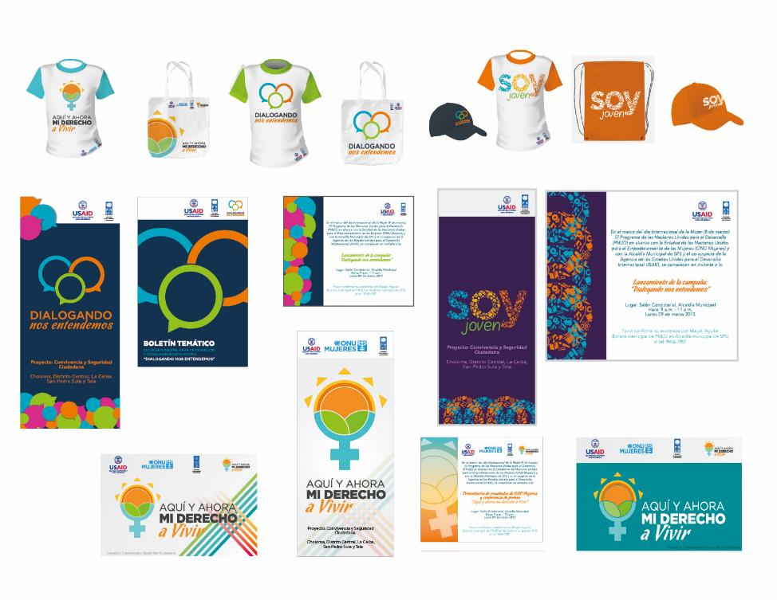

**Press**

<http://www.abriendobrecha.tv/aprueban-plan-de-convivencia-y-seguridad-ciudadana/>

<https://www.facebook.com/PNUD?hc_location=timeline>

<http://www.amuprev.org/noticias/?id=3927>

<http://www.hondudiario.com/?q=node/13728>

<http://www.diarioelarticulista.com/2014/10/este-jueves-habra-cabildo-abierto-en-la.html>

<http://www.lacapitaldehonduras.hn/Sala-de-Prensa/Convocan-a-pobladores-del-Distrito-Central-a-un-cabildo-abierto.html#.VEaS_fl5N8E>

<https://www.facebook.com/convivenciayculturaciudadana>

<https://twitter.com/PNUD_seguridadc>

**Audio and visual Media**

Links to gender spots:

Tela: <https://vimeo.com/121550633>

La Ceiba: <https://vimeo.com/121550662>

Choloma: <https://vimeo.com/121550661>

SPS: <https://vimeo.com/121550660>

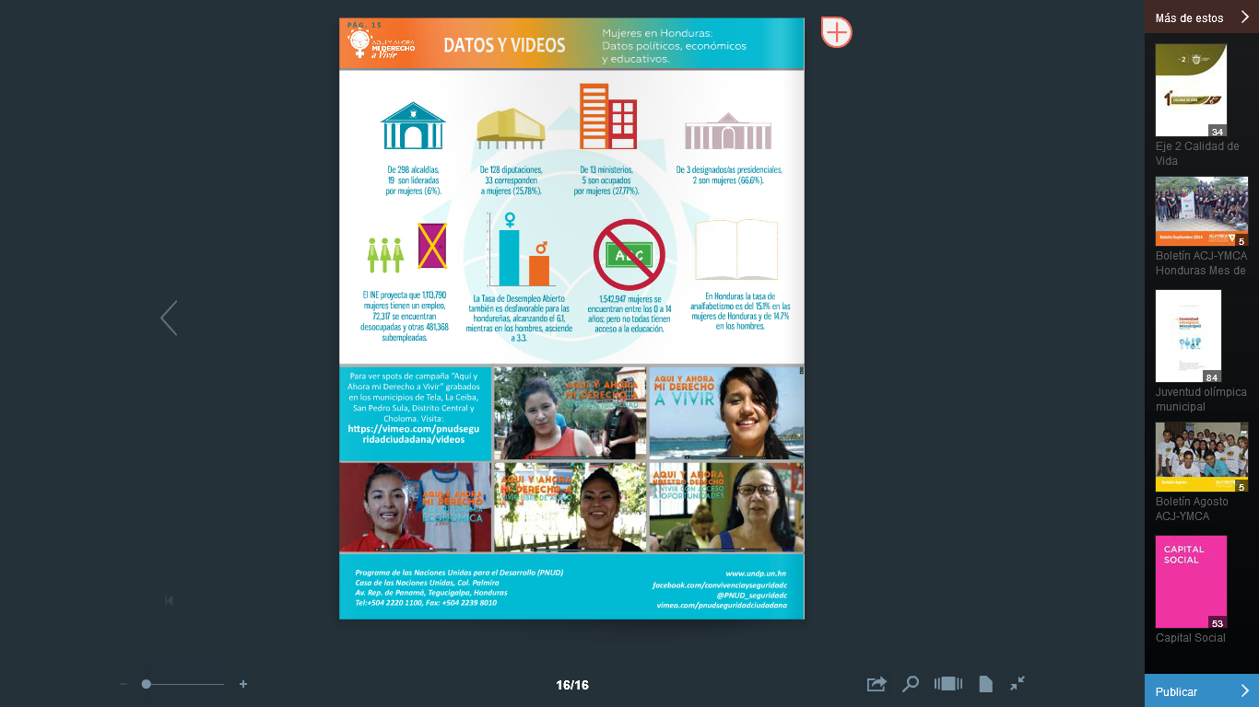

**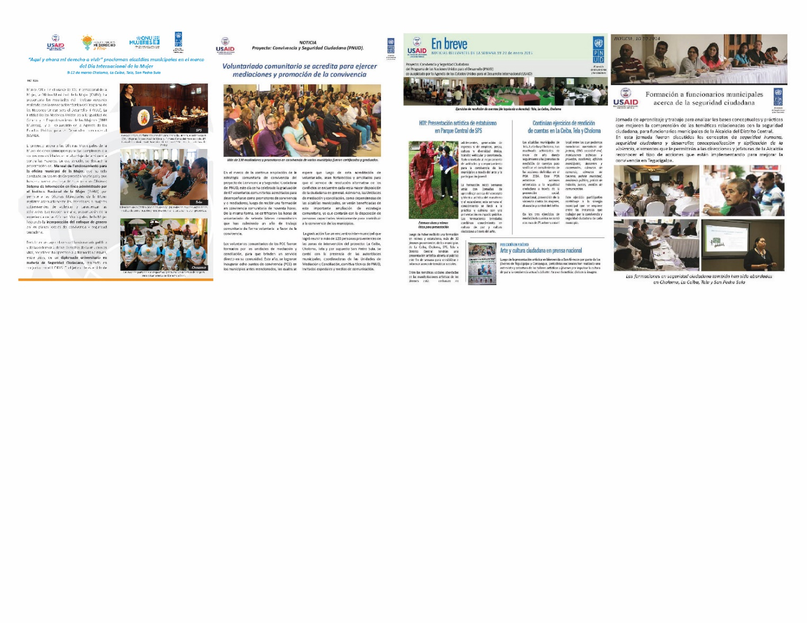Bulletins**

**Additional products:**

Podium labels, background banner (2mx2m), invitation cards.

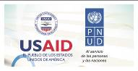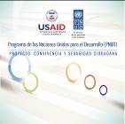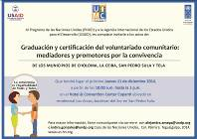

# 12. Sustainability and exit strategy

## 12.1 Component 1: Electoral Technical Assistance

One of the main assistance activities given by the ATE Project to the TSE, is to strengthen its operative units and help in the professionalism process of its personnel. For that reason, as part of the institutional strengthening component, in this pre-electoral period, the ATE Project has targeted its efforts on training qualified staff to conduct activities with efficiency and professionalism, as well as to replicate the trainings through knowledge transfer in other electoral units that did not receive direct technical assistance from the ATE Project.

## 12.2 Component 2: Technical Assistance in Citizen Identification

Supporting the participation of the transparency roundtable and the institutional strengthening group (G-FORT) as external actors in the institutional strengthening process is notable for two reasons – (1) the political will and openness of the RNP to participatory process with civil society, donors and other government agencies, and (2) the commitment from civil society, donors, and other government agencies who decided to support the changing processes in public administration. Both have been key factors in achieving the project’s objectives and making it replicable for other public institutions.

Another key element for the technical and political sustainability of the Project has been the negotiations with political parties. Through this cooperation, RNP has shared its new computerized processes with the political parties so they could monitor and update their internal party identification processes. Until now, the political parties had been managing their registration lists manually, which impeded efficiency in organizing their activities. With the transfer of this technology, facilitated by the Project, the political parties have the capacity to update their own voter rolls in an efficient manner.

In addition, the strengthening of human capital, equipment, and organizational infrastructure will help the citizenry view the RNP as a public institution that offers an efficient service, surrounded by honesty and legal security. This, in turn, will better position the RNP in its interaction with key stakeholders of society (political parties, citizen organizations, media) as well as its coordination with other government institutions (the Executive Branch, Health, Education, the Comptroller General’s Office, etc).

## 12.3 Component 3: Development of Public Policies for Citizen Security and Coexistence

The development of a sustainability plan has been proposed, seeking coordination of local actors for the formulation, implementation and evaluation of Citizen Security and Coexistence Plans in the 5 target municipalities. Identification of stakeholders is essential for transfer of processes, knowledge and equipment, in order to strengthen municipal capacity to manage the prevention of violence and public safety.

The participatory development of the sustainability plan is considered essential to ensure continuity of products and services offered in the 5 municipalities. It is essential that local municipalities ensure continuity and follow- up of processes driven at municipal level regarding Citizen Coexistence and Security, with especial attention to processes established in the local plans of Citizen Coexistence and Security

**Life History – Community Heroine**

Calixta Martínez

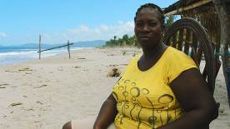Calixta is a 43 woman born in the Tornabé Village in Tela. She has voluntarily performed community service for the past 10 years. In the past 3 years, she has been a victim and a witness of domestic violence. Many of her relatives have migrated to the United States in search of a better future because of lack of opportunities to study and work in the country, a very common phenomenon in the families of the north coast of Honduras. Calixta, as a Garifuna woman with limited resources, has become a well-respected leader, and has been able to find sustainable ways to favor community coexistence.

In 2013, Calixta joins Community Mediation training sessions delivered by the Network of Voluntary Stakeholders in Community Coexistence ( AVCC ), to acquire methodological tools and knowledge on conflicts resolution , which are often mediated using the Garifuna language. Calixta also supports promotion of Coexistence initiatives as workshops, lectures, sporting events and visits to schools. She has contributed to the Mediation and Conciliation Unit in promotion of knowledge regarding Coexistence triggering practices among the citizens; in preventing the scaling up of conflicts into violence through mediation and strengthening of community justice through dissemination and application of alternative methods of dispute resolution.

Her work as a mediator has allowed her to perform mediation on a voluntarily basis, practicing skills and tools acquired in the training processes. She has also participated in the development of direct prevention activities for conflict management, in line with strategies developed by the network.

Calixta has also been involved in the following activities: case attending and orientation guidelines, conducting mediation sessions, development of human rights issues, and alternative methods of dispute resolution. Community and family cases amount as the highest type of cases attended, which have reached satisfactory agreements through dialogue.

Calixta also heads the group of women "Free Butterflies", a network of more than 120 women aged 13 to 56 years old, from the villages of San Juan, Triunfo de la Cruz and Tornabé. The network has delivered workshops on sexual and reproductive health, culture and national identity. Calixta thus feels that she is contributing to her people and to generations of her community. See the interview performed in December 2014 https://vimeo.com/114815306.

# 13. Annexes

## 13.1 Annex 1: Component 2: Technical Assistance in Citizen Identification

### 13.1.1 Success Stories

*Not applicable for this report period*

### 13.1.2 Training report

|  |  |  |  |  |  |  |  |
| --- | --- | --- | --- | --- | --- | --- | --- |
| **Name of the training programme** | **Field of study** | **Relationship to the objectives** | **Start date** | **End date** | **Estimated cost** | **Number of male** | **Number of female** |
| Training in System Security |  |  | November 2014 | November 2014 | USAID:  Instruction: USD 0  Trainee: USD 2,000.00  Travel:  Partner cost: USD 0 | 110 | 90 |
| Training for the Brigade Staff of the visit tour to implement the Diagnostic pilot plan for under registration of deaths. |  |  | November 2014 | November 2014 | USAID:  Instruction: USD 0  Trainee: USD 1,000.00  Travel: Partner cost: USD 0 | 20 | 30 |

### 13.1.3 Pictures (events, trainings, etc)

**Nation Report “Consolidating Democracy: RNP strengthens Honduran democracy, a feasible formula”, May 2014, CABEI**

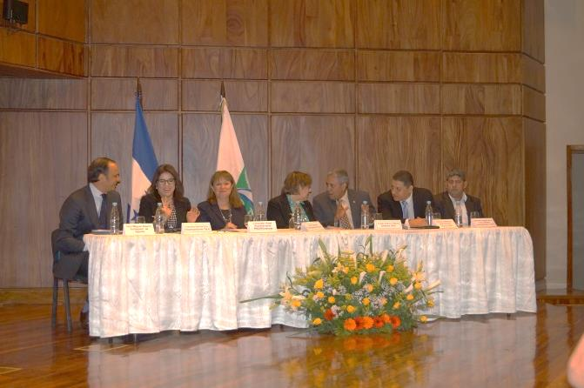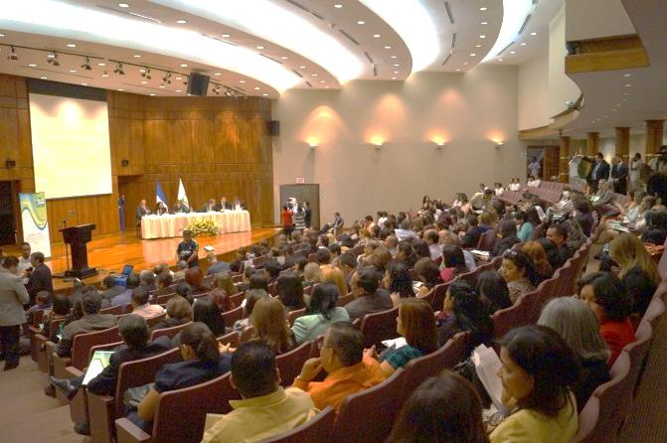

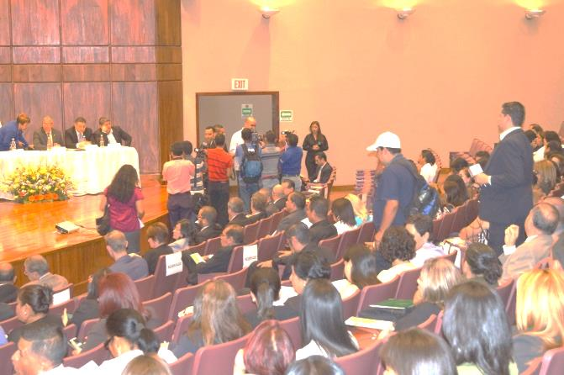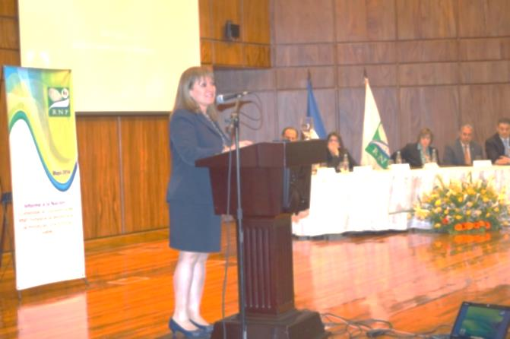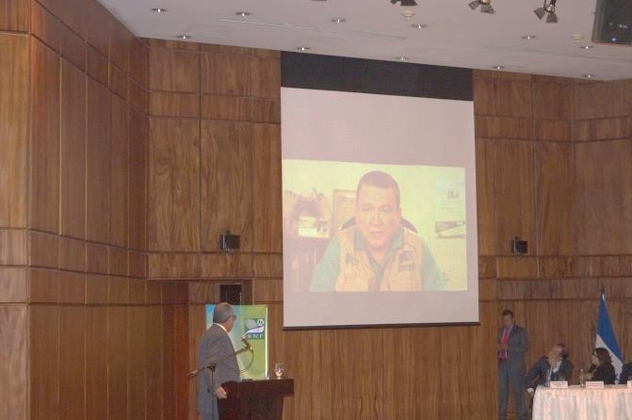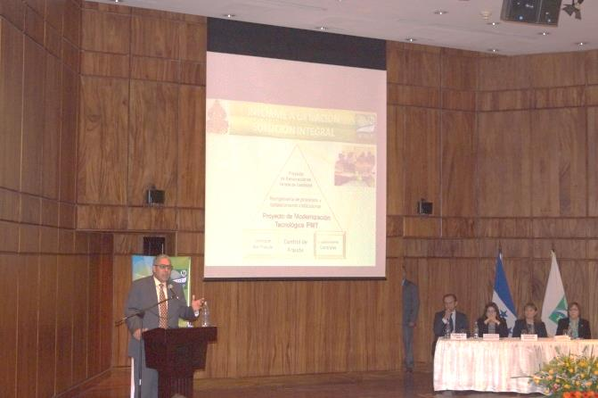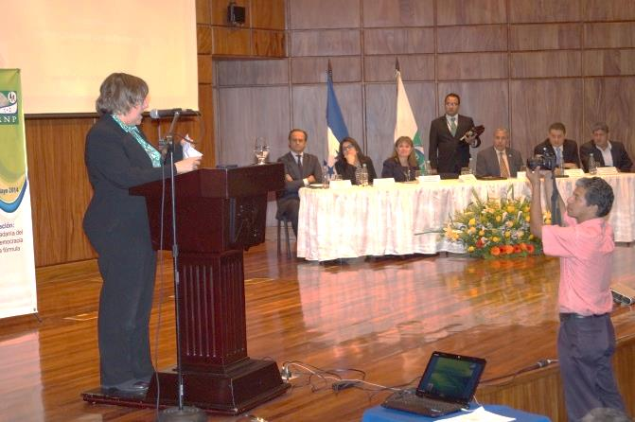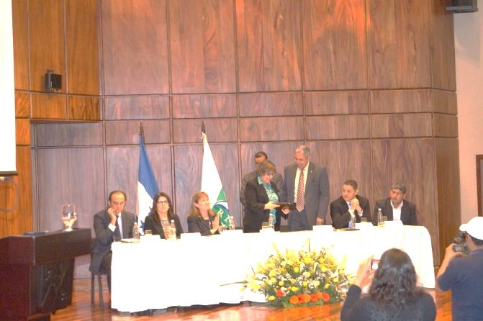

**Meeting among the Inter institutional Sub Regional Round table and National Civil Registries of El Salvador, Guatemala and Honduras**

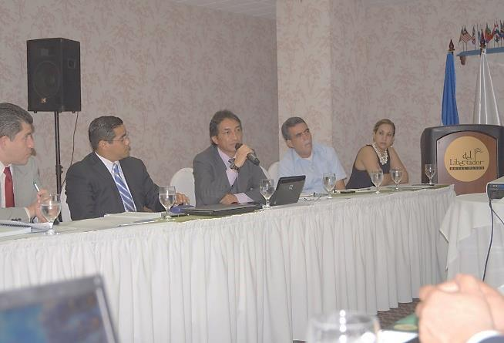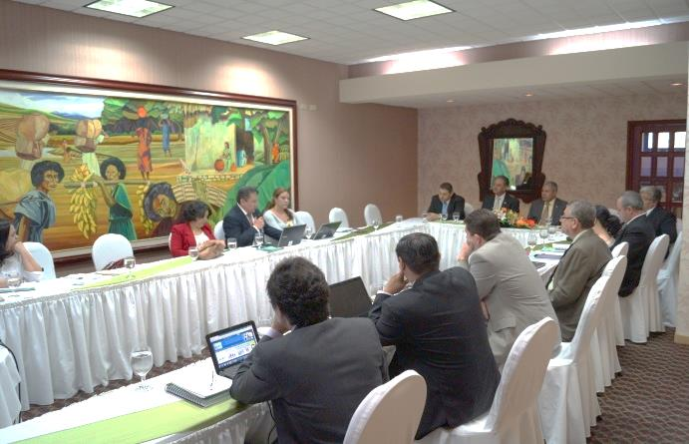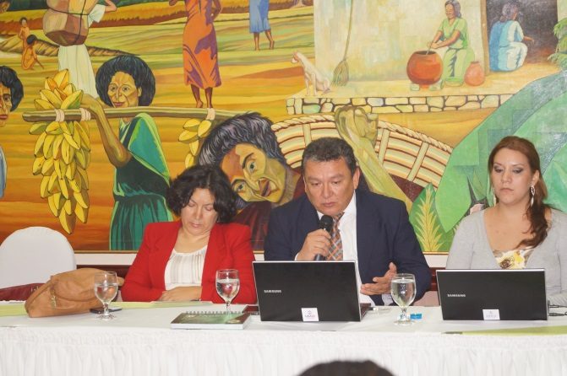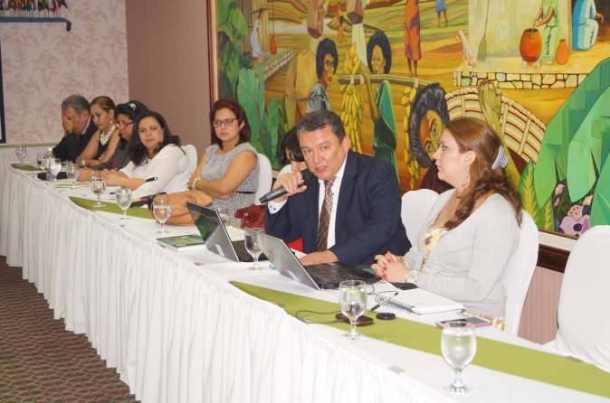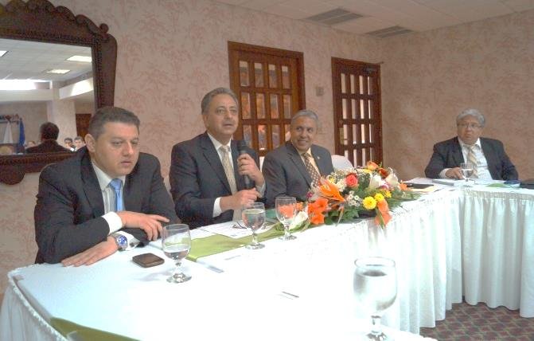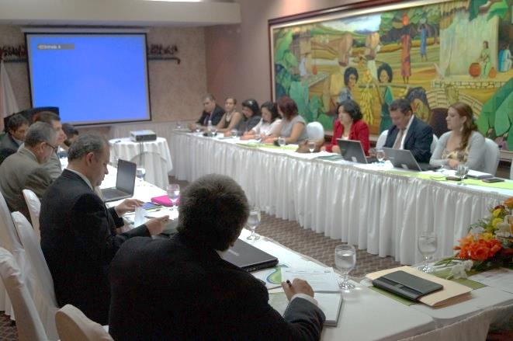

**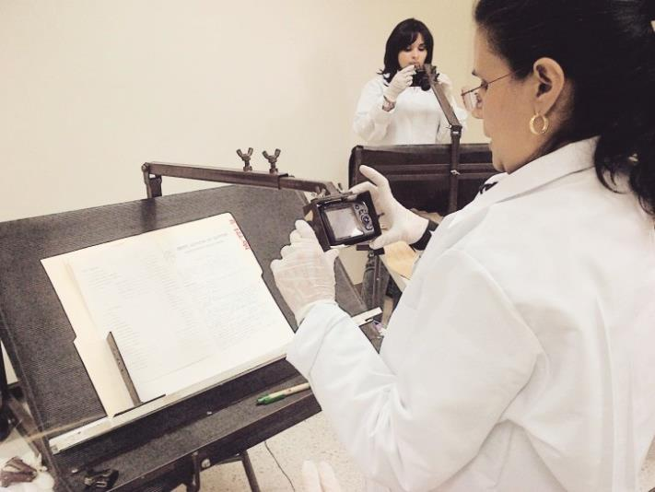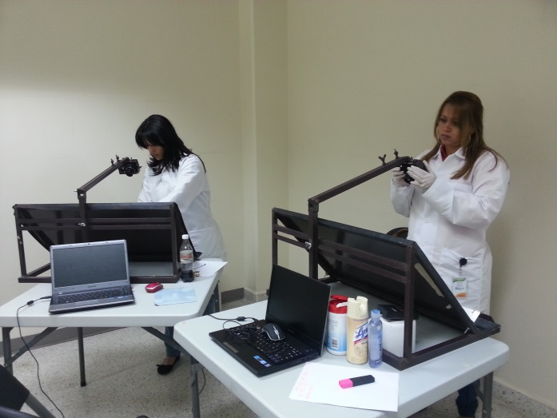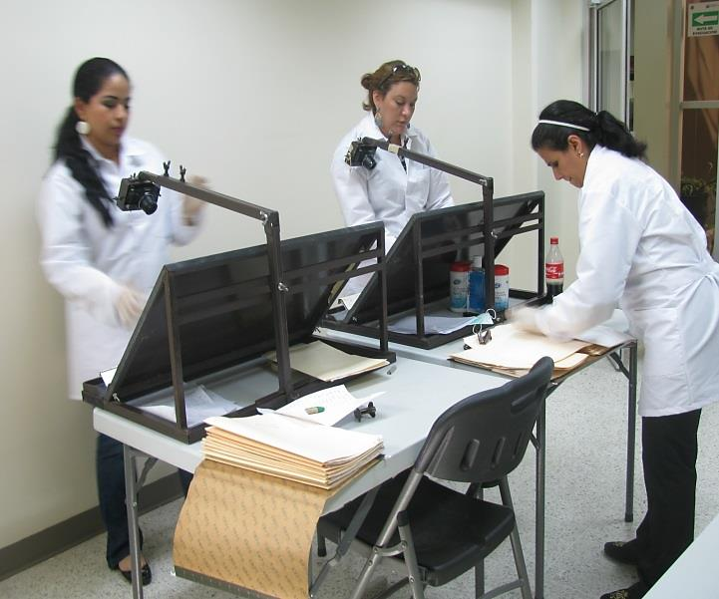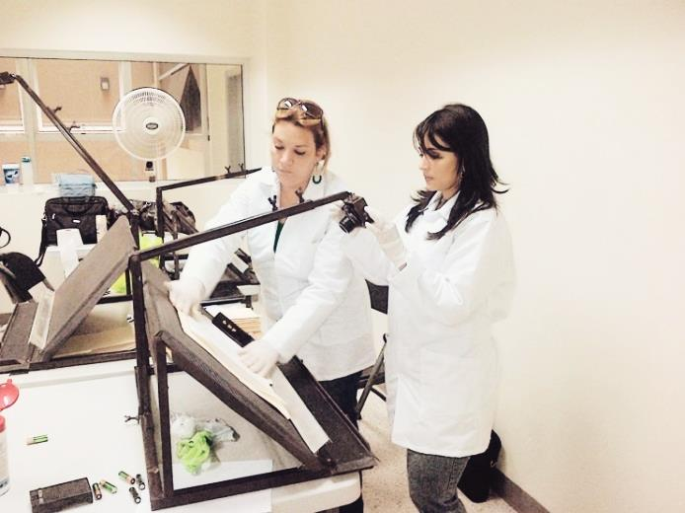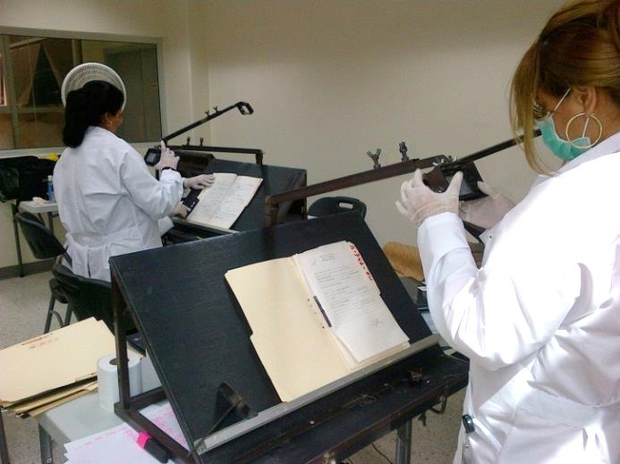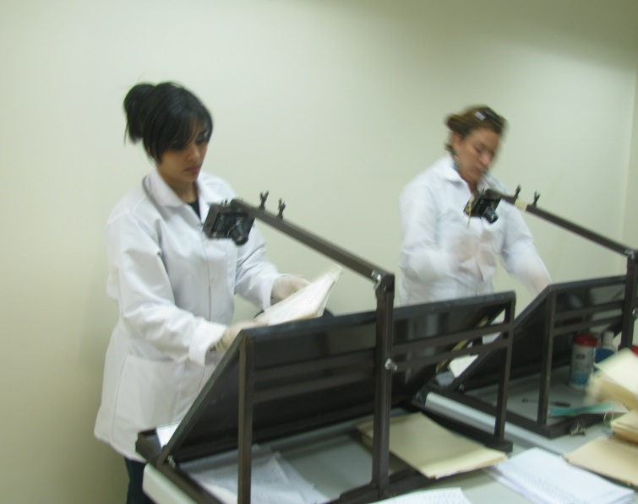Pilot Plan for the RNP data base updating, using information from 500 files at Forensics.**

**Pilot Visiting Tour to 25 cities, for generation of a Diagnosis on the under registration of deaths**

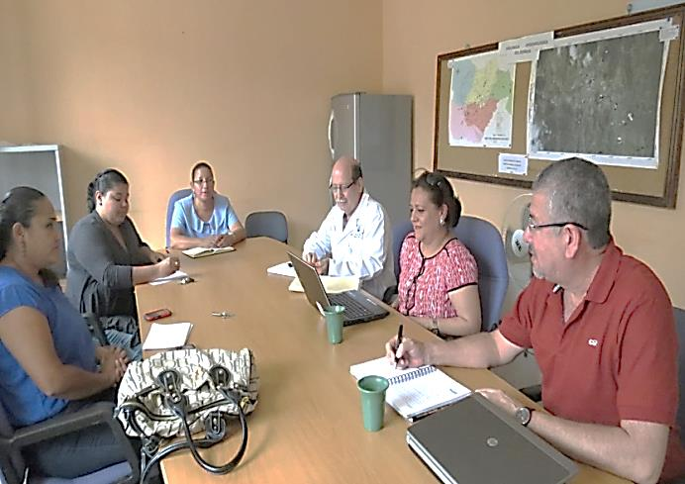

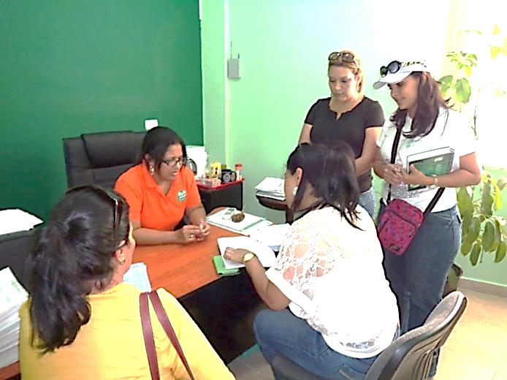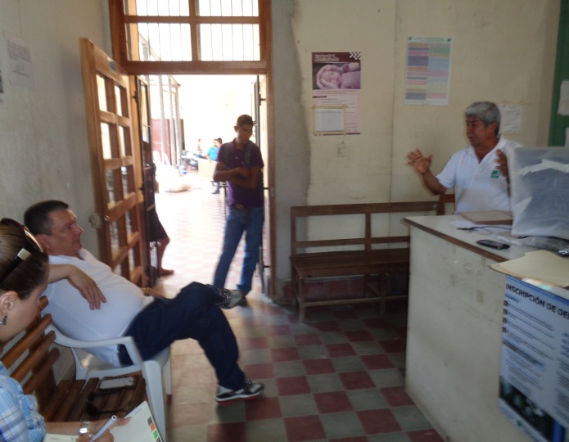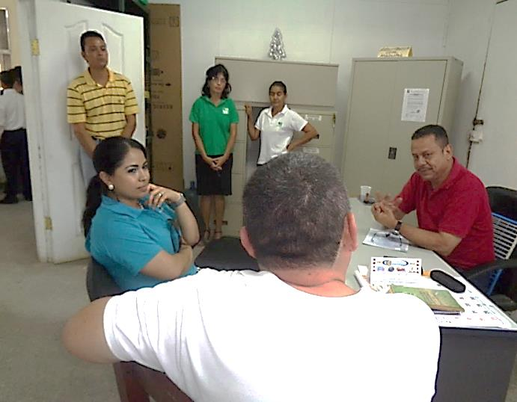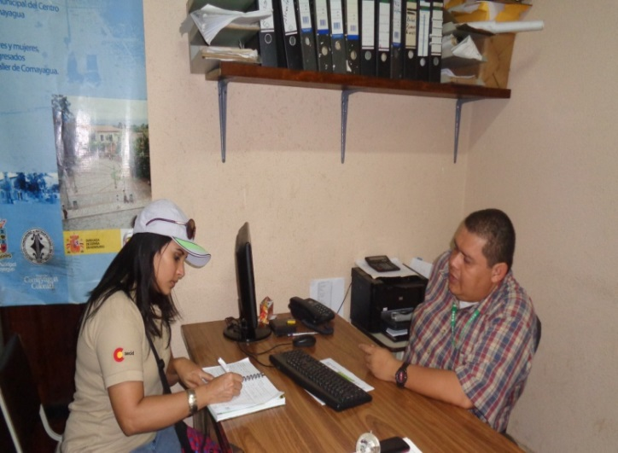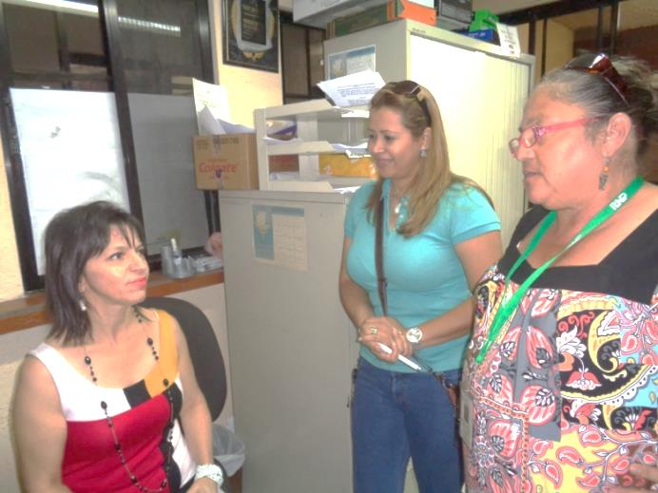

## 13.2 Annex 1: Component 3: Development of Public Policies for Citizen Security and Coexistence

### 13.2.1 Success Stories

*Not applicable for this reporting period*

### 13.2.2 Training report

| **Name of the training programme** | **Field of study** | **Relationship to the objectives** | **Start date** | **End date** | **Estimated cost (US$)[[2]](#footnote-2)** | **Number of female** | **Number of male** |
| --- | --- | --- | --- | --- | --- | --- | --- |
| **Planes Locales** | | | | | | | |
| Second Exercise of Accountability in San Pedro Sula | Local Plans for Citizen Security for municipalities from Central District, San Pedro Sula, Tela, Choloma and La Ceiba | Local Authorities, Municipal officers and other actors from the municipality of San Pedro Sula | October 23 | October 23 | 2,286.18 | 13 | 23 |
| Capacity building workshop for resource management - San Pedro Sula | Local Plans for Citizen Security for municipalities from Central District, San Pedro Sula, Tela, Choloma and La Ceiba | Commitment to implement AOP 2015 activities that should have been implemented at municipal level in the first half of 2015. | November 2014 | November 2014 | 1,000.00 | 6 | 15 |
| Second exercise Accountability in La Ceiba | Local Plans for Citizen Security for municipalities from Central District, San Pedro Sula, Tela, Choloma and La Ceiba | Operating plans that integrate social prevention, situational prevention, deterrence and crime control actions in Tegucigalpa, San Pedro Sula, La Ceiba, Tela and Choloma. | October 24 | October 24 | 1,000 | 18 | 14 |
| Accountabilty exercise at Choloma | Local Plans for Citizen Security for municipalities from Central District, San Pedro Sula, Tela, Choloma and La Ceiba | Operating plans that integrate social prevention, situational prevention, deterrence and crime control actions in Tegucigalpa, San Pedro Sula, La Ceiba, Tela and Choloma. | October 23 | October 23 | 1,000 | 22 | 19 |
| Workshop for definition of indicators and geo –referenced mapping. | Local Plans for Citizen Security for municipalities from Central District, San Pedro Sula, Tela, Choloma and La Ceiba | Operating plans that integrate social prevention, situational prevention, deterrence and crime control actions in Tegucigalpa, San Pedro Sula, La Ceiba, Tela and Choloma. | October 1 | October 2 | 2,200 | 7 | 13 |
| Presentation of the Methodological Guide | Local Plans for Citizen Security for municipalities from Central District, San Pedro Sula, Tela, Choloma and La Ceiba | Operating plans that integrate social prevention, situational prevention, deterrence and crime control actions in Tegucigalpa, San Pedro Sula, La Ceiba, Tela and Choloma. | November 19 | November 19 | 4,000 | 52 | 62 |
| Fifth Training Workshop Choloma | Local Plans for Citizen Security for municipalities from Central District, San Pedro Sula, Tela, Choloma and La Ceiba | Operating plans that integrate social prevention, situational prevention, deterrence and crime control actions in Tegucigalpa, San Pedro Sula, La Ceiba, Tela and Choloma. | February 13 2015 | February 13 2015 | 500 | 17 | 7 |
| Second training workshop at San Pedro Sula | Local Plans for Citizen Security for municipalities from Central District, San Pedro Sula, Tela, Choloma and La Ceiba | Operating plans that integrate social prevention, situational prevention, deterrence and crime control actions in Tegucigalpa, San Pedro Sula, La Ceiba, Tela and Choloma . | February 12 | February 12 | 400 | 7 | 16 |
| Fifth Training Workshop Tela | Local Plans for Citizen Security for municipalities from Central District, San Pedro Sula, Tela, Choloma and La Ceiba | Operating plans that integrate social prevention, situational prevention, deterrence and crime control actions in Tegucigalpa , San Pedro Sula , La Ceiba, Tela and Choloma . | Ferbruary 11 | February 11 | 600 | 13 | 13 |
| Training Workshop on Communication for Development in La Ceiba. | Local Plans for Citizen Security for municipalities from Central District, San Pedro Sula, Tela, Choloma and La Ceiba | Operating plans that integrate social prevention, situational prevention, deterrence and crime control actions in Tegucigalpa, San Pedro Sula, La Ceiba, Tela and Choloma . | February 10 2015 | February 10 2015 | 500 | 18 | 9 |
| Accountabilty exercise at Tela | Local Plans for Citizen Security for municipalities from Central District, San Pedro Sula, Tela, Choloma and La Ceiba | Operating plans that integrate social prevention, situational prevention, deterrence and crime control actions in Tegucigalpa, San Pedro Sula, La Ceiba, Tela and Choloma. | January 22 2015 | January 22 2015 | 500 | 15 | 18 |
| Accountabilty exercise at Choloma | Local Plans for Citizen Security for municipalities from Central District, San Pedro Sula, Tela, Choloma and La Ceiba | Operating plans that integrate social prevention, situational prevention, deterrence and crime control actions in Tegucigalpa, San Pedro Sula, La Ceiba, Tela and Choloma. | January 23 2015 | January 23 2015 | 600 | 14 | 17 |
| Accountabilty exercise at La Ceiba | Local Plans for Citizen Security for municipalities from Central District, San Pedro Sula, Tela, Choloma and La Ceiba | Operating plans that integrate social prevention, situational prevention, deterrence and crime control actions in Tegucigalpa, San Pedro Sula, La Ceiba, Tela and Choloma. | January 20 2015 | January 20 2015 | 650 | 23 | 15 |
| Validation of the Annual Work Plan 2015 at Choloma | Local Plans for Citizen Security for municipalities from Central District, San Pedro Sula, Tela, Choloma and La Ceiba | Operating plans that integrate social prevention, situational prevention, deterrence and crime control actions in Tegucigalpa, San Pedro Sula, La Ceiba, Tela and Choloma. | March 6 2015 | March 6 2015 | 300 | 19 | 12 |
| Validation of the Annual Work Plan 2015 at La Ceiba | Local Plans for Citizen Security for municipalities from Central District, San Pedro Sula, Tela, Choloma and La Ceiba | Operating plans that integrate social prevention, situational prevention, deterrence and crime control actions in Tegucigalpa, San Pedro Sula, La Ceiba, Tela and Choloma. | March 3 2015 | March 3 2015 | 400 | 17 | 9 |
| Validation of the Annual Work Plan 2015 at Tela | Local Plans for Citizen Security for municipalities from Central District, San Pedro Sula, Tela, Choloma and La Ceiba | Operating plans that integrate social prevention, situational prevention, deterrence and crime control actions in Tegucigalpa, San Pedro Sula, La Ceiba, Tela and Choloma. | March 4 2015 | March 4 2015 | 500 | 15 | 17 |
| **UMC** | | | | | | | |
| University Diploma in Mediation and Conciliation community conflict | Development of fifth module of the social networks coexistence and the peaceful resolution of community | Development of a Diploma orientated to the current needs of the units of mediation and conciliation | 9/10/2014 | 11/10/2014 | 1,900 | 22 | 5 |
| AVCC network meeting, in the municipalities of La Ceiba and Tela, | Strengthen community strategy, assess the actions taken to date and identify activities that can be performed in 2015 | Partnerships between operators of justice and UMC | 2 /10/2014 | 2 /10/2014 | 1,130 | 24 | 16 |
| AVCC network meeting, in the municipalities of Choloma and San Pedro Sula | Strengthen community strategy, assess the actions taken to date and identify activities that can be performed in 2015 | Monitoring and Tracking for the network of AVCC | 7/10/2014 | 7/10/2014 | 1,150 | 26 | 2 |
| Promoters training Coexistence of the municipalities of Tela and La Ceiba. | Expanding the network of promoters | Expansion of the network of community mediators and promoters in coexistence. | 6/10/2014 | 10/10/2014 | 1,000 | 7 | 2 |
| Promoters training Coexistence of the municipalities of Choloma y San Pedro Sula. | Expanding the network of promoters | Expansion of the network of community mediators and promoters in coexistence. | 6/10/2014 | 10/10/2014 | 1,000 | 13 | 4 |
| Journey feedback to staff that will be working in UMC at Tegucigalpa | Strengthen practical and theoretical knowledge to staff working in the UMC DC | Strengthen mediation skills in coordinating the UMC | 23/10/2014 | 23/10/2014 | 20 | 3 | 1 |
| University Diploma in Mediation and Conciliation community conflict | Sixth Module Process of mediation and mediator skills. | Development of a Diploma orientated to the current needs of the units of mediation and conciliation | 6/11/2014 | 8/11/2014 | 1,900 | 21 | 4 |
| Development Code of Ethics workshop network AVCC | To make known the code of ethics by which the network is regulated AVCC | Expansion of the network of community mediators and promoters in coexistence. | 18/11/2014 | 18/11/2014 | 400 | 56 | 17 |
| Meeting of coordinators of the Mediation and Conciliation Units (UMC) of Tela, La Ceiba, SPS, Tegucigalpa and Choloma | Certification coordination network AVCC, approval campaign logo "We understand dialogue" | Capacity building of the UMC staff. | 2/12/20014 | 3/12/2014 | 500 | 4 | 2 |
| University Diploma in Mediation and Conciliation community conflict | Graduation and completion of training in alternative methods of conflict resolution officials of the 5 goals municipalities. | Development of a Diploma orientated to the current needs of the units of mediation and conciliation | 6/12/2014 | 6/12/2014 | 1,900 | 23 | 7 |
| Opening of the Mediation and Conciliation Unit | Ceremonial opening event. | Functioning of the Mediation and Conciliation Unit at de Central District | 9/12/2014 | 9/12/2014 | 200 | 14 | 6 |
| Graduation and certification of hours Volunteer Actors Network in Community Life | Fortalecer la estrategia comunitaria de las UMC | Expansion of the network of community mediators and promoters in coexistence atSan Pedro Sula, Choloma, Tela y La Ceiba | 11/12/2014 | 11/12/2014 | 3,800 | 109 | 39 |
| Formation of a Network of Volunteers Coexistence in Community Actors at the Central District | Meeting of the technical assistance project, UMC and leaders of patronage 4 sectors at the Central District | Capacity building of the UMC staff at D.C | 30/01/2015 | 30/01/2015 | 100 | 9 | 4 |
| Formation of a Network of Volunteers Coexistence in Community Actors at the Central District | Journey motivation in the areas of Kennedy, Villa Nueva, United States | strengthening of the Mediation and Conciliation Unit on the Central District | 25/02/2015 | 27/02/2015 | 850 | 92 | 49 |
| Formation of a Network of Volunteers Coexistence in Community Actors at the Central District | Journey motivation in the areas of the college in Jesús Milla Selva | strengthening of the Mediation and Conciliation Unit on the Central District | 02/03/2015 | 02/03/2015 | 50 | 53 | 15 |
| Formation of a Network of Volunteers Coexistence in Community Actors at the Central District | Journey motivation in the areas of Kennedy, Villa Nueva, Estados Unidos y Colegio Jesús Milla Selva | strengthening of the Mediation and Conciliation Unit on the Central District | 3/03/2015 | 15/03/2015 | 8,500 | 140 | 51 |
| **CULTURA** | | | | | | | |
| First workshop of artistic technical strengthening youth group Comvida Central District. | Strategies civic culture in municipalities with high incidence of insecurity and violence in the country | Strengthened strategies of art and culture of peace in Central District, San Pedro Sula, Choloma, Tela and La Ceiba | 11 octubre | 12 de octubre | 272 | 27 | 31 |
| Second workshop of artistic technical strengthening youth group Comvida Central District. | Strategies civic culture in municipalities with high incidence of insecurity and violence in the country | Strengthened strategies of art and culture of peace in Central District, San Pedro Sula, Choloma, Tela and La Ceiba | 25 de octubre | 26 de octubre | 272 | 23 | 27 |
| Workshop developing business plans for arts groups Bullara of Tegucigalpa and Ayacaste from Comayagua | Strategies civic culture in municipalities with high incidence of insecurity and violence in the country | Strengthened strategies of art and culture of peace in Central District, San Pedro Sula, Choloma, Tela and La Ceiba | 27 de noviembre | 30 de noviembre | 5,636 | 6 | 13 |
| First workshop of physical theater (mimes and estatuismo in the framework of communication campaign | Strategies civic culture in municipalities with high incidence of insecurity and violence in the country | Strengthened strategies of art and culture of peace in Central District, San Pedro Sula, Choloma, Tela and La Ceiba | 2 de diciembre | 6 de diciembre | 5,500 | 10 | 22 |
| First Workshop Facilitator Training community arts for young volunteers Comvidas of La Ceiba, Tela, Choloma, San Pedro Sula and the Central District. | Strategies civic culture in municipalities with high incidence of insecurity and violence in the country | Strengthened strategies of art and culture of peace in Central District, San Pedro Sula, Choloma, Tela and La Ceiba | 13 de enero | 17 de enero | 5,954 | 25 | 26 |
| Second Workshop Facilitator Training community arts for young volunteers Comvidas of La Ceiba, Tela, Choloma, San Pedro Sula and the Central District. | Strategies civic culture in municipalities with high incidence of insecurity and violence in the country | Strengthened strategies of art and culture of peace in Central District, San Pedro Sula, Choloma, Tela and La Ceiba | 27 de enero | 30 de enero | 6,000 | 25 | 26 |
| Second First workshop of physical theater (mimes and estatuismo in the framework of communication campaign | Strategies civic culture in municipalities with high incidence of insecurity and violence in the country | Strengthened strategies of art and culture of peace in Central District, San Pedro Sula, Choloma, Tela and La Ceiba | 19 de enero | 24 de enero | 11,500 | 14 | 18 |
| Workshop for Artistic developed by young volunteers Comvida Choloma, held in neighborhood “la Concepción” | Strategies civic culture in municipalities with high incidence of insecurity and violence in the country | Strengthened strategies of art and culture of peace in Central District, San Pedro Sula, Choloma, Tela and La Ceiba | 22 de febrero | 23 de febrero | 300 | 27 | 25 |
| **TOTAL US$** | | | | | **76,270.18** | **1,049** | **808** |

**ANNEX 2**

**QUARTERLY PERFORMANCE REPORT**

**PERIOD: APRIL – JUNE 2015**

## 13.3 Annex 3: Quarterly Performance Report (April 1 – June 30, 2015)

## 13.3.1 Executive Summary

The Project: “Strengthening Democratic Governance in Honduras through Technical Electoral Assistance and the Promotion of Citizen Security and a Culture of Peace” is structured along three components:

1. Electoral Technical Assistance (ATE)

2. Technical Assistance in Citizen Identification

3. Development of Public Policies for Citizen Security and Coexistence

### 13.3.1.1 Component 1: Electoral Technical Assistance

The ATE Project continued implementing the activities foreseen in the 2014-2015 AWP. Several activities took place during this period mostly related to the strengthening of the operation units, the support to civic education and the implementation of the RNP-TSE interconnection system.

In the framework of south-south cooperation, a technical mission to Costa Rica took place in mid-May with the aim to continue supporting the strengthening of the Planning and Monitoring Unit (Unidad de Planificación y Evaluación de la Gestión UPEG). The ATE Project accompanied the 4 participants from the TSE (3 members of the UPEG Unit and the TSE Electorate Director) in order to visit the Costa Rica´s Electoral Authority and exchange ideas, experiences and best practices related to the management, follow up and evaluation practices carried out in that organism.

As for the TSE´s Unit for Electoral Training and Civic Education (Unidad de Capacitación Electoral y Educación Cívica Electoral), UNDP has supported the electoral observation of the Students Governments elections, that took place on April 24th. The Project formed an alliance with UNV in order to be able to deploy volunteer for the electoral observation thought the country for the above-mentioned elections and also supported the TSE with technical assistance in order to prepare the election observation process. Furthermore, Ms. Carmen Chacon de Carcamo was again invited by the Project, in the framework of the South-South cooperation, in order to build the capacities of the staff of the Unit for Electoral Training and Civic Education and also in order to support the observation process of elections of the Students Governments.

The Project also supported the Unit for Electoral Training and Civic Education, both technically and financially, with the launching of the “Electoral bulletin Connected with the citizenry”. The official launch ceremony in Tegucigalpa took place with the presence of the Magistrates, staff from the TSE, UNDP and USAID on May 14, 2015.

As for the RNP-TSE interconnection system for the creation of the electoral census, the IT expert hired by the Project has continued to work on the system, holding regular meetings with the TSE Units responsible for the project (Census and IT). Furthermore, UNDP organized and hosted an official event with the presence of the four TSE Magistrates, the three RNP Directors and technical and legal staff from both institutions in order to present the preliminary design of the system and to stablish a roadmap for the following months.

Finally, the Project has been supporting the electoral reform efforts of the TSE by starting a hiring process of consultants that will analyze the electoral law (LEOP) and the 2011 Bill in order to propose improvements to the electoral process that could be implemented with a Regulation passed by the TSE.

### 13.3.1.2 Component 2: Technical Assistance in Citizen Identification

Citizen identification and civil registration are instrumental to the realization of human rights, the strengthening of democracy, and the development and security of a country. Identification expressed as the right to a name and a nationality is the basis for citizenship, which in turn is the essence of democracy. Similarly, a timely, reliable, secure, and transparent civil registry is a fundamental input not only for the development and maintenance of a reliable electoral census, but also for the design of inclusive public policies aimed at strengthening democratic governance by reducing poverty, promoting development, and improving security. These are public goods that a democratic State should not, under any circumstances, postpone. For this reason, UNDP, with the support of USAID, has agreed to support the RNP through a project to strengthen its capacities.

The work of government institutions, civil society, and donors, united by a commitment to advance the process of democratization in this country, has made possible the encouraging results described in this report and serves an example of the optimization of resources, in the context of efficient and transparent public administration.

**Results**

The “Support for Strengthening Management Capacity of the National Civil Registry” Project set as a result at this stage, that the RNP develops appropriate capacities to provide better service to citizens through the following products:

1) "Increased Security and Transparency in Honduran Identification",

With the aim of bringing the services provided by the National Civil Registry closer to citizens, and to reduce rates of under reporting and under identification, the construction of 4 Civil Registry and Citizen identification Centers (CRIC) has been completed , two of which are located in Tegucigalpa, and two in the city of San Pedro Sula. Currently, provision of equipment for the CRICs is being implemented, as well as connectivity tests to the RNP central base as to become functional

2) " Strengthened Capacities of the National Civil Registry".

Acquired equipment for the project is currently undergoing installation and tests, with the purpose of increasing security of RNP

### 13.3.1.3 Component 3: Development of Public Policies for Citizen Security and Coexistence

Throughout the reporting period from April to June 2015, the municipal teams in charge of applying the methodology along with IDECOAS - FHIS teams, and responsible for supporting and disseminating CPTED methodology , have worked intensively to implement the first instruments and tools. The process comprises several stages and began with previous arrangements among local teams and IDECOAS. Afterwards, the Exploratory Walk tool was applied in each of the neighborhoods, running a survey among citizens about different aspects of the neighborhood, and then implementing a drawing workshop with 5th grade school children of the local school.

The first draft of the Community CPTED Diagnosis in each neighborhood is formulated with field input and office information that the municipal team has obtained from internal databases and from other institutions, and is designed and formulated. The next step is delivering the draft to IDECOAS, who reviews and delivers the draft to municipal teams, who fo3rmulates comments and recommendations. Municipal technicians edit the document and deliver the final report, the CPTED Diagnosis of each neighborhood.

UNDP's role in this dynamic is to guide and coordinate actions among municipal teams and IDECOAS, especially in municipalities where there was no previous experience as Tela and the Central District. In San Pedro Sula, the Honduran Fund for Social Investment has been registering CPTED projects from 2013-2014, although there was no trained partner personnel. UNDP Municipal liaisons perform their role of supporting the design of the diagnostics. Previous experience of working with Choloma and La Ceiba, where a number of CPTED projects are registered, allows the dynamic to incorporate members of the Municipal Commission of Citizen Security and Coexistence.

The summary table below shows the work developed by municipal teams who received the University Certificate Diploma in Situational Prevention. These teams, supported by IDECOAS-FHIS technicians at the DIM, work towards achieving a diagnosis in each neighborhood.

Progress summary on the formulation of Community Diagnosis from February to June 2015.

|  |  |  |  |  |  |  |  |  |
| --- | --- | --- | --- | --- | --- | --- | --- | --- |
| **Municipality** | **Neighborhood** | **Previous arrangements among the Municipality and FHIS** | **Exploratory Walk** | **Drawing Workshop** | **First draft of CPTED Diagnosis** | **Amendments sent by FHIS to the Municipality** | **Final report CPTED Diagnosis** | **Integration of the Diagnosis to the PLCySC** |
| AMDC\*\* | Los Pinos | Ok | June 4th | June 3rd | Ok | Ok | Pend |  |
| Villanueva S-6 | Ok | April 28th | April 28th | Ok | Ok | Pend |  |
| CHOLOMA | Victoria | Ok | May 11th | May 12th | Pend | Pend |  |  |
| Armando Gale | Ok | May 13th | May 14th | Pend | Pend |  |  |
| LA CEIBA | Las Delicias | Ok | March 16th | March 16th | Ok | Ok | Pend |  |
| La Isla | Ok | March 18th | March 18th | Ok | Ok | Pend |  |
| SAN PEDRO SULA | Rivera Hernández - Centro | Ok | March 25 th | March 26 th | Ok | Ok | Ok | Pend |
| Chamelecón Centro | Ok | May 27th | May 28th | Ok | Pend |  |  |
| TELA | 15 de Septiembre\* | Ok | May 5th | May 6th | Ok | Ok | Pend |  |
| El Retiro\* | Ok | May 5th | May 6th | Pend | Pend |  |  |
| Grant | Ok | Feb 18th | Feb 19th | Ok | Ok | Pend |  |

The *15 de Septiembre* and *El Retiro* neighborhoods are located within the same zone in Tela city. The Municipality trained both neighborhoods as part of a single CPTED project

\*\* The local Central District Citizen Security and Coexistence plan is waiting for approval

**Completion of the University Certificate Diploma in Situational Prevention (CPTED)**

The University Certificate Diploma in Situational Prevention was completed on June 8th, designed with the aim of providing academic training for Municipal officials and various government entities. The methodology is based on the practical experience that the transformation of the urban environment in public spaces can help improve the sensation of fear that people experience, and can help to increase community participation, but above all, reduce opportunity violence or situational crime.

The University Certificate Diploma, first of its kind in Central America, trained 34 officials from target municipalities, IDECOAS - FHIS and other institutions. It was also supported by the United Nations Development Programme in partnership with the Graduate Institute of Development , Peace and Security , in coordination with the Institute for Community Development , Water and Sanitation and sponsored by the United States Agency for International Development .

Through innovative support and intervention models, communities can find benefits of the practical application of CPTED concepts, which, along with other support and social assistance initiatives, allow the creation of resilient communities where citizens appreciate better perspectives for their future. Municipalities can now explore and address community work with new tools.

**Updating the Comunity Implemented Projects (PEC) Handbook**

The revision of the Community Implemented Projects (PEC) Handbook began in June. This methodology originated on the initial pilot projects implemented by FHIS from 2003 until 2004. Currently, 5 previous versions of the PEC Handbook have been adapted throughout time in line with agreements among the institution and cooperation agencies, serving water and sanitation projects in villages of ethnic communities. Currently, FHIS is developing a new version through the DIM with support from UNDP, which adapts to challenges and changes related to work in high violence urban and peri -urban areas. The methodology was originally designed for application in rural areas, where high violence level dynamics in social community work is absent.

The PEC Handbook will display new training modules to include ( i ) prevention and community coexistence, ( ii ) Gender Equity and ( iii ) Trafficking.

**The mediation and conciliation component** of this quarter was directed to finalize the process of conformation of the Central District Network of Voluntary Stakeholders in Community Coexistence. Its purpose is to boost the Municipality’s community strategy, not only because of the delay experienced by the UCM, but also due to population density and complex characteristics regarding conflicts within the urban area of the city. The percentage of trained leaders has surpassed other municipalities, which proves that the initial purpose has been reached.

Concerning the municipalities of Tela, La Ceiba, San Pedro Sula and Choloma, the Network of Voluntary Stakeholders in Community Coexistence has been implementing activities in coordination with the Mediation and Conciliation Unit, supported by local governments, civil society and UNDP, through technical monitoring.

Several activities and objectives framed within expected results were achieved during the April2015-june 2015 quarter. Some of the main activities are shown below:

Central District

- Implementation of the Community Mediators training workshop, at the Estados Unidos, Kennedy and Villa Nueva neighborhoods, and at the Colegio España Jesus Milla Selva.

- Implementation of the Cexistence Promoters training workshop, at the Estados Unidos, Kennedy and Villa Nueva neighborhoods, and at the Colegio España Jesus Milla Selva.

- Implementation of the Ethics Code training workshop Workshop for the leaders who are to become certified as members of the Voluntary Stakeholders in Community Coexistence network. The aim is to promote responsibility in the service of the community, and community credibility in the actions of volunteers towards peaceful resolution of family, neighborhood and community conflicts.

- Certification of 113 leaders trained as promoters and mediators in the Central District.

|  |  |  |  |  |  |  |  |  |
| --- | --- | --- | --- | --- | --- | --- | --- | --- |
| **Mediators Training** | | | **Promoters Training** | | | **Certified Citizens AVCC Network** | | |
| **M** | **F** | **Total** | **M** | **F** | **Total** | **M** | **F** | **Total** |
| **11** | **46** | **57** | **16** | **39** | **55** | **27** | **85** | **112** |

**Activities supported by local governments at Tela, La Ceiba, Choloma and y San Pedro Sula Municipalities:**

Quarterly UMC and AVCC Network Activities Planning in four municipalities:

San Pedro Sula:

* Talks on the 7 pillars of coexistence delivered for 1460 children from Basic Education Center Lempira.
* Training of 84 mothers and parents of kindergarten ‘Col. Lempira’, through a ‘Parents School’ that addresses issues related to parenting, values, coexistence and conflict resolution.
* A Workshop on responsibility and the role of parents within the household was delivered to 40 people from ‘Salem’ Church.
* Promotion of the UMC at the First Meeting of People with Disabilities, where 200 people were informed about the services provided by the UMC and the San Isidro PCC.
* A Talk for Parents at the ‘Fuente de Amor’ Church was delivered for 36 parents, on the subject of Household Values
* A Talk on the 7 pillars of coexistence was delivered for 250 young persons and adults at the ‘Kattan’ School in the Morales sector of the Chamelecón.
* A coexistence talk was delivered for 38 children at the outreach center.

Tela:

* Talks of the AVCC on the 7 pillars of coexistence for students of the ‘15 de Septiembre’ School.
* Promotion of the UMC and the Tornabé PCC by the AVCC at the ‘Jerusalén’ Radio Station in Tornabé Community
* Promotion of the Tornabé PCC and coexistence, at the community fair in Tornabé
* A talk on the 7 pillars of coexistence was delivered for families at the Antonio ‘Jose Coello’ School

La Ceiba:

* Socialization of the UMC and PCC among the Corozal Community Organisations , (local civil society, local water board, school, Secondary school)
* Promotion of the UMC y PCC at the central square, through playful activities involving children from the ‘Francisco Morazán’ School, as well as the citizens.

This quarter registered progress at three areas within the **Youth and Civic Culture component**:

1. The base group of Artists for Peace, and the leading group of young trainers were conformed at the five Municipalities, regarding the strengthening of the Youth of the Municipal Units of Children, Adolescents and Youth / COMVIDA. In turn, these young leaders who were trained as facilitators , have replicated the process through two workshops in a neighborhood selected by each Municipality, supported by the art and culture project promoter, a COMVIDA technician, and in coordination with outreach centers in each of the neighborhoods. A second workshop in Tela and the Central District is due on July, as well as the conformation of the National Network of Youth leaders in Arts and Culture of Peace

2. Communication: Final production of the song and video clip created collectively by young artists participating in the Art and Peace Culture training processes. The video clip was filmed in Chamelecón, San Pedro Sula, with the participation of over 50 youth. This video highlights the importance of value and dignity of being young, and the importance of being involved in decisions about the country and the community. A media dissemination plan has been designed

3. Entrepreneurship Funds: Once the alliances in La Ceiba, Tela and Choloma, with the municipal authorities, Chambers of Commerce, UNAH, and in the case of Tela, with the Chamber of Tourism and the CEPUDO foundation, are established.

Progress has been made on business training, development and support to business plans, selection of 16 projects and delivery of seed capital in the city of La Ceiba to most entrepreneurs. A percentage of the contribution from the Municipality and the Chamber of Commerce is currently being awaited, which is why the process has been delayed, and which has also made the extension of the Agreement necessary. The contribution is expected to be finalized by July in La Ceiba.

The first resources transfer from UNDP has been implemented in Choloma and Tela, as well as the identification and training of young people. The selection and delivery of seed capital (in Tela) and Credits (in Choloma) and the transfer of the contribution from both Municipalities is still to be implemented. It was therefore necessary to extend the agreement with UNDP until August in Choloma and October in Tela.

Seed capital was delivered to 4 groups of entrepreneurs who were earlier trained by this project in artistic matters, and whom at this stage, led the training process for further groups of young people. These groups were formed in late 2014 in business plans, and come from Comayagua and the Amarateca community in the Central District.

Once their business plans were approved, seed capital was delivered through equipment and materials to start their artistic enterprises for peace. The groups who received seed capital were: 1) Collage (Comayagua) 2) Percu Honduras (Comayagua) 3) Buyara (Amarateca) y 4) STOP V (Amarateca).

Closure activities of the process of strengthening of the Municipal Offices for Woman have been implemented in the period from April to June 2015, as follows:

1. Completion of the settlement of the second disbursement of the partner “Las Hermanas Asociadas de la Misericordia”, implemented through the ‘Women for Life’ Forum.

Since the second disbursement was delivered in May, the partner implemented activities through own funds in order to continue initiated processes.

1. Two Sex - Gender Workshops aimed at Prevention Committees were implemented at the Central District and San Pedro Sula municipalities, as follow up to the training process that was defined from the Local Plans Component (the same workshop was conducted at Tela in January).
2. Ongoing production of Annual Work Plans for 2015, including specific activities for violence against women prevention, at the Choloma, San Pedro Sula, La Ceiba and Tela Municipalities

A work tour was implemented during the week of 26 to 30 April and on April 22, with the purpose of once again reviewing the Annual Work Plans in each Municipality jointly with OMMs representatives and technical liaison project officers. Aspects as writing, budget and activities definition were under review during the work tour.

On the same week, follow up of the installation and monitoring of the OMM/INAM Information System was performed at the Municipalities as follows:

La Ceiba : An exchange session with Lilian Cerezo, Director of the OMM, with Essika Rodas, Responsible for projects. Tela: An exchange session with Dayanna Chávez and Helen Umanzor Umanzor, who are in charge of Projects. Choloma : An exchange session with Belinda Domínguez , Director of the OMM and Etelinda Reyes Posas, Technical staff. San Pedro Sula: An exchange session with Luis Alonso Perez, Office Manager. Important inputs for the continuity and development of the information system were identified through the sessions.

## 13.3.2 Activity implementation

### 13.3.2.1 Component 1: Electoral Technical Assistance

#### 13.3.2.1.1 Indicator performance tracking table

**Output 1: Technical Assistance for the Legal and Regulatory Framework and Restructuring of the TSE’s Operating Units**

**Description:** Development of a proposal for comprehensive legal reform of the electoral system. A comprehensive assessment of the 2012 and 2013 electoral processes. Creation of the TSE’s institutional report for 2009-2014. Deepening and consolidating the TSE’s organizational reform process which began in 2009, through its operating units, such as Mapping and Census, Information Technology, and Public Relations.

|  |  |
| --- | --- |
| **Indicators** | **Indicator performance** |
| Matrix with comments on the various electoral reform proposals (July 2014) | The initiative to create the matrix is currently being implemented by NIMD and NDI. |
| Proposal with articles and input from relevant stakeholders (December 2014) | The ATE Project is currently supporting the analysis of the electoral law in order to make modifications through regulations in order to improve the quality of the electoral process. This job is being carried out by 4 experts on electoral reform that have been hired by UNDP as national consultants.  A first 2 days internal workshop took place in Comayagua in July in order to analyze all articles in the LEOP to identify those aspects that should be regulated.  The experts are currently working on 4 different proposals of Regulations aimed at improving the electoral processes. |
| Congressional debates (2015) | No progress on this indicator |
| Magistrates and department Directors have participated in 2 regional trainings (December 2014) | The Magistrates and department Directors participated in May in 1 in a regional training workshop that took place in Honduras with the participation of the Electoral Authorities of Panama, Guatemala, Costa Rica and Honduras. The training workshop was organized by the KAS. |
| Assistance plan agreed on by the directors of the Unit for Electoral Training and Civic Education and the Gender Unit (June 2014) | The ATE Project has worked in close collaboration with the Magistrates and the staff and coordinators of the Unit for Electoral Training and Civic Education, in order to prepare an assistance plan for activities for 2015-2017, in order to improve the coordination and implementation of activities in various areas such as research methods, organization and planning, mainstreaming democratic/civic education, training and implementation of educational campaigns, and creation and dissemination of printed and digital materials especially with mass media.  In addition, this plan will maintain focus and increase the efficiency of activities aimed at the various stakeholders, such as political parties, students and school boards, first-time voters, women, and government agencies, as well as the staff of the Unit for Electoral Training and Civic Education and of the Gender Unit. |
| At least 3 parties have taken actions to promote women’s participation (December 2014) | No progress on this indicator  Nonetheless, the TSE is currently finalizing the Regulation for parity and alternation. |
| Pilot plan to include civic education activities in a municipality (December 2014) | No progress on this indicator |
| Expert hired and trained to adaptthe electoral census with the RNP’s advances (July 2014) | The ATE Project hired in 2014 an IT expert in order to develop a software that effectively connects the databases of the TSE and the RNP, with the ultimate objective of updating the electoral census with reliable information about citizens who have the right to vote and exclude duplicate registrations, errors, deceased voters, and those voters who are ineligible to vote.  The expert has been working since the beginning of January and has been holding regular meetings with the ATE Project staff and with staff at the TSE and the RNP, so that the software developed is in line with the needs and demands of the 2 institutions.  Currently the software is being finalized. |
| At least 3 political parties have signed a cooperation agreement with the ATE Project (August 2014) | No progress on this indicator |
| At least 2 political parties have modified or adapted their internal regulations to the electoral law (December 2014) | No progress on this indicator |

**Output 2: Technical Assistance to Strengthen the Training Unit and the Institute for Civic and Citizen Participation and Training (IPECC)**

**Description:** Strengthen the TSE’s Electoral Training Unit by incorporating it into the Institute for Civic and Citizen Participation and Education (*Instituto de Participación y Educación Cívica y Ciudadana* or IPECC) which was created in 2011. In particular, incorporating civic, electoral, and democratic training programs, which involve representatives of the TSE and support the building of citizenship, and making use of previously designed tools, such as the “democratic values” campaign.

|  |  |
| --- | --- |
| **Indicators** | **Indicator performance** |
| Memos of understanding (MOUs) signed with the Ministry of Education and at least one teacher training school (August 2014) | The TSE signed an agreement with the Ministry of Education. The “*Convenio marco de cooperación en material cívica electoral*” was signed on 20 February 2015. |
| At least one institution has approved a plan for incorporating civic education (December 2014) | No progress on this indicator |
| Network of CSOs formed in a municipality (August 2014) | No progress on this indicator |

**Output 3: Maintenance of the Unit of Implementation, Monitoring and Follow-Up of the ATE Project**

**Description:** Maintenance of the Project’s core team to coordinate horizontal cooperation for the various activities conducted by the TSE, with the goal of identifying weaknesses and opportunities for participation by international experts. The team includes an international consultant, a national technical assistant, and a financial administrator. It also includes the cost of the Project’s facilities, stationary, communications, and services necessary for the operation of the office such as electricity, water, internet, cellular phones, transportation, and security.

|  |  |
| --- | --- |
| **Indicators** | **Indicator performance** |
| 2014-15 AOP of the ATE Project approved by the Project Board (May 2014) | Following the August notification of the approval of the ATE Project extension, the Project Board met at the beginning of September and discussed two important points: (1) the approval of the Project’s AOP for the end of 2014 and the beginning of 2015, and (2) the drafting of a revised budget based on the approved AOP. |

#### 13.3.2.1.2 Progress narrative

Once the authorization of USAID funds to run until June 2015 took place, the team continued to develop ATE activities within AWP 2014-2015. For example, it was able to provide continuity of support to the TSE in electoral civic education as elections for Student Governments took place on April 25 in 17,000 schools in the public education system at the national level, with the participation of over a million children and young people.

The day of the elections were conducted in an atmosphere of civility and democracy thanks in part to the support of TSE and UNDP, and to the funds contribution for the production of toolbox support material for shaping student governments. During the day, as in the past, Mrs. Carmen Chacon, head of the training electoral department of TSE in Panama, along with the ATE team acted election observers of the process, participated. Also, this work of electoral observation was supported by the volunteer network in Honduras, who was approached by UNDP with support from the UN Volunteers Program.

The extension in time for project implementation also allowed extension of the contracts of the two experts hired by the project on the topic of IT and gender equity, so they could continue to perform their assigned work as well as the contracts of the ATE team. The contracts of the based project team could be extended to June 30, 2015 for the National Technical Assistant, and in to July 7, 2015 for the Electoral Technical Advisor. Also, the process of hiring the Project Manager and the Financial Manager could proceed.

The IT expert allowed continuance in the development and refining of the system interconnection among the databases and the TSE RNP for safe, fast, transparent and efficient formation of the National Electoral Census. The expert could continue also defining interconnection protocol supported by the IT department, Census and legal TSE and RNP. The consultant in gender allowed continuance in the process of research and data collection for the definition of a parity index that currently has been developed and adopted by some countries in Latin America. Obtaining this index may support decisions concerning the political participation of women.

The UNDP also supported the launching and publication, in digital and printed format, of the monthly electoral Bulletin “Connected with citizenry”, which provides information on various electoral issues through opinion articles and news about actions taken by the TSE that are of national interest. This bulletin has the purpose of keeping the public informed, which is a fundamental pillar in the process of building a more inclusive, participatory, and transparent and more efficient democratic system. The official launching of the Bulletin took place in May 14, the last day of the presidency of Magistrate David Matamoros.

Due to social and political momentum on electoral reforms, particularly on the financing of political parties’ campaigns and citizenship polling stations, UNDP continued addressing these matters through implementation of two main activities: the implementation of an international workshop for the discussion of the Electoral Law and the 2011 Bill, and a technical mission to Dominican Republic. The internal workshop might bring to light the necessity to discuss and formulate electoral regulations that given the complexity of the environment on electoral reforms could be an alternative to improve the application of the current electoral law. The technical mission’ visit to the Dominican Republic specifically targets the TSE and the Electoral Central Board of that country, in order to deepen their knowledge of citizenship polling station and new electoral technologies. This mission is expected to have the participation of a wide range of stakeholders such as TSE magistrates, political parties’ representatives and members of the Electoral Affairs Commission of the National Congress.

The UNDP, in the framework of institutional strengthening, conducted a technical mission to the TSE of Costa Rica, in order to support the consolidation of the newly created Planning and Monitoring Unit and the Electoral Directorate. The mission lasted a week from 10 to 16 May, where meetings were held with authorities of the Costa Rican TSE in order to have an exchange of ideas, experiences and best practices in the areas of planning, evaluation, monitoring and other election issues related to good electoral administration. Moreover, the TSE staff who participated in the mission could gain knowledge on electoral warehouse management and management of electoral files.

Most of the month of May and June, the ATE team were concentrated to prepare a proposed extension of the USAID Project: “Strengthening Democratic Governance in Honduras Through Technical Electoral Assistance and the Promotion of Citizen Security and a Culture of Peace”, to be submitted before June 30, so that USAID could have the time to provide feedback on the draft of the proposal previous to its approval.

Based on USAID’s extension period program description, the project proposal for the new phase was prepared on the framework of one main objective: Honduran Electoral System Strengthened, aiming at two results: (1) Electoral legal and regulatory framework improved and (2) Electoral institutions’ administration improved. This proposed extension was for 24 months, and the activities considered on it aimed at broadening existing lines of work under the USAID/UNDP # IO-522-11-00001 Agreement. Therefore, UNDP will continue to work towards supporting the strengthening of democratic governance: (1) by enabling participatory and inclusive dialogue and activities with key stakeholders including Civil Society Organizations and political parties that promotes legislative and regulatory proposals on key electoral reforms issues and (2) by strengthening the administrative and technical capacity of the Supreme Electoral Court.

#### 13.3.2.1.3 Status of activity level logic models

*Not applicable.*

#### 13.3.2.1.4 Implementation challenges and opportunities

**Challenges:**

* One of the main challenges concerning the process of electoral reforms was the lack of initiative of the TSE in order to propose a holistic electoral reform (due to the fact that the proposal for electoral reform in 2011 was rejected by the Congress).
* Furthermore, the lengthy administrative processes inside the TSE, the politization of the staff of the TSE, and a lack of internal coordination hindered the implementation of many activities that had been foreseen.

**Opportunities:**

* Due to the current volatile political situation in the country, there is a space for participation of the TSE in the public debate related to the electoral reform. The TSE, with the support of the ATE Project, could play a central role in the debates and discussions that could lead to an electoral reform.
* The TSE is very interested in continuing with the capacity building of its staff and with the institutional strengthening of the organization. The ATE Project will continue supporting these efforts.
* The TSE is very interested in focusing on the issues of inclusion and gender.

### 13.3.2.2 Component 2: Technical Assistance in Citizen Identification

#### 13.3.2.2.1 Indicator Performance Tracking Table

**Output 1: Security and Transparency in Honduran Identification**

|  |  |
| --- | --- |
| **Indicators** | **Indicator performance** |
| Number of installed and functioning Civil Registry and Citizen identification Centers (CRIC) at the Directorate of Forensic Medicine and Universities | Four (4) built Civil Registry and Citizen identification Centers in Tegucigalpa y San Pedro Sula (at the Directorate of Forensic Medicine and Universities).  Civil Registry and Citizen identification Center at the Tegucigalpa morgue has been inaugurated |

**Output 4: Strengthened capacities of the National Civil Registry**

|  |  |
| --- | --- |
| **Indicators** | **Indicator performance** |
| Number of installed and functioning equipment and security licenses | At installation and security equipment tests stage |

#### 13.3.2.2.2 Progress Narrative

**Period achievements by Output**

**Output 1: Security and Transparency in Honduran Identification**

a. Inauguration of the Civil Registry and Citizen identification Centers at the Directorate of Forensic Medicine offices (morgue) in Tegucigalpa.

b. Completion of the construction of two CRICs in San Pedro Sula, at the Directorate of Forensic Medicine offices (morgue) and Universidad Nacional Autónoma de Honduras in the Sula Valley.

c. Currently, three of the CRICs are undergoing adaptation processes, since optical fingerprint blocks necessary for the identification process are yet to arrive. Also, the interagency committee comprising the RNP and the Public Ministry is on the process of formation, with the purpose of implementing the protocol for deaths registration process to be held at the CRICs located within Tegucigalpa and San Pedro Sula morgues.

**Output 4: Strengthened capacities of the National Civil Registry**

a. Security equipment has been acquired and us in process of installation: Web application firewall , a tool that allows scanning , inspecting, and accelerating web traffic generated in the new WEB Civil Registry application at the Official web site of RNP *www.rnp.hn* , and at the external inquiry websites of the organization, providing controls to prevent malicious misconfiguration attacks on servers; and **SSL Wildcard Certificate** to ensure the institutional domain of RNP and any of its existing or planned subdomains.

b . Beginning of the process of hiring the consultancy for Amendments to the Law and RNP Regulations to decrease rates of under registration of Deaths.

##### **Other Project Activities**

Documentation for management of fresh Project funds was implemented during June for USAID.

* Budget narrative
* Budget detail
* Monitoring plan
* Annual Operative Plan

##### **Pictures ( events, trainings, etc)**

Completed Civil Registry and Citizen identification Centers (CRIC) at San Pedro Sula

**CRIC UNAH-Valle de Sula**

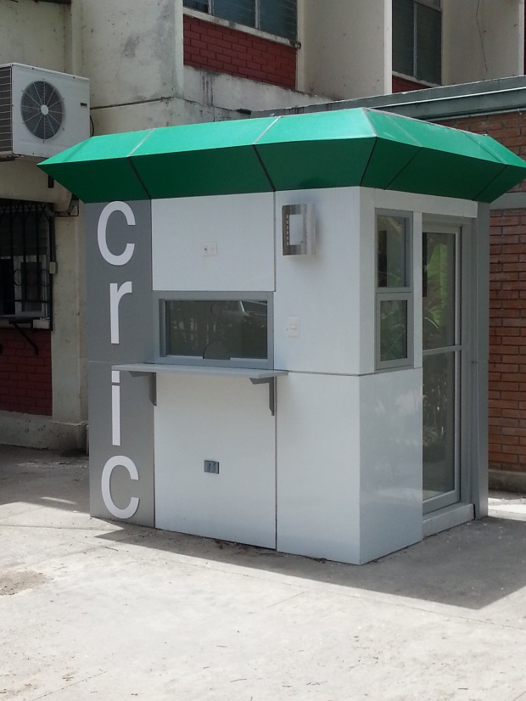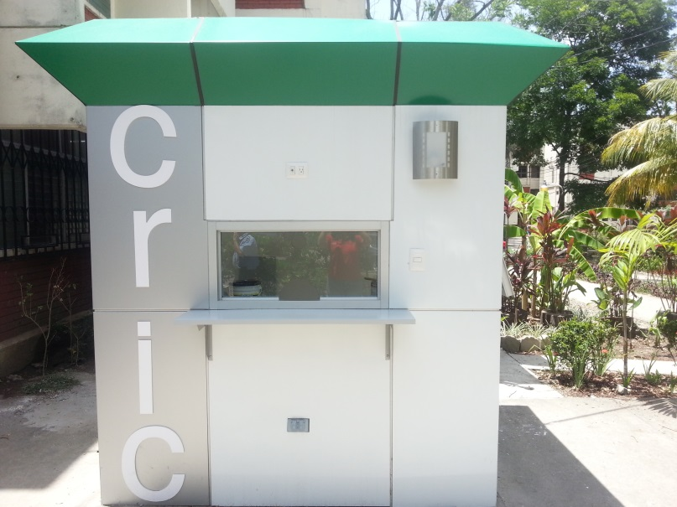

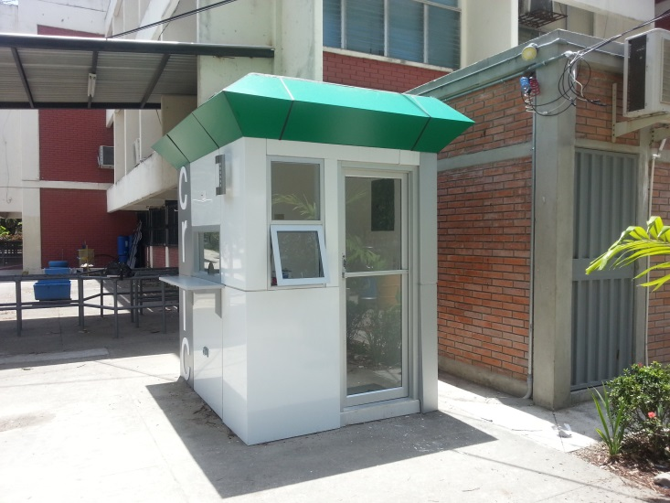

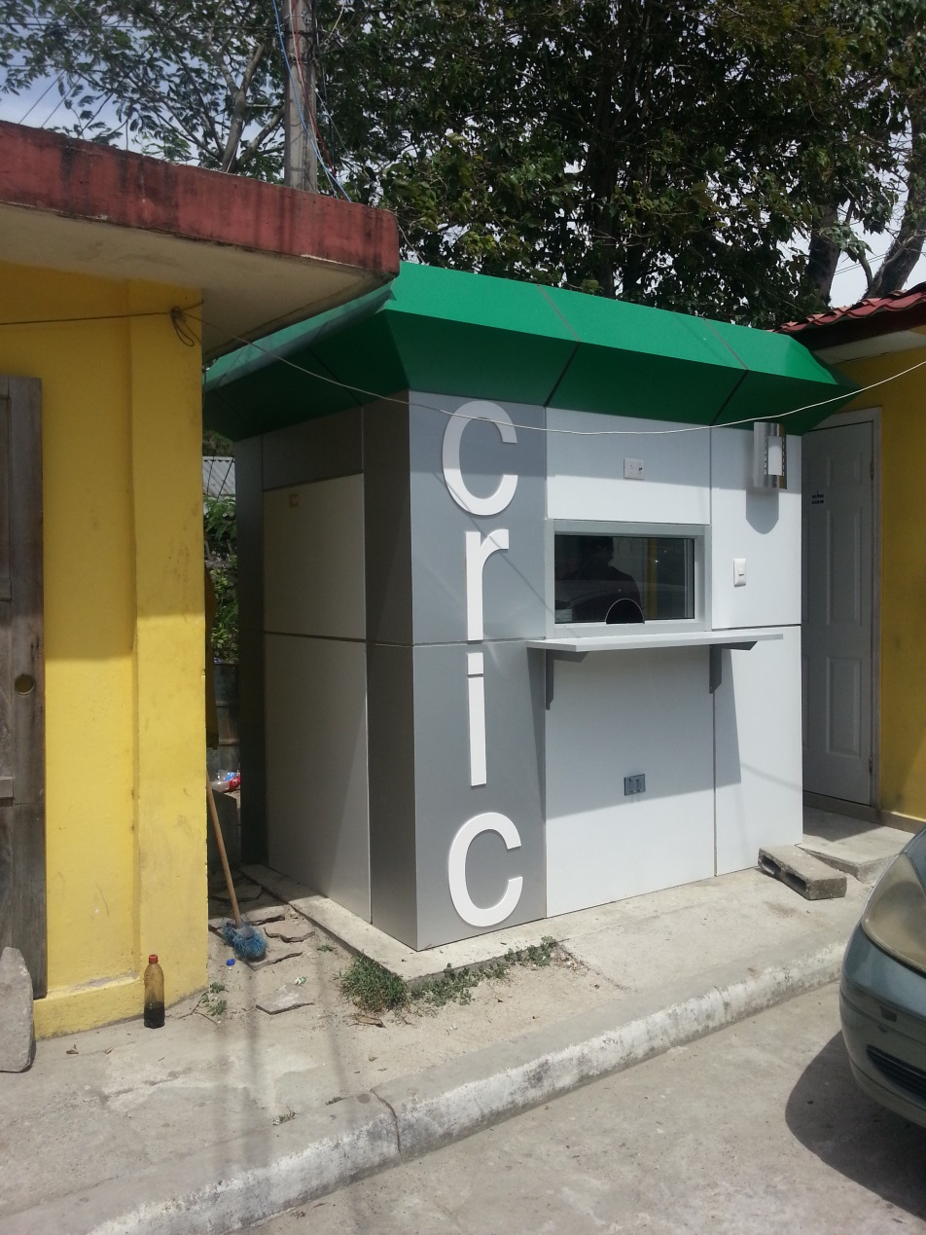**CRIC MORGUE SAN PEDRO SULA**

**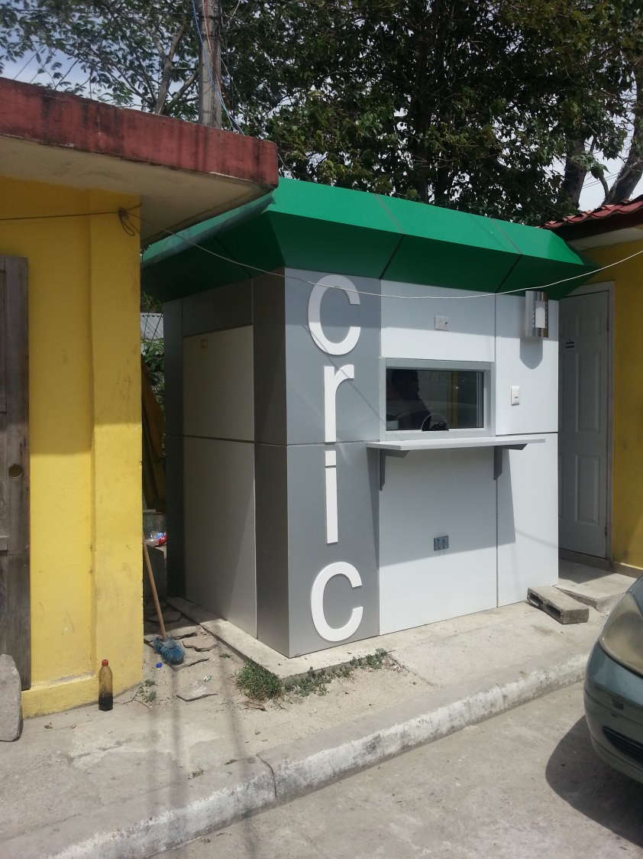**

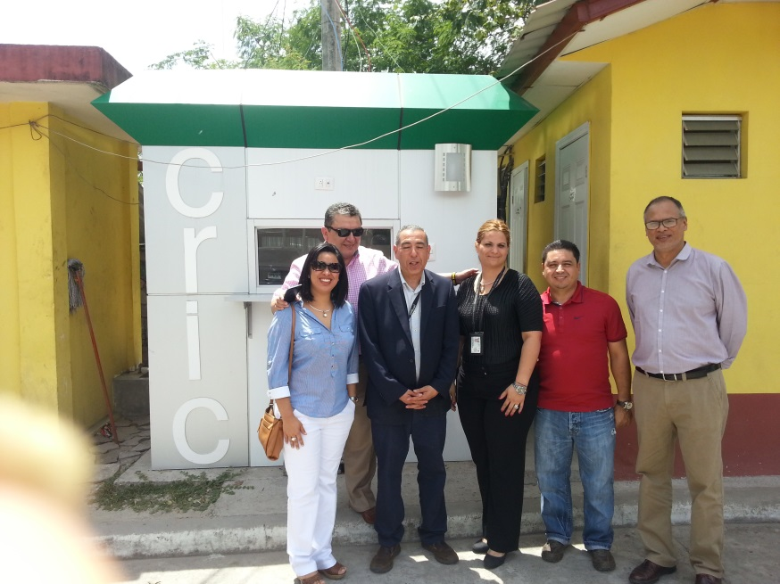

**INAUGURATION CRIC MORGUE TEGUCIGALPA**

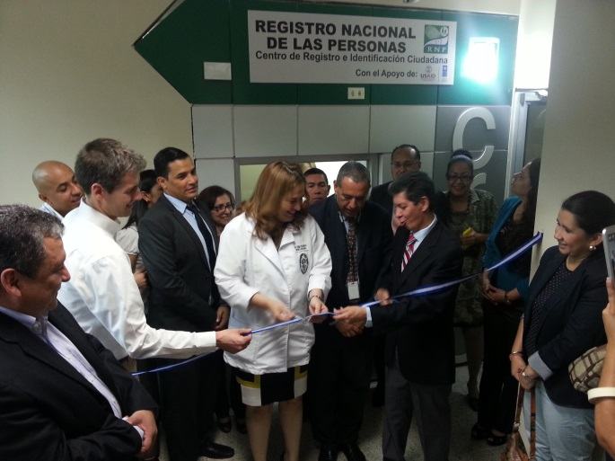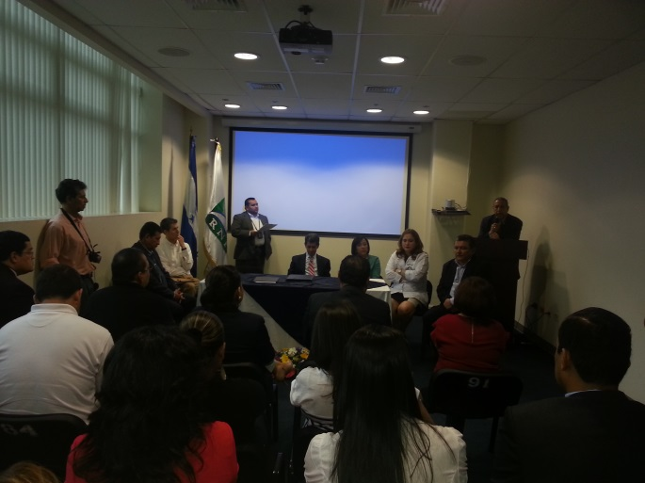

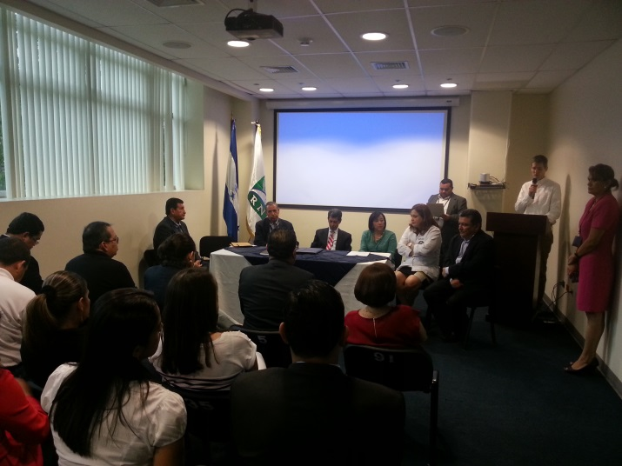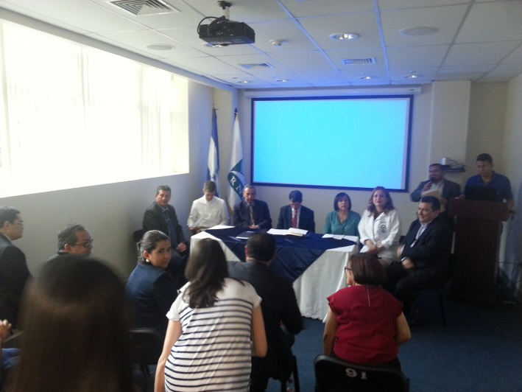

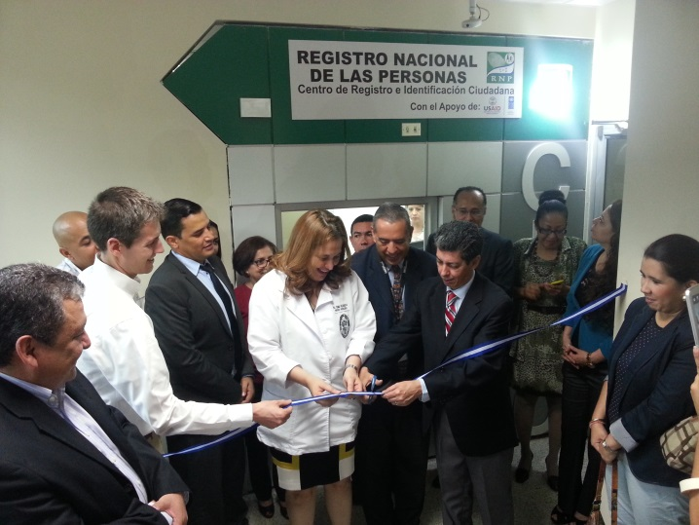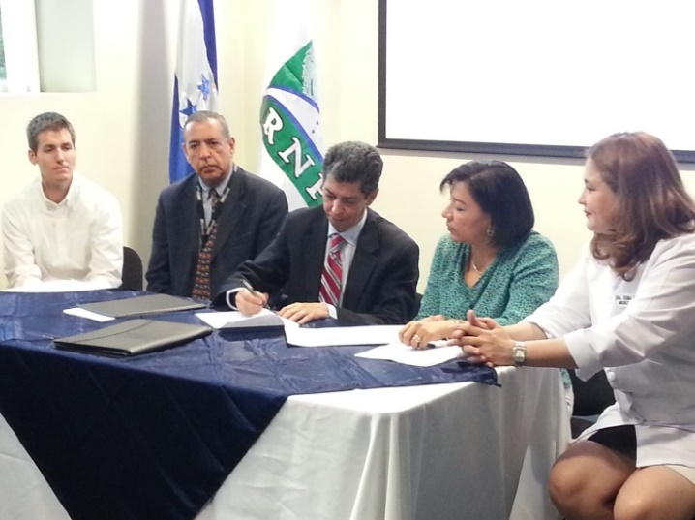

### 13.3.2.3 Component 3: Development of Public Policies for Citizen Security and Coexistence

#### 13.3.2.3.1 Indicator Performance Tracking Table

|  |  |
| --- | --- |
| **Indicators** | **Indicator performance** |
| Number of bi annually published Violence Bulletins at local level | 1. Validation, contrasting and unification of information with security and justice authorities at the national and municipal levels. 2. Generation of Variables crossing and indicators needed to design Bulletins for 5 municipalities. Development of municipal graphs of deaths from external causes, incidence of crime and injury. 3. Province and Municipal (San Pedro Sula, Choloma, Tela, La Ceiba and the Central District) thematic georeferenced urban maps development. 4. Preparation of charts, graphs and thematic georeferenced urban maps for 6 2014 annual Bulletins of the local and National Observatories. 5. Six Bulletins with geo-referenced time, person and place data have been analyzed, diagrammed and published, in the period from January to December 2014 in the municipalities of San Pedro Sula, Choloma, Tela, La Ceiba and the Central District at local level. Also, the Local Observatory of Violence has been designed; analyzed, charted and published using validated data at national level in 2014.   Three special Bulletins were produced :   * Violent deaths of women and female children in Choloma, San Pedro Sula Tela,  La Ceiba and Central District, from January to December 2013. * Bulletin of multiple homicides from January to September 2014. * Special Bulletin of transport Carriers from January to September 2014. |
| Number of government institutions using information of the Violence Observatory to design and implement public policy | 5 Local governments use information from violence and insecurity from the municipalities Diagnosis, which has allowed municipal authorities and security committees to acknowledge reality and establish public policy strategies and actions.  Security and prevention of violence municipal committees have reliable information, as a product of the validation and analysis of deaths and injuries from external causes, which allows characterization of operating styles and the main violence victims.  Tourist sites and areas where property crimes occur were geo referenced in La Ceiba, which was requested by the Municipality and the Chamber of Commerce.  19 organizations and institutions in the area use the information from the Observatory of Violence in the design and implementation of public policies of municipal governments; as well as 5 security committees of the municipalities , 10 NGOs, (CDM 'CEM-H ,Catholic church, women for life forum , yacshe, Visitación Padilla, Rainbow, CPTRT, Kukulcan) and 4 Cooperation Organizations (NDI, GIZ, WB, UNDP). |
| Number of projects submitted by municipalities for funding by the protection and security population fund and other sources | 1. The implementation of the Video and loudspeaker monitoring system Project at the Central Beach in Tela was funded by Municipal funds.  2. In Choloma, the following projects were implemented:  • IDECOAS- FHIS- BM ,15 Projects;  • IDECOAS- FHIS- USAID 20 Projects ;  • Security Tax: 10 Projects were presented, but progress was registered only for the Video monitoring system Project in Choloma;  • Private sector: 15 Projects;  • UNICEF-ACDI: 10 Projects.  3. In La Ceiba , the following projects were implemented:  • Security Tax: 8 Projects  • USAID-IDECOAS-FHIS-DIM: 45 Projects  • IDECOAS-FHIS-Banco Mundial: 15 Projects  • JICA : 2 Projects  • AECID: 11 Projects  4. Progress on the Security Tax Fund expenditures have not been registered in San Pedro Sula  5. Progress on the Security Tax Fund disbursement has not been registered in the Central District. |
| Number of operating plans that integrate social prevention, situational prevention, deterrence and crime control actions in Tegucigalpa , San Pedro Sula, La Ceiba , Tela and Choloma. | The development and ownership of the Annual Operating Plan 2015 by local governments and key stakeholders in La Ceiba, Choloma, Tela and San Pedro Sula was achieved.  At the Central District, actions related to Citizen Security defined in the 2014 operational plan were integrated into the 2015 Municipal Development Plan, considering that certification of PLCySC from the Ministry of Security has not yet been achieved. |
| Percentage of increase on the cases that have been mediated by the UMCs and PCCs in the 5 municipalities of the project. | Increased percentages on implemented mediations on the current quarter: Choloma: 200%, Tela: 400%, San Pedro Sula 11.9%, La Ceiba 60.0%.  An exception occurs at the Central District, where the percentage decreased by 33.3%. Total mediation percentage increase in 5 municipalities during the implementation stage was 109.4%.  PCCs : San Pedro Sula 200.0%, Choloma 0.0%, La Ceiba -100%, Tela 100.0%. 36 mediations were implemented during last quarter. During the current quarter, 11 mediation cases are registered, equivalent to 69.4%. Total implemented mediations in 13 PCC active months is 73%, with a monthly average of 5.6%. |
| Number of people in the five municipalities that have received the Diploma Certificate in Conflict Mediation and Conciliation for Civic and Community Coexistence. | 24 persons received a Diploma Certificate on Conflict Mediation and Conciliation for Civic and Community Coexistence by the end of the project in June 30, 2015. |
| Number of OMM technicians who complete the "Gender , violence against women and security" Diploma Certification. | The Diploma certification has been completed, having lasted for 7 months and certificating 35 persons belonging to OMMs, Municipal Justice Administrators and Women Networks. |
| An operating Handbook for the 5 OMMs emphasizing women’ roles in addressing violence has been produced. | 4 Handbooks for the functioning of the OMMs have been produced, printed and delivered in Choloma, La Ceiba, Tela y San Pedro Sula. The handbook for the Central District is awaiting approval. |
| Number of functioning youth enterprises in at least three Municipalities, having previously received funds and undergone a training process. | 1. In La Ceiba, transference of resources and capacity building for 40 youngsters was conducted n partnership with CURLA and the Chamber of Commerce. 16 business plans from the trainees were approved, of which 7 have been funded in kind. Inputs for the 9 remaining entrepreneurs are to be delivered at the beginning of July. The agreement was extended until August 31.  2. Seed capital was delivered to 4 enterprises in Comayagua (Ayacaste) and Amarateca (Buyara), who emerged from the cultural enterprises training delivered by the project : a) Collage (8 young persons from Comayagua); Percu Honduras (4 young persons from Comayagua); BUYARA (5 young persons from Amarateca), and Collectivo Stop V (8 young persons).  3. At Tela, 15 young persons received a resource transfer and entrepreneurship training. The selection and financing has not yet occured. The Agreement was extended until October 31.  4. At Choloma resources for the Revolving Credit Fund to the Chamber of Commerce of Choloma were transferred. The chamber of Commerce and COMVIDA Choloma have trained 30 young people in entrepreneurship. Resources are expected to be allocated by July. The Agreement was extended until 31 August. |
| Number of proposals for intervention in the arts and civic culture at the Central District, Choloma, La Ceiba, San Pedro Sula and Tela. Formulated and implemented Civic Culture Strategies in the 5 municipalities of the project. | 5 proposals for intervention in coordination with the Municipal Programmes for Children, Adolescents and Youth PMIAJ / COMVIDA were implemented. Achieved results are as follows:  1) A base group in each Municipality comprising 40 community artists for peace was conformed, trained on 6 artistic disciplines  2) A group of 10 young facilitators / trainers for each municipality was conformed, to replicate the processes at the level of communities vulnerable to violence.  3) Two workshops on Community Arts for Peace were replicated, in at least one vulnerable neighborhood in the 5 municipalities.  Additionally, regarding communications, the final production of a video clip in the form of rap and hip hop was participatory produced by the Colectivo Notas de Barrio, integrated by 6 young group leaders from Choloma, Chamelecón and Comayagua. The video is ready for broadcast. |
| Creation of a National Leader Group of youth trained in the Program for the creation of Youth Trainers in Arts and Culture of Peace in the 5 Municipalities. | 3 training workshops targeting 50 young persons (10 per Municipality) and 5 technicians of the Children, Adolescents and Youth PMIAJ / COMVIDA Programs in the 5 partner municipalities were implemented.  This young people have created a leading group which has been technically empowered as trainers in Arts and Culture of Peace, and are facilitating training processes of other young people in poor communities in their municipalities in the Chamelecón (Municipalities SPS), September 15 (Municipality of Tela ) ; El Barrio Inglés and El Centro neighborhoods (Municipality of La Ceiba) ; Barrio Concepcion ( Municipality of Choloma ) neighborhoods. The last replication training workshop is expected to take place by early July at the Central District. The group of young leaders intends to become a network of young artists for peace. |

##### **Completion of activities**

A summary of the successful completion of activities for the second stage of the project follows below:

* Creation of the Network of Voluntary Stakeholders in Community Coexistence in San Pedro Sula, Choloma, Tela y La Ceiba, which is made up by 164 citizens who are currently actively working
* Implementation of 8 Community Coexistence Groups/Centers[[3]](#footnote-3) (San Pedro Sula sector de Chamelecón, Choloma Col. Lopez Arellano, Tela Tornabe, Col. 15 de Septiembre, Col. Normal Mixta, La Ceiba Los cedros, Corozal y las Delicias.
* Monitoring and technical assistance to the Network of Voluntary Stakeholders in Community Coexistence regarding attention statistics , development of mediation sessions and activities related to advocacy and training provided by the promoters and the Mediation and Conciliation Unit.
* Volunteer hours’ certification for the Network of Voluntary Stakeholders in Community Coexistence. In 2014; 2,525 hours of voluntary work were reported.
* Implementation of 70 hours - training for officers in the Mediation and Conciliation Units, on advanced techniques for mediation and networking.
* A socialization workshop for judicial officers on the reasons, justification, objectives and attention strategies of community work developed by judicial officers was implemented in San Pedro Sula, Choloma, Tela, La Ceiba y Tegucigalpa . Currently, progress has been made on higher work coordination with some of the judicial officers at the before mentioned Municipalities.
* Participative production of an Ethics Code for the Voluntary Stakeholders in Community Coexistence, through the participation of the entire network and the Mediation Units. This Code supports self-regulation code of the actions taken by the network itself.
* Implementation of a Diploma Certification on Conflict Mediation and Conciliation for Citizen and Community Coexistence, attended by 24 Municipal officials from the five municipalities, who have come to know mediation techniques and have provided support to the Mediation Unit on educational processes.
* Implementation of the Mediation and Conciliation Unit of the Central District.
* Creation of the Voluntary Stakeholders in Community Coexistence network in the Central District, placing the Central District as the largest network among the municipalities (113 members).
* Creation of a Communications Campaign, built with participation of the Mediation Unit and the Voluntary Stakeholders in Community Coexistence network. Expected implementation will be on the first half of 2015.

##### Strengthening of the Municipal Women Office (OMM)

**Output 1: Strengthening of the Municipal Women Office to coordinate gender violence prevention strategies in La Ceiba , Tela, Choloma , San Pedro Sula , Central District .**

*Activity: Develop a diagnosis on gender violence and citizen security, and a support plan for OMMs.*

* The diagnosis on "Violence and citizen security. A View from a gender perspective " was published and presented to 4 deputy mayors of the Municipalities of La Ceiba , Choloma , San Pedro Sula, the Central District and Tela (The deputy mayor of Tela attended the event in Tegucigalpa, on June 10th 2015), and the Mayor of Tela in the launch held in Tegucigalpa on 10 June 2015. The event was attended by women from networks belonging to these municipalities, judicial officers, the international cooperation and technical staff from various agencies of the UN system.
* The diagnosis comprises data from 2008 to 2015, and highlights the behavior of various types of violence manifested in the municipalities: domestic, sexual, commercial exploitation and trafficking. It also highlights subjects that require further research.
* The document is a tool for decision making and for development of public policies based on its findings.

*Activity: Provide technical assistance for the integration of a gender focus in the formulation of 4 Annual Work Plans (AOPs), 1 PLC and SC*

* The "Guide to Integration of gender into local coexistence and citizen security plans” has been published. The Guide was developed in a participatory manner, and it will help support the formulation of AOPs and plans as well as their monitoring in municipalities, so that a gender perspective is effectively implemented to benefit women.
* A component for prevention of violence against women was included in the 2015 AOPs. The OMM, women's net Works, development organizations and public institutions participated on its production. Also, BA1 project actions were included in the AOP 2015 of the 4 municipalities.

*Activity: To implement and information system at the OMMs*

* The installation and training of the OMM/ INAM Information System at the 5 municipalities has been completed, although reported records in the system include the months of January through June 2015 in 4 municipalities (except La Ceiba). Continuous monitoring of the platform use is necessary, as well as the promotion of reports generation that promote the design of public policies in municipalities.

*Activity: Implementation of a Diploma Certification in Gender and Citizen Security, for the OMM, MP, the Police, the Judicial Sector, Women Organizations, UMC, COMVIDA.*

* The 7 Diploma Certificate Modules have been completed, and presentation of research results, as well as the graduation ceremony has taken place on March 23rd.

*Activity: Production of OMM operating handbooks, emphasizing citizen security and gender violence*

* Hand books for 4 municipalities have been printed and delivered to OMMs in an amount of 20 units per municipality, in connection with the campaign “Here and Now, my right to live " held in March 2015; except for the Central District.
* Negotiations with the Central District Mayor to find the way to approve the handbook and to promote its appropriate use have continued throughout the April-June quarter. The Manager of the human development department and the human resources department has shown willingness to do so.

*Activity: Equipment provision for the OMMs, acquisition of office supplies, adaptation of physical spaces.*

* Adaptation of the OMM in Tela had progressed up to 90% by June 30th. Completion and delivery is expected in July. Administrative aspects and monitoring of this process was addressed along the appointed responsible official by the Municipality, Mauricio Dueñas, Engineer.

*Activity: Launch a communications campaign to prevent and promote violence gender attention services*

* Launching of the campaign took place during the week from March 9th to March 13th, 2015

**Product 2: Grants Plans to support women's organizations promoting joint work with the Offices of Women in La Ceiba , Tela, Choloma and San Pedro**

* Completion of settlements and second disbursement to “Las Hermanas Asociadas de la Misericordia”, implemented through the ‘Women for Life’ Forum.

Overall, activities implemented in this quarter by the Forum, and that contribute to strengthening joint work along the OMM and women's networks in the municipalities were:

|  |
| --- |
| **Citizen Security Meetings implemented in:** |
| Tela |
| Choloma |
| San Pedro Sula |
| **12 Bi-montlhy meetings implemented in:** |
| Tela |
| Choloma |
| San Pedro Sula |
| La Ceiba |
| Tegucigalpa |
| **3 modules of the training course on Security Plans implemented** |
| **3 modules of the training course on Social Audit implemented** |

|  |
| --- |
| **Citizen Security Meeting in La Ceiba** |
| **Production of a report on findings that** |
| Facilitation |
| Publication of 200 bulletins |
| **Production of a document for systematization of achievements and knowledge** |
| Facilitation |
| Publication of 200 bulletins |

#### 13.3.2.3.2. Training workshops delivered from April 1 to June 30, 2015

| **Name of the training programme** | **Field of study** | **Relationship to the objectives** | **Start date** | **End date** | **Estimated cost (US$)[[4]](#footnote-4)** | **Number of female** | **Number of male** |
| --- | --- | --- | --- | --- | --- | --- | --- |
| **Observatories** | | | | | | | |
| Visits to regional Observatory centers (visiting tour to four cities in the north part of the Country) | Local Observato-ries | Information generation for bulletins | June 15 | June 27 | 7,600 | 35 | 45 |
| **Local Plans** | | | | | | | |
| First verification test of accomplishment of actions defined for the period January – June 2015 | Identification of implemented actions that require more time to ensure accom-plishment in La Ceiba | Commitment to implement AOP 2015 activities that should have been implemented at municipal level in the first half of 2015. | June 23 | June 24 | 2,286.18 | 12 | 6 |
| Workshop with stakeholders involved in the prevention and safety committees in the framework of strengthening technical capacities in "Communication and Development". | Capacity building for the Prevention Committee and the Security Committee on Communications and Development in San Pedro Sula. | Work plans that integrate actions of social prevention, situational prevention, deterrence and crime control in Tegucigalpa, San Pedro Sula, La Ceiba, Tela and Choloma. | May 21 | May 21 | 1,310 | 18 | 12 |
| Training process for members of the municipal authorities responsible for the management of public safety | Capacity building process development | Work plans that integrate actions of social prevention, situational prevention, deterrence and crime control in Tegucigalpa, San Pedro Sula, La Ceiba, Tela and Choloma. | April 24 | April 24 | 850 | 14 | 8 |
| First verification test of accomplishment of actions defined for the period January – June 2015 in Choloma | Identification of imple-mented actions that require more time to ensure accom-plishment in Choloma | Commitment to implement AOP 2015 activities that should have been implemented at municipal level in the first half of 2015. | June 25 | June 25 | 600 | 20 | 15 |
| Training process for members of the municipal authorities responsible for the management of public safety in La Ceiba | Capacity building process develop-ment in San Pedro Sula | Work plans that integrate actions of social prevention, situational prevention, deterrence and crime control in Tegucigalpa, San Pedro Sula, La Ceiba, Tela and Choloma. | April 21 | April 22 | 480 | 18 | 14 |
| Workshop with stakeholders involved in the prevention and safety committees in the framework of strengthening technical capacities in "Citizen Culture" | Capacity building process develop-ment in San Pedro Sula | Work plans that integrate actions of social prevention, situational prevention, deterrence and crime control in Tegucigalpa, San Pedro Sula , La Ceiba, Tela and Choloma. | June 04 | June 05 | 690 | 15 | 15 |
| **UMC** | | | | | | | |
| Training workshop on mediation in the following neighborhoods: Villanueva, Estados Unidos, Kennedy and at the Instituto Jesús Milla Selva | Strengthening Mediation and Concilia-tion Units | Strengthening of the Mediation and Conflict Conciliation Units through the Community Mediators Network in the Central District | April 14 | May 3 | 2,057.91 | 47 | 18 |
| Promoters workshop in the following neighborhoods: Villanueva, Estados Unidos, Kennedy and at the Instituto Jesús Milla Selva | Strengthening Mediation and Concilia-tion Units | Strengthening of the Mediation and Conflict Conciliation Units through the Community Mediators Network in the Central District | May 12 | May 24 | 2,301.49 | 52 | 18 |
| Promoters workshop in the following neighborhoods: Villanueva, Estados Unidos, Kennedy and at the Instituto Jesús Milla Selva | Strengthening Mediation and Concilia-tion Units | Strengthening of the Mediation and Conflict Conciliation Units through the Community Mediators Network in the Central District | May 31 | June 2 | 880.08 | 53 | 40 |
| Certification of trained Leaders as promoters and mediators in the Central District | Strengthening Mediation and Concilia-tion Units | Strengthening of the Mediation and Conflict Conciliation Units through the Community Mediators Network in the Central District | June 20 | June 20 | 2,197.37 | 97 | 40 |
|  |  |  |  |  |  |  |  |
| **OMM** | | | | | | | |
| Sex - Gender workshop in San Pedro Sula, aimed at the Prevention Committees, as a continuation of the training process defined from the Local Plans Component | Strengthening Municipal Women Offices | Strengthening Municipal Women Offices to coordinate gender violence prevention strategies in La Ceiba, Tela, Choloma, San Pedro Sula and the Central District. | April 23 | April 23 | 1,000 | 5 | 6 |
| Work visiting tour :    -Second AOPs review in each municipality  -Monitor the use of the OMM/INAM Information System | Strengthening Municipal Women Offices | Strengthening Municipal Women Offices to coordinate gender violence prevention strategies in La Ceiba, Tela, Choloma, San Pedro Sula and the Central District. | April 22  San Pedro Sula | April 22  San Pedro Sula | 1,000 | 2 | 1 |
| April 27  La Ceiba | April 27  La Ceiba |  | 2 | 1 |
| April 28  Tela | April 28  Tela |  | 2 | 1 |
| April 29  Choloma | April 29  Choloma |  | 2 | 1 |
| Sex - Gender workshop in San Pedro Sula, aimed at the Prevention Committees, as a continuation of the training process defined from the Local Plans Component | Strengthening Municipal Women Offices | Strengthening Municipal Women Offices to coordinate gender violence prevention strategies in La Ceiba, Tela, Choloma, San Pedro Sula and the Central District. | April 23 | April 23 | 1,000 | 5 | 6 |
| Work visiting tour :    -Second AOPs review in each municipality.  -Monitor the use of the OMM/INAM Information System. | Strengthening Municipal Women Offices | Strengthening Municipal Women Offices to coordinate gender violence prevention strategies in La Ceiba, Tela, Choloma, San Pedro Sula and the Central District. | April 22  San Pedro Sula | April 22  San Pedro Sula | 1,000 | 2 | 1 |
| **CULTURE** | | | | | | | |
| Second replica workshop in the neighborhood of Suyapa, in Chamelecón, San Pedro Sula | Training in art and culture of peace to young people. The art area focused on five disciplines: dancing (break dance, Samba) stilts, percussion and murals | Art and Culture Strategies have been strengthened in San Pedro Sula, Choloma, Tela y La Ceiba | May 15 | May 16 | 600 | 18 | 22 |
| Second replica workshop in La Ceiba Downtown | Training in art and culture of peace to young people. The art area focused on five disciplines: dancing (break dance, Samba) stilts, percussion and murals | Art and Culture Strategies have been strengthened in San Pedro Sula, Choloma, Tela y La Ceiba | June 21 | May 23 | 850 | 22 | 18 |
| Second replica workshop in the CEDEN neighborhood in Choloma | Training in art and culture of peace to young people. The art area focused on five disciplines : dancing (break dance, Samba) stilts, percussion and murals | Art and Culture Strategies have been strengthened in San Pedro Sula, Choloma, Tela y La Ceiba | June 20 | June 21 | 600 | 20 | 12 |
| Citizen Culture Workshop for COMVIDA in the Central District | Concep-tual elements on Youth and Citizen Culture for violence prevention | Art and Culture Strategies have been strengthened in San Pedro Sula, Choloma, Tela y La Ceiba | April 10 | April 10 | 0 | 14 | 11 |
| Final workshop for collective creation of the Youth video clip song. | Creation, composition , musical lyric to achieve the creation and recording of the theme song of the video clip | A communication strategy has been implemented for dignifying youth | April 19 | April 20 | 2,500 | 4 | 2 |
| Video Clip recording in Chamelecón | Video Clip recording | A communication strategy has been implemented for dignifying youth | June 6 | June 7 | 2,900  3,500  (payment to producers for production and post production)  6,400 | 30 | 23 |

## 13.3.3 Modifications and amendments

Modification No. 7, dated June 8, 2015, extended the grant from June 30, 2015 through June 30, 2017, and increased the total estimated amount by US$4,859,186.49 (from $7,367,365.79 to $12,226,552.28). The obligated amount was $1,359,186.49.

## 13.3.4 Financial Information

### 13.3.4.1 Financial status as of June 30, 2015 - Component 1: Electoral Technical Assistance

**Budget:**

|  |  |  |  |  |  |
| --- | --- | --- | --- | --- | --- |
|  | **Original grant (September 30, 2011)** | **Modification 1 (July 9, 2012)** | **Modification 4 (October 31, 2013)** | **Modification 7 (June 8, 2015) Extension through June 30, 2017** | **Total** |
| **Federal** | $ 300,000.00 | $ 500,000.00 | $ 1500,000.00 | $ 786,056.75 | $ 3086,056.75 |
| **Non-Federal** | $ 130,000.00 | $ 150,000.00 | $ 162,386.24 | $ 0.00 | $ 442,386.24 |
| **Total** | $ 430,000.00 | $ 650,000.00 | $ 1662,386.24 | $ 786,056.75 | $ 3528,442.99 |

**Financial status:**

|  |  |
| --- | --- |
| **Description** | **Amount US$** |
| **Federal Cash:** | |
| a. Cash Receipts | 2300,000.00 |
| b. Cash Disbursements | 1755,590.91 |
| c. Cash on Hand (line a minus b) | 544,409.09 |
| **Federal Expenditures and Unobligated Balance:** | |
| d. Total Federal funds authorized | 3086,056.75 |
| e. Federal share of expenditures | 1755,590.91 |
| f. Federal share of unliquidated obligations | 67,162.92 |
| g. Total Federal share (sum of lines e and f) | 1822,753.83 |
| h. Unobligated balance of Federal funds (line d minus g) | 1263,302.92 |
| **Recipient Share:** | |
| i. Total recipient share required | 442,386.24 |
| j. Recipient share of expenditures | 524,300.76 |
| k. Remaining recipient share to be provided (line i minus j) | -81,914.52 |

### 13.3.4.2 Financial status as of June 30, 2015 - Component 2: Technical Assistance in Citizen Identification

**Budget:**

|  |  |  |  |  |  |
| --- | --- | --- | --- | --- | --- |
|  | Original grant (September 30, 2011) | Modification 1 (July 9, 2012) | Modification 4 (October 31, 2013) | Modification 7 (June 8, 2015) Extension through June 30, 2017 | Total |
| Federal | N/A | $500,000.00 | $1500,000.00 | $773,129.74 | $2773,129.74 |
| Non-Federal | N/A | $155,000.00 | $121,411.76 | $0.00 | $276,411.76 |
| Total | N/A | $655,000.00 | $1621,411.76 | $773,129.74 | $3049,541.50 |

**Financial status:**

|  |  |
| --- | --- |
| **Description** | **Amount in US$** |
| **Federal Cash**: | |
| a. Cash Receipts | 2000,000.00 |
| b. Cash Disbursements | 1859,078.93 |
| c. Cash on Hand (line a minus b) | 140,921.07 |
| **Federal Expenditures and Unobligated Balance:** | |
| d. Total Federal funds authorized | 2773,129.74 |
| e. Federal share of expenditures | 1859,078.93 |
| f. Federal share of unliquidated obligations | 99,995.76 |
| g. Total Federal share (sum of lines e and f) | 1959,074.69 |
| h. Unobligated balance of Federal funds (line d minus g) | 814,055.05 |
| **Recipient Share:** | |
| i. Total recipient share required | 276,411.76 |
| j. Recipient share of expenditures | 501,540.94 |
| k. Remaining recipient share to be provided (line i minus j) | -225,129.18 |

### 13.3.4.3 Financial status as of June 30, 2015 - Component 3: Development of Public Policies for Citizen Security and Coexistence

**Budget:**

|  |  |  |  |  |
| --- | --- | --- | --- | --- |
|  | **Original grant (September 30, 2011)** | **Modification 3 (September 26, 2013)** | **Modification 7 (June 8, 2015) Extension through June 30, 2017** | **Total** |
| **Federal** | $773,610.00 | $2293,755.79 | $3300,000.00 | $6367,365.79 |
| **Non-Federal** | $211,855.61 | $294,000.39 | $150,000.00 | $655,856.00 |
| **Total** | $985,465.61 | $2587,756.18 | $3450,000.00 | $7023,221.79 |

**Financial status:**

|  |  |
| --- | --- |
| **Description** | **Amount in US$** |
| **Federal Cash**: | |
| a. Cash Receipts | 3067,365.79 |
| b. Cash Disbursements | 2920,611.39 |
| c. Cash on Hand (line a minus b) | 146,754.40 |
| **Federal Expenditures and Unobligated Balance:** | |
| d. Total Federal funds authorized | 6367,365.79 |
| e. Federal share of expenditures | 2920,611.39 |
| f. Federal share of unliquidated obligations | 106,389.79 |
| g. Total Federal share (sum of lines e and f) | 3027,001.18 |
| h. Unobligated balance of Federal funds (line d minus g) | 3340,364.61 |
| **Recipient Share:** | |
| i. Total recipient share required | 655,856.00 |
| j. Recipient share of expenditures | 966,315.86 |
| k. Remaining recipient share to be provided (line i minus j) | -310,459.86 |

## 13.3.5 Further information on Component 1: Electoral Technical Assistance

#### Collaboration and/or knowledge sharing with other USAID activities

##### Relationship with other USAID activities

Collaboration with two other USAID-funded UNDP projects (Technical Assistance for Citizen Identification and Developing Public Policies for Citizen Security and Coexistence) remains positive and follow up meetings with representatives of USAID Democracy and Governance Office and the Coordinator of UNDP’s Governance Unit were periodically held for information and collaboration purposes.

##### Key highlights of collaboration

As in previous reports, the meetings and presentations of the achievements and obstacles of each of the USAID-funded UNDP projects (ATE, RNP, and citizen security) allow for more effective cooperation in the assistance provided to the beneficiary institutions.

##### Challenges of collaboration

One challenge is keeping the needs of the Project within the framework of assistance internally approved by USAID.

#### Collaboration and/or knowledge sharing with government partners or other donors

##### Links with relevant ministries and donor agencies

* The ATE Project was actively participating in the meetings of the Electoral Monitoring Group (Grupo de Seguimiento Electoral or GSE) of the Transparency and Good Governance Roundtable of the G16. This Group has been transformed in to an autonomous Roundtable.
* The ATE Project has participated in meetings addressing Gender issues. The meetings were held among the Magistrates and UNWomen, and also among the Academia de Parlamentarias (Academy of female deputes) and the INAM.

#### Special reporting requirements (USAID forward, presidential initiative)

*Not applicable*

#### Integration of cross-cutting variables

##### Gender

The ATE Project has supported the ATENEA regional initiative (promoted by UNDP, UN Women, and IDEA International): a System for Monitoring Women’s Political Participation in Honduras with the objective of generating reliable information and conducting a comprehensive assessment of the exercise of women’s political rights in the country. A Gender Expert was hired to carry out this work.

#### Environmental compliance

*Not applicable*

#### Global climate change

*Not applicable*

#### Administrative and management issues

##### Constraints and critical issues

Many of the responsibilities of coordination and management of the project were made by both the electoral technical advisor and the national technical assistant, due to the non-renewal of the contract of the former manager and the resignation of the financial administrator assistant in late January. This situation had consequences on the implementation of the project activities due to the heavy workload that was generated, although many activities were carried out since late February.

##### Personnel

The recruitment status processes for this quarterly are as follows:

* International Technical Advisor/Manager. The recruitment process is ongoing and potential candidates have been identified. Nevertheless, this process could be completed in about three more months.
* A temporary administrative assistant was hired by the end of March to support the ATE technical team, while the recruitment process of the administrative financial assistant is in process. His contract concluded at the beginning of June 2015.
* Administrative financial assistant hiring process was completed on mid-June.
* The process of recruitment for national experts on electoral reforms has started. These experts will collaborate with the TSE to discuss and analyze the current electoral law and the 2011 bill in order to identify and probably formulate electoral regulations.

The following chart details the status of the recruitment processes for the new ATE Project team and other consultants:

|  |  |  |
| --- | --- | --- |
| **Type of Consultant** | **Status** | **Period** |
| International Technical Advisor/Coordinator | In progress | ----- --- ----- |
| Administrative financial assistant | Completed | June 2015 – December 2015 |
| National consultants on electoral reforms | In progress | ----- --- ----- |

##### Changes to activities

No change to activities, as the ATE project work at the lines of assistance referred to in the AWP 2014-2015.

##### Modifications and amendments

As stated before, the new phase of the project was prepared on the framework of one main objective: Honduran Electoral System Strengthened that aims at two results: (1) Electoral legal and regulatory framework improved and (2) Electoral institutions’ administration improved. Besides continuation of provision of technical assistance to the TSE, this new phase considers the assistance to two more stakeholders within the political-electoral arena: civil society organization and political parties.

The new phase of project entries into effect by final approval from USAID. However, it is expected to start from July 1, 2015, and end in June 2017.

#### Evaluations and lessons learned

##### Lessons learned and best practices

The ATE Project has experienced some difficulties when trying to implement the activities that where agreed with the TSE. On one hand, the lack of enough staff at the Project represented a serious hindrance. On the other hand, it was difficult to work with the TSE due to its internal disorganization.

New staff is joining the project which will help a better implementation. Furthermore, UNDP will periodically subscribe agreements (that specify all the activities to be implemented) with the TSE, empowering UNDP to directly do all the administrative arrangements without the need of the signature of the counterpart for each activity.

##### Actions and next steps

The ATE Project is currently defining a strategy to implement the AOP for the next 3 and 6 months, including the hiring of consultants, the organization of workshops and seminars and the support to several activities of the TSE´s Training Unit.

#### Activities planned for the next semester

|  |  |  |  |
| --- | --- | --- | --- |
| **Planned Activities from previous semester**  **(Oct 2014 – March 2015)** | **Current Status (July 2015)** | **Explanation for Changes** | **Proposed Activities for the next quarterly**  **(July 2015 – September 2015)** |
| * 1. **Support for Electoral Reform**      1. Review the electoral reform bill presented by the TSE with support from UNDP.      2. Internal discussion about the revised electoral reform proposal.      3. Draft the bill’s articles.      4. Workshops, seminars, and forums on electoral reform with civil society organizations, the National Congress, and electoral officials.      5. Consultations and citizen education about the content of the electoral reform, in collaboration with civil society organizations.      6. Training on the electoral law for media.   2. **Support to Strengthen the TSE’s Operating Units**       1. Support for training the TSE’s new magistrates and directors.      2. Support for the Census and Mapping Unit: hire experts to link the TSE and the RNP.      3. Creation of a Monitoring and Follow-up Unit (Executive Office).      4. Provide assistance to the Gender Unit.      5. Support the adjustment of the gender requirements of the political party law: statutes, offices, etc. | Electoral reform consultants are working on the analysis of the LEOP and the 2011 Bill in order to deliver a first draft of proposed electoral reforms in the form of regulations to the TSE.  Also, the technical mission to Dominican Republic is currently being developed with the participation of the four Judges of the TSE, three members of the Electoral Affairs Commission of the National Congress and representatives of political parties. Additionally, the mission is accompanied by a representative of CSOs, one from USAID and one from UNDP/Honduras. | The project proposal for the new phase was prepared based on existing lines of work contemplated in the previous phase of the project. Therefore, no substantial changes in activities other than the inclusion of activities related to political parties and civil society were made, so that these actors also have an impact on the discussion of possible electoral reforms. |  |
| * 1. **Support to Student Governments. Civic and Democratic Education. Creation of a Citizens’ Network.**      1. Support to the 2014 Student Governments, University Elections, and the Ministry of Education’s campaign for civic information.      2. Pilot experience with a Citizens’ Network.      3. Training on non-sexist reporting for the TSE.      4. Agreement among TSE, UNDP & the Ministry of Education for democratic training campaigns.      5. Evaluation and selection of consultants for the TSE’s Training Unit/IPECC      6. Support for the TSE’s Democratic Values campaign      7. Training of trainers in the Citizen Participation division      8. Education certificates in democracy and electoral law | It is continuing with the support of the Unit for Electoral Training and Civic Education with the publication of the electoral bulletin. | The project proposal for the new phase was prepared based on existing lines of work contemplated in the previous phase of the project. Therefore, no substantial changes in activities other than the inclusion of activities related to political parties and civil society, so that these actors also have an impact on the discussion of possible electoral reforms. |  |
| * 1. **Functioning of the ATE Project’s Office**      1. Drafting of the team’s terms of reference.      2. Hiring of experts and consultants.      3. Implementation of activities in accordance with the AOP.      4. Monitoring, follow-up, and reporting about the Project’s achievements.      5. Effective and timely administrative management of the Project. | After the Project’s AWP approval, UNDP engages in a recruitment process to form the ATE technical base team. Currently, the hiring of the new project manager and the administrative financial assistant is ongoing. | The project proposal for the new phase was prepared based on existing lines of work contemplated in the previous phase of the project. Therefore, no substantial changes in activities other than the inclusion of activities related to political parties and civil society were made, so that these actors also have an impact on the discussion of possible electoral reforms. |  |

#### Branding, communication and dissemination

The ATE Project coordinated with the Communications Unit of PNUD in order to effectively communicate the activities that were implemented.

Two main activities had an important space in the national press and TVs:

1) The workshop to present the interconnection system between the RNP and the TSE (Jornada presentación protocolo de interconexión RNP-TSE): with the presence of the 4 Magistrates of the TSE, and the 3 Directors of the RNP, the ATE Project (UNDP), the RNP Project (UNDP) and staff from the TSE and from the RNP.

2) The workshop to present the Electoral Bulletin (Lanzamiento de Boletín Electoral "Conectados con la Ciudadanía"): with the presence of the 4 Magistrates, Sergio Membreño (UNDP), Theodore Glenn (USAID), the ATE Project (UNDP), and staff from the TSE.

|  |  |
| --- | --- |
| ***Key communication activities***  **Publications** | |
| Electoral Bulletin “Connected with Citizenry” May 2015  This is the first publication of the bulletin, which had two main objectives: (1) generate a communication channel between the citizenry and the TSE and (2) share the main activities implemented by the TSE. This bulletin contains activities supported by UNDP such as the workshops and later the event for the presentation of the design of the interconnection system TSE-RNP and the elections for Government Students implemented nationwide. Moreover, it includes news about the creation of the TSE Planning and Monitoring Unit (UPEG), Parity and Alternation Electoral Regulation and the electoral regulation for Political Parties Inscription, all these initiatives have been supported by UNDP Electoral Technical Assistance Project.  <http://www.tse.hn/boletinelectoral/Boletines_2015/boletin_mayo_2015/index.html> |  |
| Electoral Bulletin “Connected with Citizenry” June 2015  The Bulletin collects electoral issues of great importance for the citizenry and activities implemented by the TSE aiming at the democracy strengthening such as: regional encounter of Electoral Management Bodies that mainly discuss the supreme character of the electoral management bodies and the administration and organization of government student’s elections. Additionally, it contains information about the technical mission to the TSE Costa Rica that counted with the participation of the TSE Electoral Director and members of the recently created UPEG and the work of the TSE Cartography Units to update the information of the Geographic Political-electoral Division in 12 municipalities of Francisco Morazán Department. The latter two actions were supported by UNDP.  <http://www.tse.hn/boletinelectoral/Boletines_2015/boletin_2015_06/index.html> |  |

|  |  |
| --- | --- |
| Events | |
| Workshop to discuss and formulate the draft of the electoral regulation “Inscription of Political Parties”  Due to the political electoral context has dramatically change from a bipartisan to a multiparty scenario after the results of the 2013 General Elections, the TSE organized a workshop with collaboration of the ATE Project in order to discuss and start drafting about the electoral regulation on political parties inscription. | E:\IMG_1156.JPG |
| C:\Users\Public\Pictures\GE_TSE\Trujillo\20150227_141820.jpgTraining session for organization of Government Students’ elections  ATE Project supported the TSE Electoral Training Unit and the TSE Civic Education Unit on implementing training session nationwide to Departmental, District, and Municipal Directors in order to share information on organization government students, so these directors would share such knowledge with school directors and students. |  |
| C:\Users\Public\Pictures\S4 SD Card Backup_June 15\DCIM\Camera\20150424_150558.jpgStudent Government’s Elections – Electoral Observation  ATE Project with collaboration of UN Volunteers and Honduras Voluntaria volunteer’s network assisted the TSE in the electoral observation of the Student Government Elections. The activity counted with more than a hundred volunteers that observed whether or not the elections were implemented according to the TSE standards. |  |

|  |  |
| --- | --- |
| Work meeting to present advances in the RNP-TSE interconnection system  The ATE Project organized a meeting with the Magistrates of the TSE and the Directors of the RNP so that the consultant on IT toghehter with the technicians of both organizations could present the advances in the development of the RNP-TSE interconnection system and agreements could be reached. | D:\Docs\04232015_disenan_sistema_para_conectar_datos_del_tse_y_el_rnp_para_depurar_censo_electoral.jpg |
|  |  |
| Launching of the electoral bulleting “Connected with citizenry”  The ATE Project supported the event where the first issue of the Electoral Bulleting “Conectados con la Ciudadanía”. A huge number of TSE staff members participated, together with representatives of the civic society. In the presiding table there were the 4 TSE Magistrates, and representatives of UNDP and USAID. | C:\Users\Carlos Vegas\AppData\Local\Microsoft\Windows\Temporary Internet Files\Content.Word\IMG_4398.jpg |
| Meeting to discuss the regulation for parity and Alternation  The ATE Project team participated in a meeting at the TSE office in order to support the discussion of the future regulation for parity and alternation. Participants included the deputies from the “Academia de Parlamentarias”, UNWomen, the INAM. | D:\Docs\11659293_10153328918685033_5867342180105380709_n (1).jpg |

**Press**

<http://www.elheraldo.hn/metro/834310-213/una-fiesta-c%C3%ADvica-se-vivi%C3%B3-en-elecciones-estudiantiles>

<http://www.elheraldo.hn/regionales/799459-364/honduras-en-marcha-elecci%C3%B3n-de-gobiernos-estudiantiles>

<http://www.hn.undp.org/content/honduras/es/home/presscenter/articles/2015/04/23/dise-an-sistema-que-conectar-datos-del-tse-y-rnp-para-depurar-censo-electoral-.html>

<http://www.latribuna.hn/2015/04/09/tribunal-supremo-electoral-aprueba-reglamento-para-nuevos-partidos/>

<http://www.laprensa.hn/honduras/829275-410/fijan-inscripci%C3%B3n-a-nuevos-partidos-pol%C3%ADticos>

<http://www.latribuna.hn/2015/06/18/preparan-reglamento-sobre-paridad-y-alternancia/>

<http://www.laprensa.hn/honduras/850600-410/hondure%C3%B1as-buscan-paridad-electoral>

<http://www.listindiario.com/la-republica/2015/07/24/381570/rosario-se-rene-con-comitiva-tse-de-honduras>

#### Sustainability and exit strategy

The ATE Project has been focusing its efforts on the institutional strengthening of the TSE, with a special focus on the Training Unit and the Management and Evaluation Unit. The purpose is to continue to build staff capacity and conduct workshops, seminars, and meetings focused on developing the necessary skills to achieve sustainability in the actions undertaken by the TSE. Therefore, UNDP will continue to build staff capacity and conduct workshops, seminars, and meetings focused on developing the necessary skills to achieve sustainability in the actions undertaken by the TSE.

1. See List of Bulletins in Annexes [↑](#footnote-ref-1)
2. Tasa de Cambio a Septiembre 2014 de acuerdo a Sistema de PNUD US$ 1= Lps.21.2254 [↑](#footnote-ref-2)
3. Translated from the original text in spanish ‘Puntos de Convivencia Comunitaria’ [↑](#footnote-ref-3)
4. 2014 Exchange rate by UNDP system USD$ 1= Lps.21.2254 [↑](#footnote-ref-4)